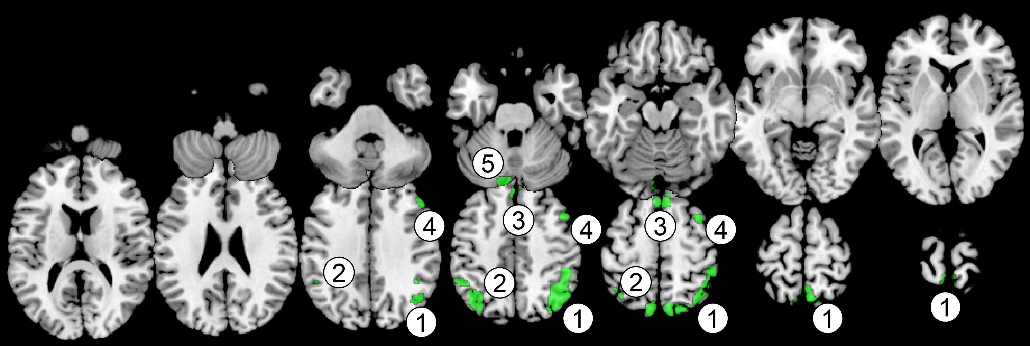
Size | Cluster composition |  | Peak coordinates |  |  | Eigen-value at peak
 | Anatomical region | % | x | y | z
(1) R Posterior part of Intraparietal Sulcus (pIPS)
1642 | R Angular Gyrus | 24.67
 | R Inferior Parietal Gyrus | 20.89
 | R Precuneus * | 15.90 | 2 | -58 | 72 | 0.018257
 | R Superior Parietal Gyrus | 15.47
 | L Precuneus | 15.23
(2) L Posterior part of Intraparietal Sulcus (IPS)
376 | L Inferior Parietal Gyrus | 60.37
 | L Angular Gyrus * | 28.99 | -38 | -66 | 46 | 0.015667
 | L Superior Parietal Gyrus | 10.11
(3) Supplementary Motor Area/Superior Frontal Gyrus (SMA/SFG)
238 | L Superior Frontal Gyrus (medial) | 47.48
 | R Superior Frontal Gyrus (medial)* | 34.45 | 4 | 26 | 58 | 0.014029
 | L Supplementary Motor Area | 10.08
(4) R Middle Frontal Gyrus (MFG)
144 | R Middle Frontal Gyrus * | 100.00 | 48 | 26 | 36 | 0.011538
(5) Posterior Cerebellum (pCBL)
141 | L Cerebellum Crus1 * | 40.43 | -2 | -88 | -16 | 0.011335
 | L Cerebellum Crus2 | 34.75
Note: Conventions follow Table S2. Shaded rows indicate clusters that were also found in the 2-nd component of Task 2 (see Table S7).

