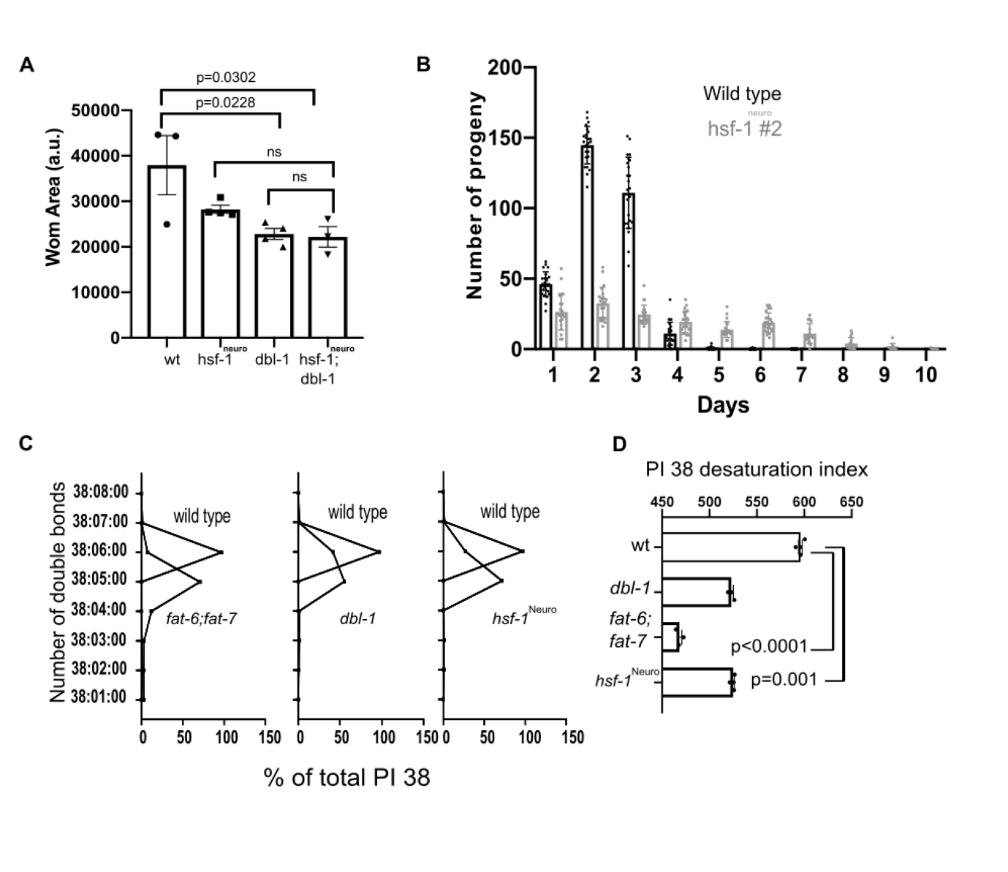
Fig S4. Overexpression of hsf-1 in neurons phenocopies TGF-β/BMP mutants.
(A) The small size of hsf-1^{neuro}#2 is caused by reduced TGF-β/BMP signalling. Area in arbitrary units (a.u.) of the genotypes: wildtype (N2); hsf-1^{neuro}#2 (AGD1289); dbl-1(nk-3) (NU3); hsf-1^{neuro}#2; dbl-1(nk3)(MOC253). BMP is epistatic to nhsf-1 because the double mutants are not shorter than any single mutant alone. Each dot corresponds to a distinct biological replicate, error bar corresponds to the SEM, and statistics were performed using a one-way ANOVA test. (B) hsf-1^{neuro}#2 causes a germline senescence phenotype. A representative biological replicate showing the number of self-progeny laid per day at 20℃ from day 1 to 10 of adulthood in hsf-1^{neuro}#2 (AGD1289, grey bars) and wildtypes (N2, black bars). Each dot represents the total progeny output of a single worm. Table S9 shows that the difference in reproductive output is significantly lower than WT during the first 3 days of adulthood and then remains higher than wt for the last two tested days (two-way ANOVA interaction, P-value= 0.0293. (C-D) Changes in the lipid composition of dbl-1 animals are consistent with decreased saturation and fluidity in the plasma membrane. (C) Relationship between the quantity (in ng/ng DNA) of acyl chain (carbon number related to the FA composition in position sn-1 and sn-2 in glycerophosphoplids) for the specified number of double bonds (from 0, saturated to 8, poly-unsaturated) in PI 38 (phosphatidylinositol with an acyl chain of 38 carbons) All normalised data is listed in Table S1. (D) Shows desaturation index. Steroyl-CoA desaturase mutants: fat-6/7=fat-6 (tm33)1; fat-7 (wa36); dbl-1= dbl-1(nk3)(NU3); hsf-1^{neuro}(AGD1289). All normalised data is listed in Table S2 and all data in in Data_Figure_S4.

