Fig S6A. Neurons expressing tax-4p::tax-4::wrmScarlet are adjacent to neurons where HSF-1 is activated. (A-D) Micrographs of animals carrying both tax-4p::tax-4::wrmScarlet (1) and hsp-16.41p::cGAL/UASp::GFP transgenes with the co-injection marker ttx-3p::RFP, expressed in the AIY neuron (2). Green neurons expressing hsp-16.41p::cGAL/UASp::GFP depict neurons where HSF-1 is activated (neuronal stress). While no direct co-localization was observed in this series of experiments between neurons expressing tax-4 and neurons where HSF-1 is activated, these images reveal that the two neuronal circuits are intricate and in close proximity. Animals were grown at 25°C and imaged at day 2 of adulthood. Images were taken on a Zeiss confocal microscope at 60X objective, left is anterior. (A) DIC, scale bar=50 µm. (B) Composite image of maximum projection of the zone delimited by a square in A. scale bar = 20 µm. (C) and (D) show respectively the green and red channels of the maximum projection in (B).
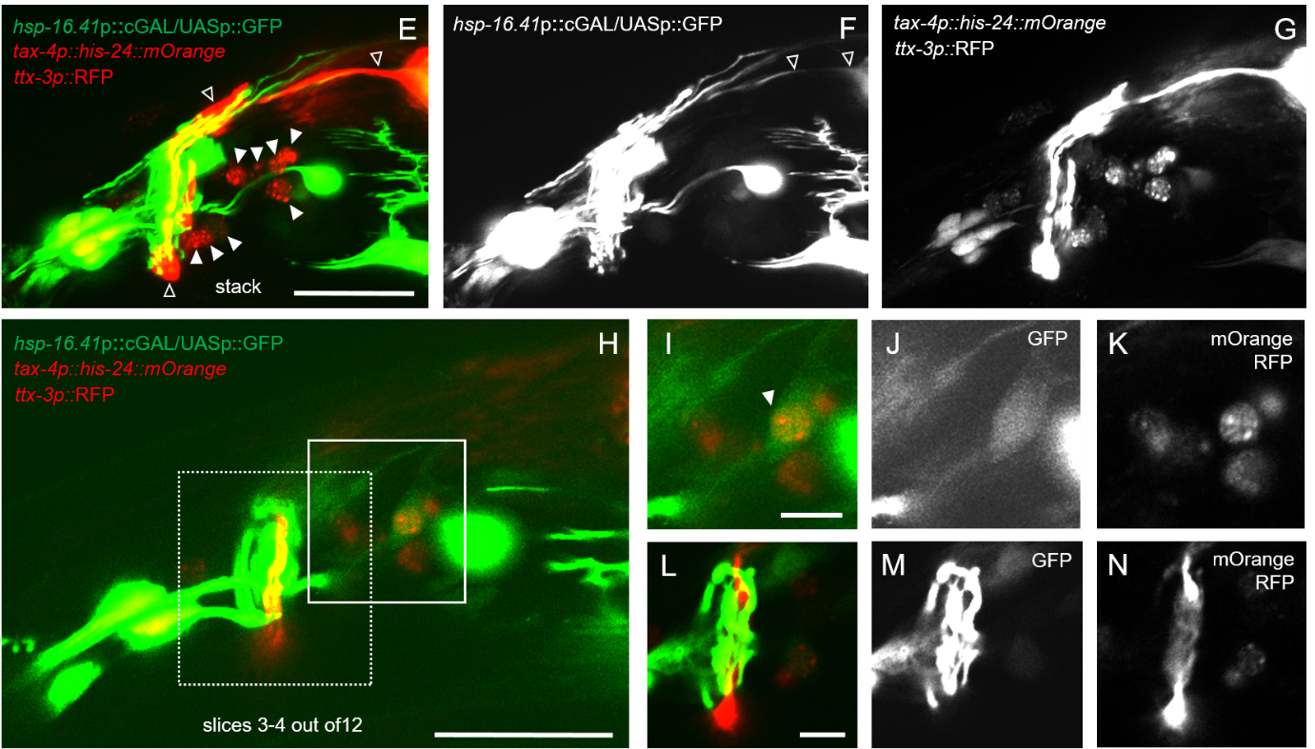
Fig S6B. Neurons expressing tax-4p::his-24::mOrange are adjacent to neurons where HSF-1 is activated, with occasional overlap. (E-N) Micrographs of animals carrying both tax-4p::his-24::mOrange and hsp-16.41p::cGAL/UASp::GFP transgenes with the co-injection marker ttx-3p::RFP, expressed in the AIY neuron (2). This series of experiments showed again that neurons expressing tax-4 and neurons where HSF-1 is activated are in close proximity and occasionally overlap, as seen in I. Green neurons expressing hsp-16.41p::cGAL/UASp::GFP depict neurons where HSF-1 is activated (neuronal stress). Red nuclei (full arrowhead in E) depict tax-4 expressing neurons, while red neurons in E is AIY (ttx-3p::RFP co-injection marker), shown by empty arrowhead in E. The expression levels of tax-4p::his-24::mOrange were very low in comparison to ttx-3p:RFP. In (E-G), we observed overlap of neurons where HSF-1 is activated with AIY (empty arrowhead in F). (E) Composite image of maximum projection, Stack of 12 slices, (F) maximum projection, GFP channel, (G) maximum projection, red channel. (H-N) Neurons where HSF-1 is activated occasionally overlap with TAX-4 expressing neurons, as seen in (I). (H-N) Maximum projection of slices 3 and 4 out of the stack of 12 from (E-G), where GFP intensity has been increased reveals overlap between . hsp-16.41p::cGAL/UASp::GFP and tax-4p::his-24::mOrange in one neuron (full arrowhead in I). (I-K) Magnification of zone delimited by full line in H. (I) composite image, (J) green channel), (K) red channel. (L-N) Maximum projection of slices 3 and 4 out of the stack of 12 from (E-G) also shows that in this animal green neurons where HSF-1 is activated are wrapped around the AIY neuron in red (ttx-3p::RFP marker) but do not directly overlap. (L-N) Magnification of zone delimited by dashed line in H. (L) composite image, (M) green channel), (N) red channel. Animals were grown at 25°C and imaged at day 2 of adulthood. Images were taken on a Zeiss confocal microscope at 60X objective, which enabled to perform differential spectral analysis of both mOrange and RFP fluorophores. left is anterior. (E, H) scale bar=20 µm. (I, L) scale bar=5 µm.

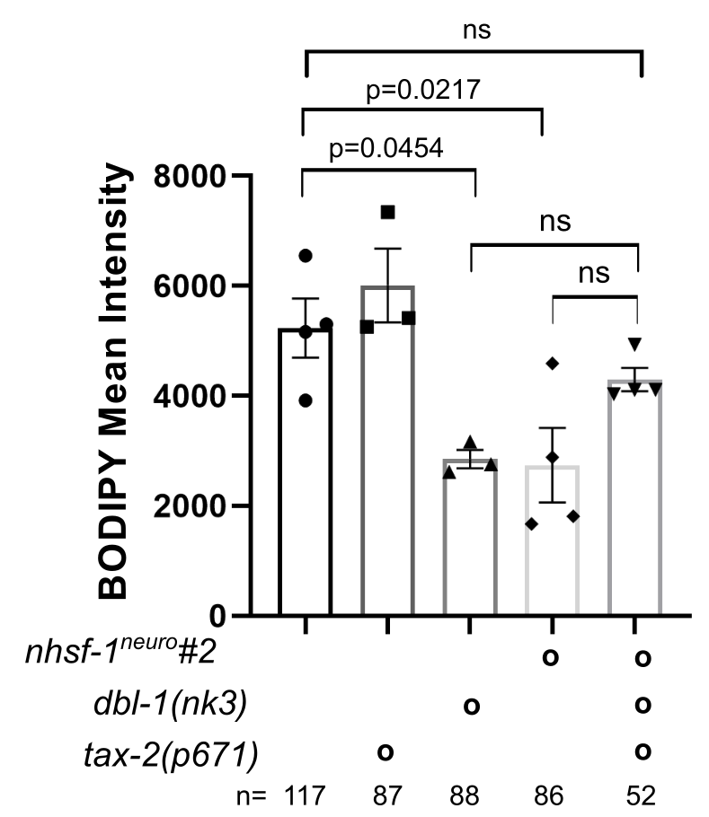
Fig S6C. Epistasis analysis suggest that tax-2 plays roles beyond the modulation of TGF-beta signaling.
Lipid droplets (LD) were quantified using BODIPY staining in: wild type; tax-2(p671) (PR671), dbl-1(nk-3) (NU3); hsf-1^{neuro} #2 (AGD1289); and hsf-1^{neuro}#2; tax-2(p671); dbl-1(nk3) (MOC253). Data and statistic can be found in Table S5. Each dot corresponds to a biological replicate, the bar indicates the SEM and n correspond to total number of worms. If the suppression of the lean phenotype of hsf-1^{neuro} caused by mutations in tax-2/4 was solely dependent on the reversion of TGF-β/BMP signalling to wild type levels, then tax-2/4 mutations should be unable to rescue hsf-1^{neuro} lean phenotype in the total absence of dbl-1 function. We find, however, that a tax-2 mutation is still able to rescue LD accumulation of hsf-1^{neuro} animals that lack dbl-1 function. Because the triple mutant has lower LD accumulation than wild type animals, we suggest that TAX-2/4 neurons rely on other mechanisms in addition to TGF-β/BMP signalling to alter fat metabolism. This idea is consistent with the observation that dbl-1 causes a decrease in fat-7/6 but does not alter lipase levels (Table S8), indicating two independent branches of gene regulation.
All data can be found in Data_Figure_S6.
References
1. Fasseas MK, Grover M, Drury F, Essmann CL, Kaulich E, Schafer WR, et al. Chemosensory Neurons Modulate the Response to Oomycete Recognition in Caenorhabditis elegans. Cell Rep [Internet]. 2021;34(2):108604. Available from: https://doi.org/10.1016/j.celrep.2020.108604
2. Bertrand V, Hobert O. Linking Asymmetric Cell Division to the Terminal Differentiation Program of Postmitotic Neurons in C. elegans. Dev Cell. 2009;16(4):563–75.

