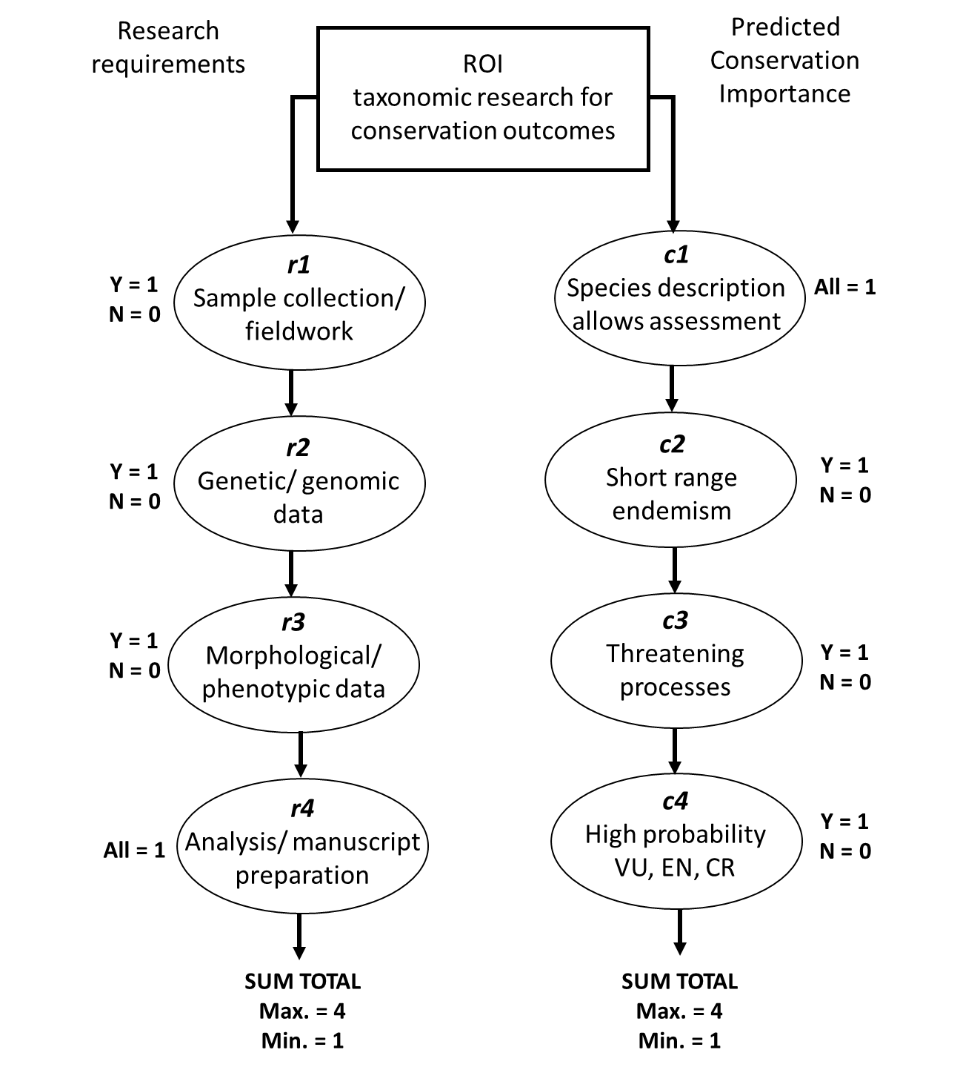

S1 Fig. Decision framework in the return on investment analysis (ROI). Categorical scores attributed to each factor are provided.

