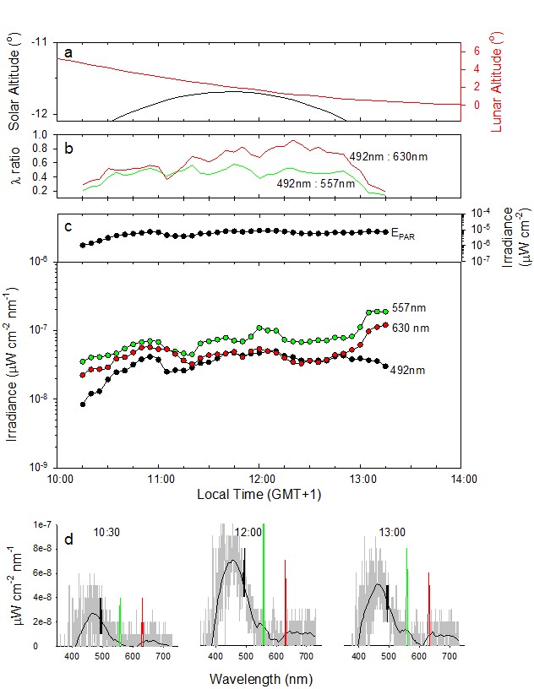

S1 Fig. Mid-day atmospheric light during Polar Night. Spectral irradiance time series measured north of Rijpfjorden, Svalbard (80º 37.79N 22º 4.14E) on January 15, 2017 over midday period. (a) Solar (black) and lunar (red) altitude during measurements. Lunar phase was a waning gibbous moon, full on January 12. (b) Ratio of 492 nm (solar/lunar light at sensitivity maximum of krill) [1] and both the 557 nm (green) and 630 nm (red) aurora lines [2]. (c) Time series of E_{PAR} (400-700 nm; upper panel) and 492 nm, 557 nm, and 630 nm light (lower panel). (d) Spectral irradiance at three time points during the time series shown in (c); with a running mean and 492 nm peaks (black lines), and aurora lines at 557 nm and 630 nm plotted green and red, respectively. For data, see S1 Data.

References
- Cohen JH, Berge J, Moline MA, Sørensen AJ, Last K, Falk-Petersen S, et al. Is Ambient Light during the High Arctic Polar Night Sufficient to Act as a Visual Cue for Zooplankton? PLoS One. 2015;10: e0126247.

- McLennan JC, Shrum GM. On the origin of the auroral green line 5577 Å, and other spectra associated with aurora borealis. Proc R Soc A. 1925;108: 501–512.

