Gene Expression levels .
Gene | Neuron | Astro | OPC | Oligo | Position of peak relative to TSS | Coordinates of amplified region cloned into pGL3-Promoter (UCSC rat 2004) | ChIP  signal in amplified region
Cntn2 | 503 | 35 | 117 | 3,395 | +4,757 bp  (intronic) | chr13:45,423,710-45,424,296 | 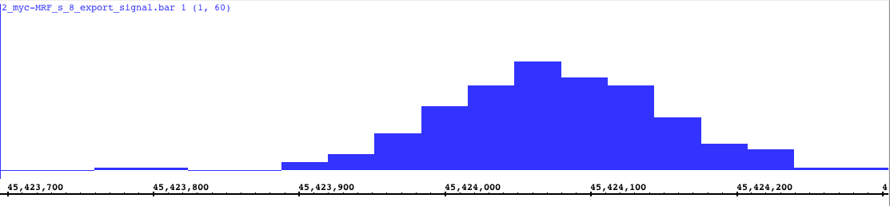
Cntn2  (-ve control region) | 503 | 35 | 117 | 3,395 | +5,605bp  (intronic) | chr13:45,422,625-45,423,448 | 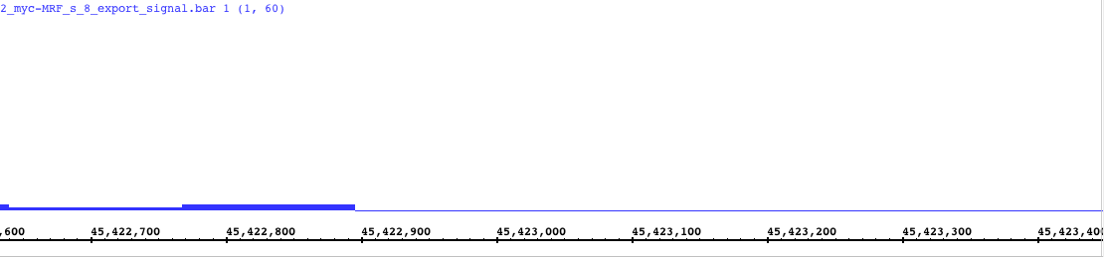
Tfn | 107 | 78 | 410 | 14,482 | -313 bp | chr8:108,244,534-108,245,244 | 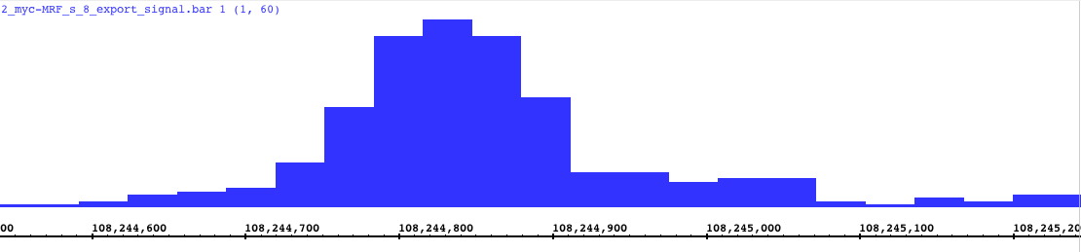
Mag | 47 | 46 | 23 | 11,866 | -16 bp | chr1:85,970,642-85,971,235 | 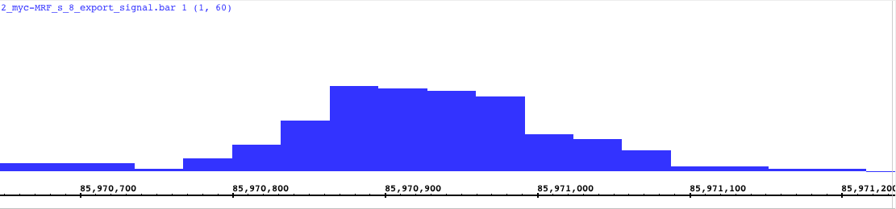
Mbp | 478 | 177 | 144 | 10,649 | -19,061 bp | chr18:79,006,011-79,006,944 | 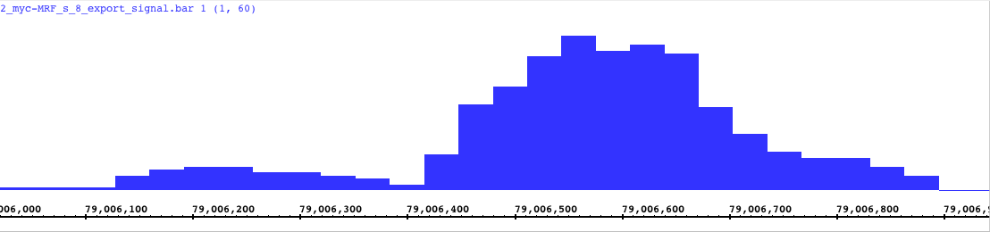
Plp1 (1) | 907 | 1,680 | 1,242 | 20,798 | -88,697 bp | chrX:124,399,436-124,400,121 | 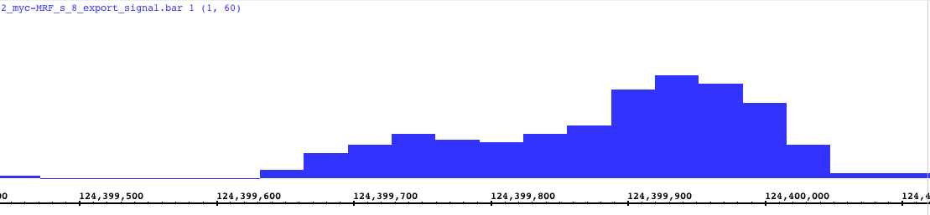
Plp1 (2) | 907 | 1,680 | 1,242 | 20,798 | -80,697 bp | chrX:124,407,459-124,408,306 | 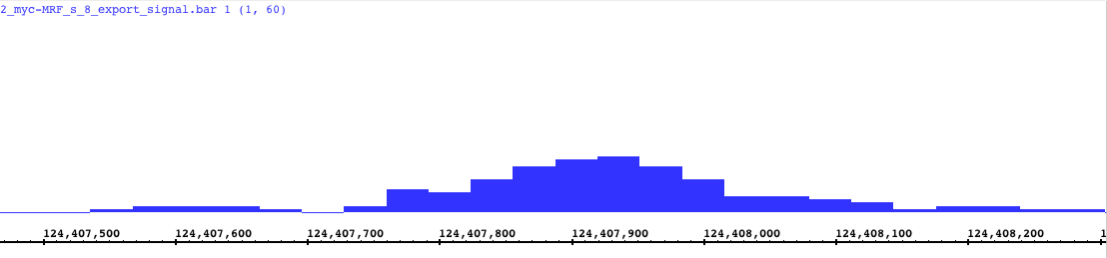
Rffl | 41 | 74 | 78 | 2,490 | +12,752 bp  (intronic) | chr10:71,034,165-71,034,749 | 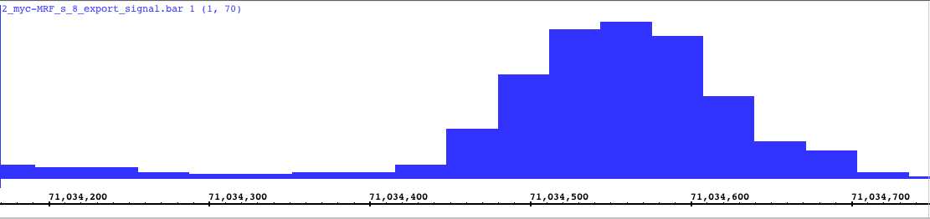
Nfasc (1) | 986 | 403 | 1,313 | 11,065 | +10,117 bp  (intronic) | chr13:45,627,390-45,628,388 | 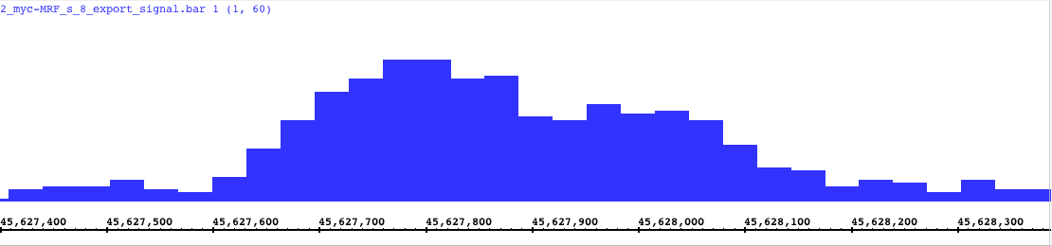
Nfasc (2) | 986 | 403 | 1,313 | 11,065 | +34,581 bp  (intronic) | chr13:45,602,970-45,603,778 | 