Supplemental Material

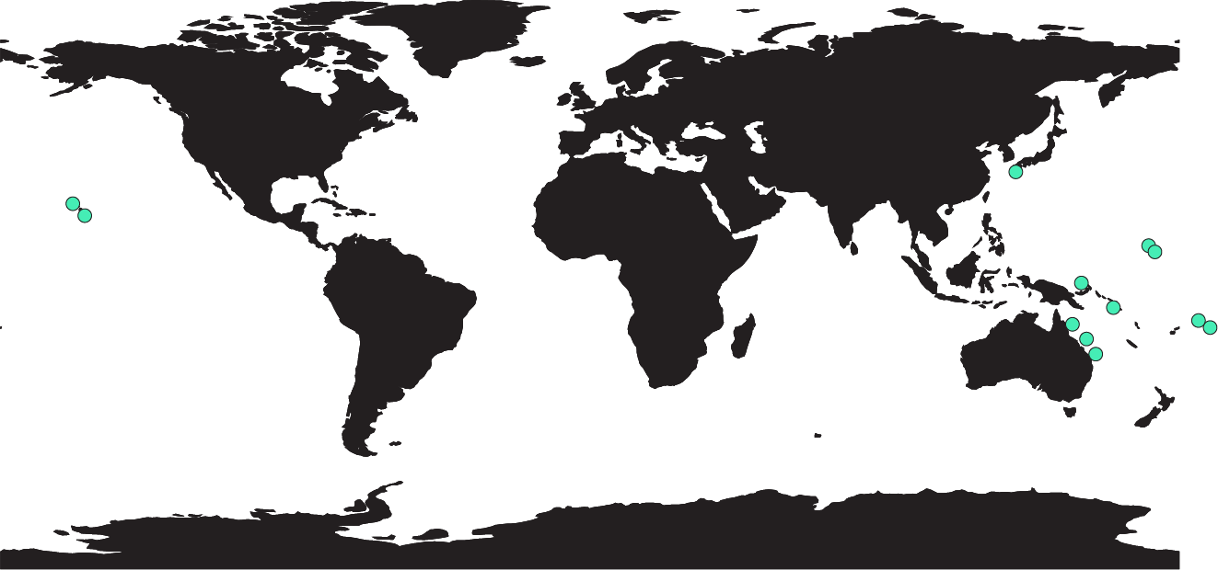
Supplemental Figure 1. Map showing the sites from which studies of our metanalysis conducted gut content analyses. Original map downloaded from Natural Earth (www.naturalearth.com/downloads).

Public domain: https://www.naturalearthdata.com/about/terms-of-use/

