S1 Table. Protein-protein interfaces and crystallization conditions of all IAV NTD^{M1} structures deposited to the protein data bank at rcsb.org
PDB | pH | C2-symmetry interface | Stacked interface | Lateral interface | No interface | Asymmetric unit
 |  | 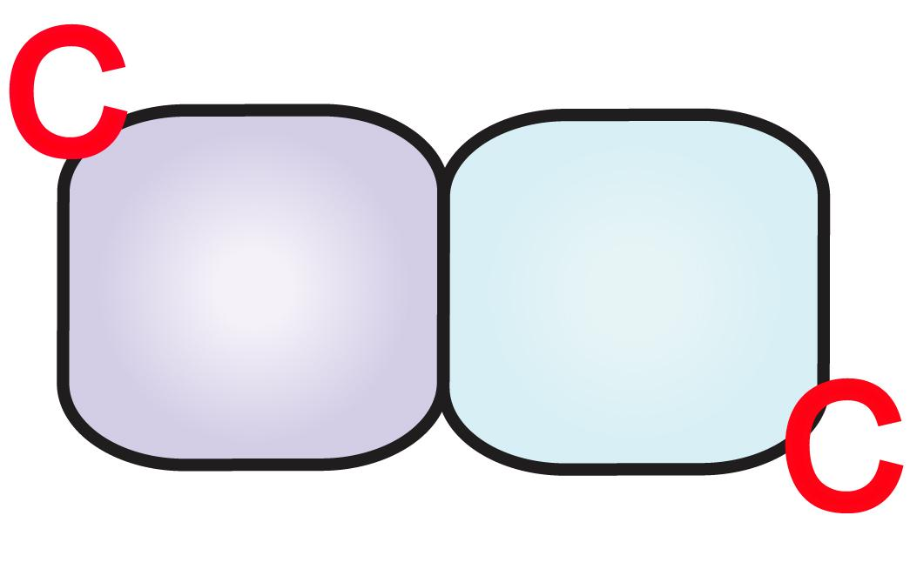 | 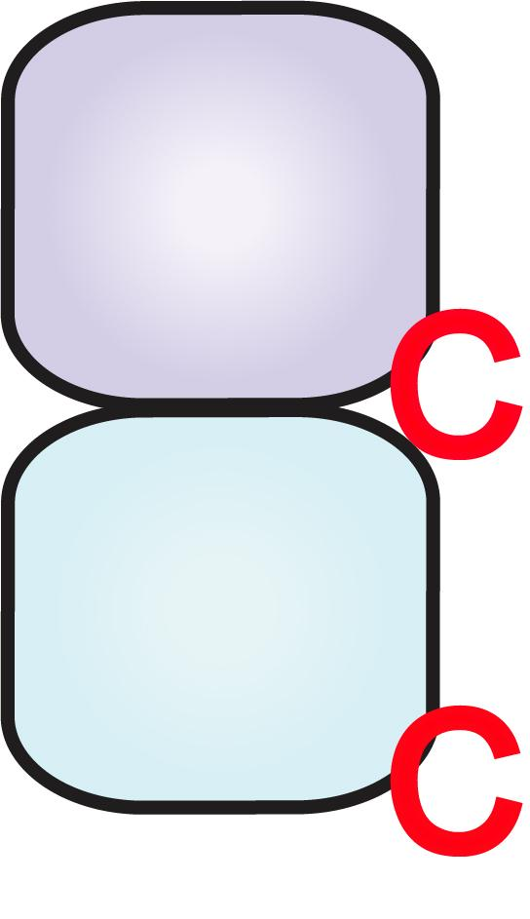 | 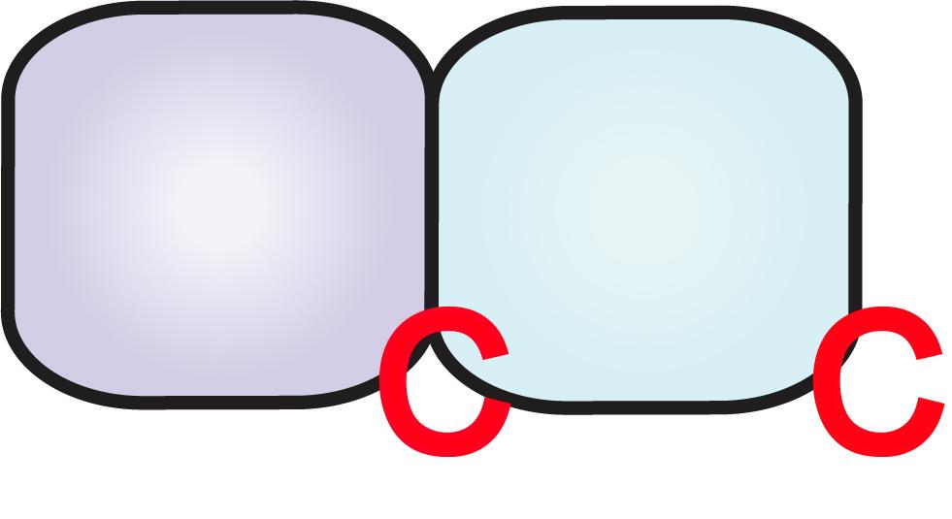
2Z16 | 8 |  |  |  |  | 2 monomers
6I3H (G18A) | 7.5 |  |  |  |  | 2 monomers
5V8A (G88R) | 7.3 |  |  |  |  | 1 monomer
1EA3 | 7 |  |  |  |  | Stacked dimer
3MD2 | 7 |  |  |  |  | C2-symmetry dimer
5V7B (G88E) | 7 |  |  |  |  | C2-symmetry dimer
5V7S (G88E) | 6.2 |  |  |  |  | Trimer with C2-symmetry and stacked interface
5V6G (G88R) | 5.5 |  |  |  |  | Trimer with C2-symmetry dimer Stacked dimer
5CQE | 5 |  |  |  |  | C2-symmetry dimer
4PUS | 4.7 |  |  |  |  | C2-symmetry dimer
1AA7 | 4 |  |  |  |  | C2-symmetry dimer

