Figure 1: Missing data patterns plot showing number of reported months by hospitals. The x – axis shows the number of months reported by health facilities. 0 means the hospitals did not report any month, while 39 means the hospitals reported all months.
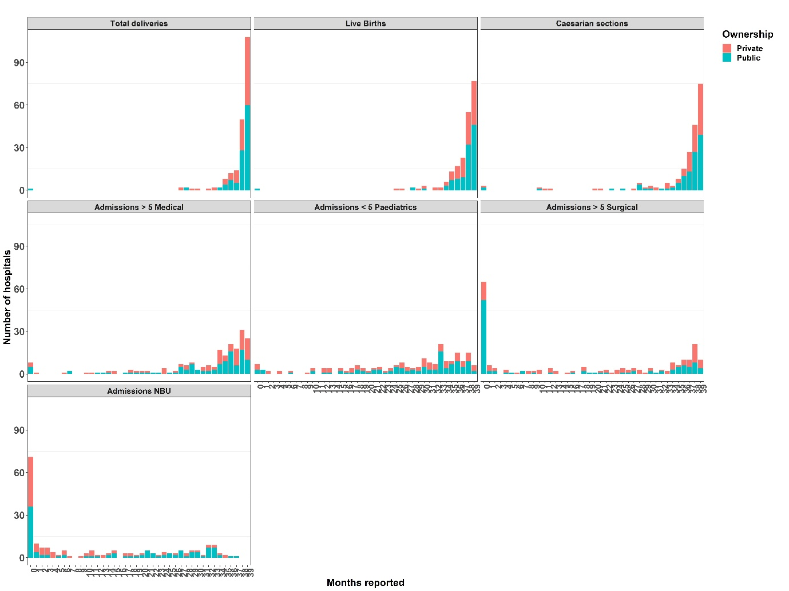

Figure 2: Multiple change points for public hospitals Red boxes show where services changed due to the national health care workers strike (December 2020)
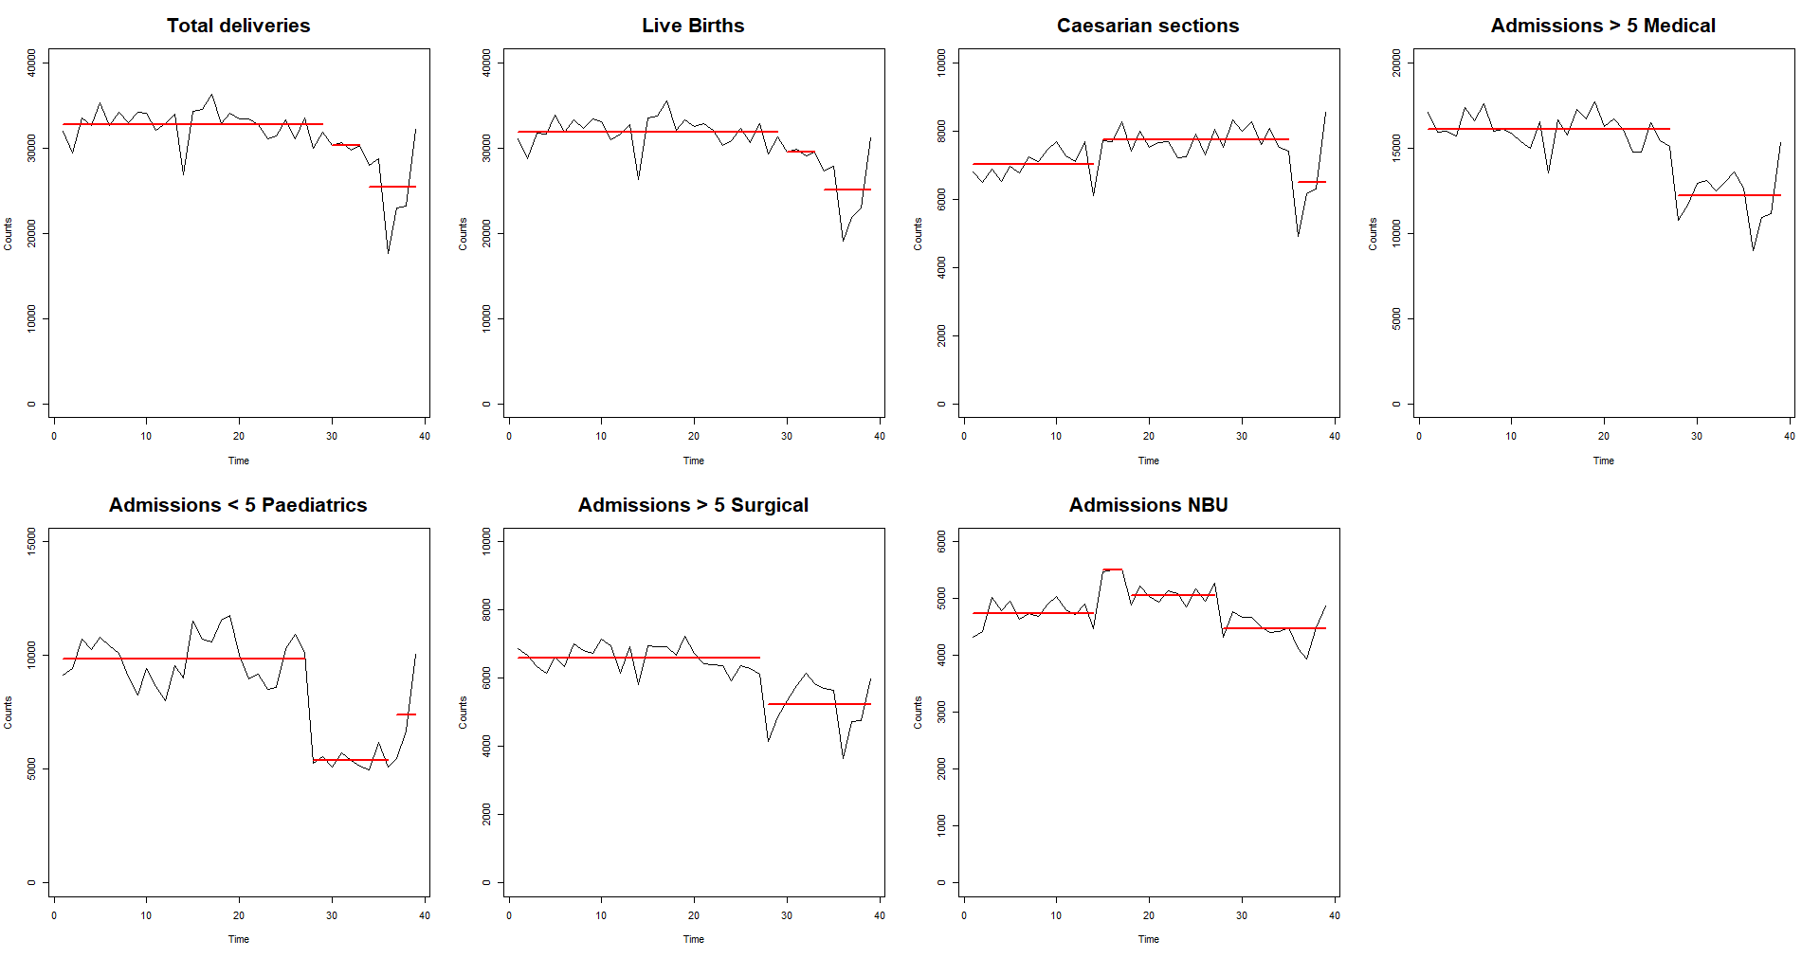
Nov20

Figure 3: Multiple change points for private hospitals. Red boxes show where services changed due to the national health care workers strike (December 2020)
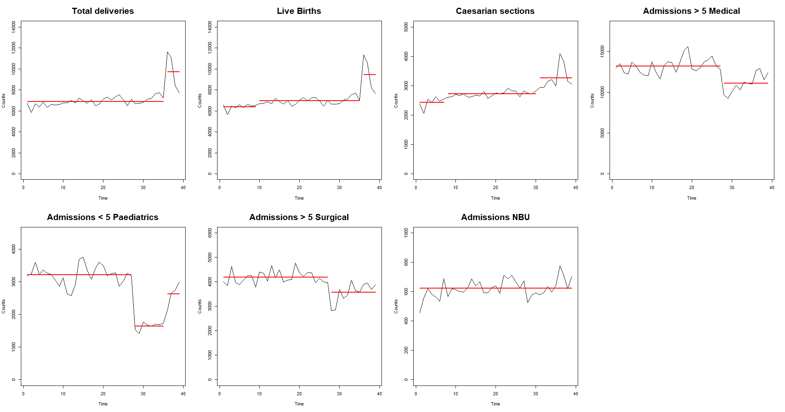
Nov20
Nov20

