**S24 Fig. Chord diagrams showing the distribution of nine most common admission diagnosis groups by phenotype in training cohort**

(i) All physiotypes

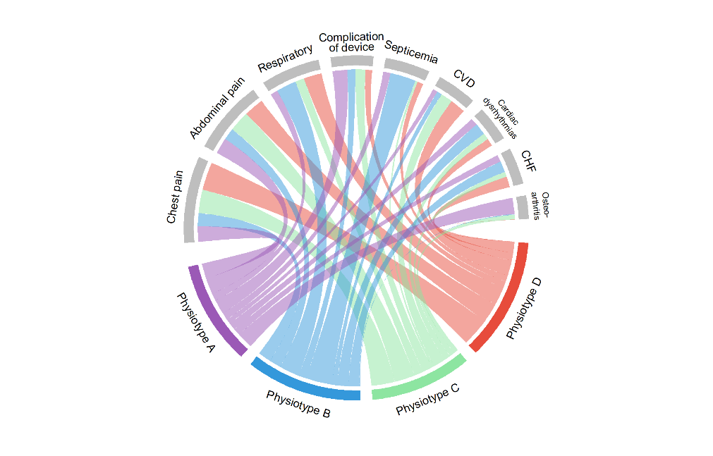

(iii) Physiotype B

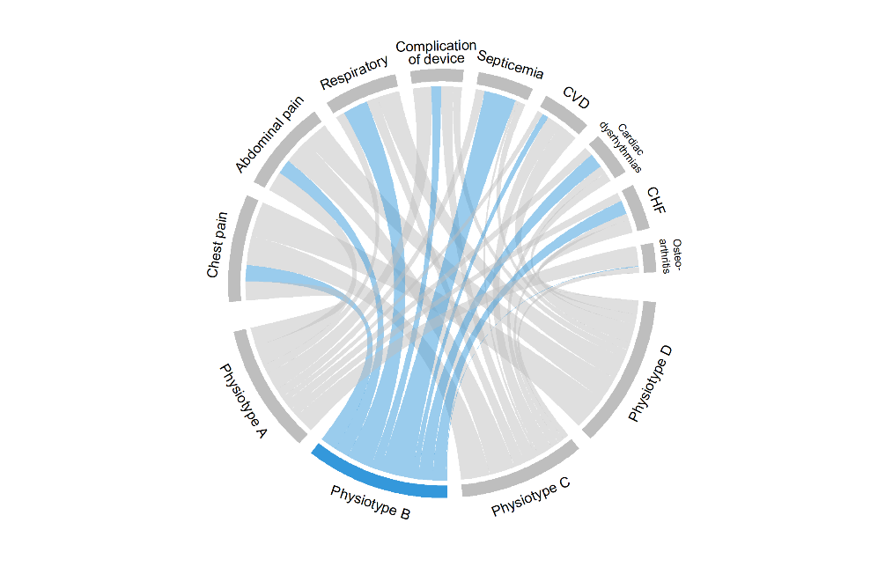

(ii) Physiotype A

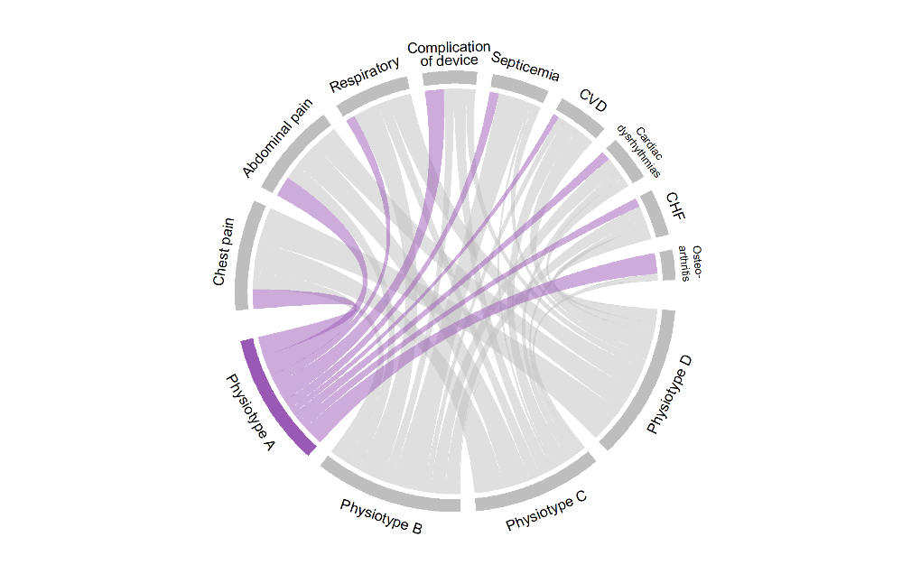

(v) Physiotype D

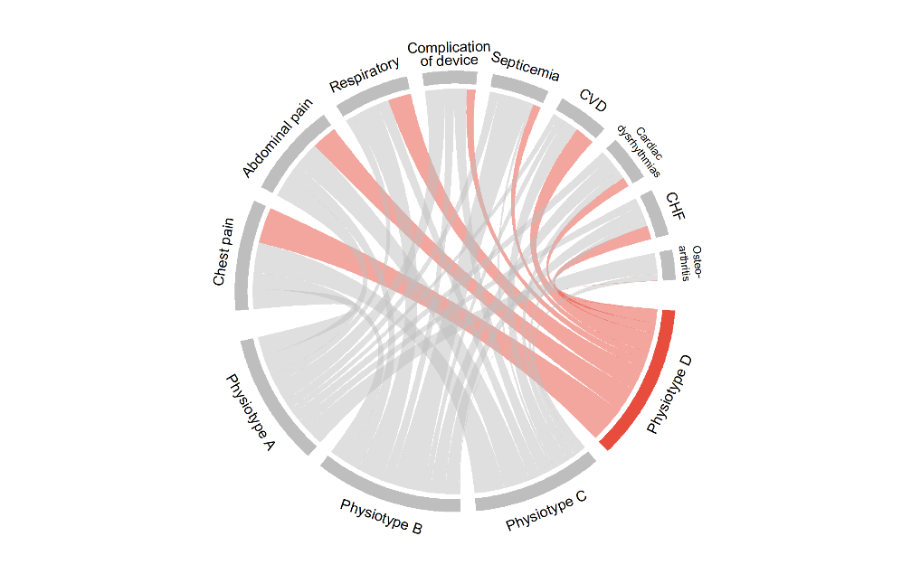

(iv) Physiotype C

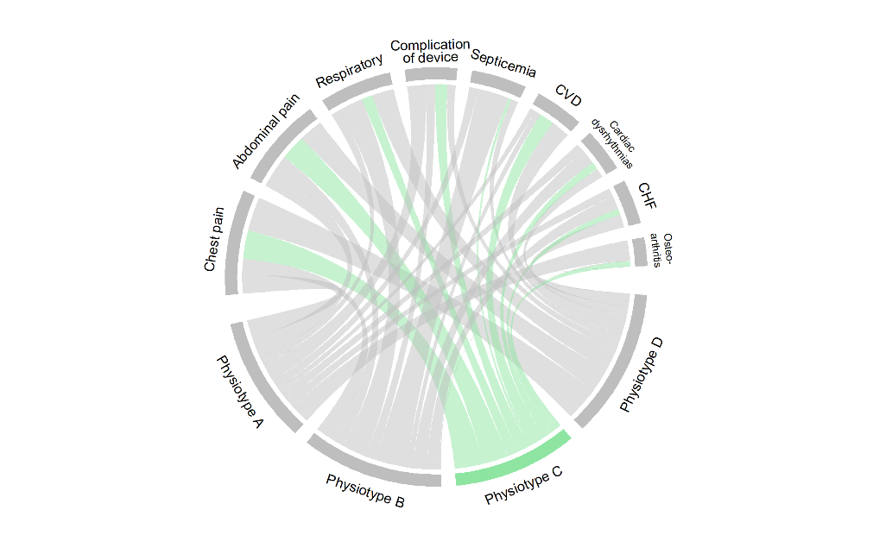

Diagnosis groups are shown in order of frequencies of all patients. For each phenotype, the larger percentage of patients with that diagnosis, the border the ribbon. Detailed diagnosis groups from left to right are: Nonspecific chest pain, Abdominal pain, Other and unspecific lower respiratory disease, Complication of device; implant or graft, Speticemia (except in labor), Acute cerebrovascular disease, Cardiac dysrhythmias, Congestive heart failure; nonhypertensive, and Osteoarthritis.