S10 Fig. Mean standardized differences between variables across phenotype pairs for training cohort (N = 41,502, dark line) and validation cohort (N = 17,415) using consensus clustering

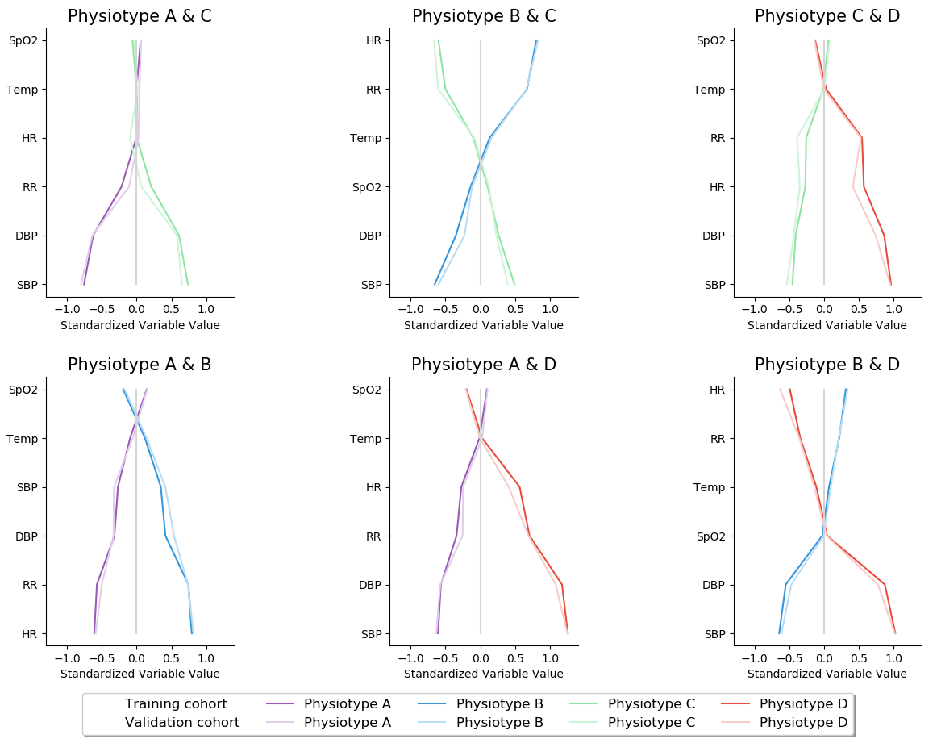
In all panels, the variables are standardized such that all means are scaled to 0 and SDs to 1. A value of 1 for the standardized variable (x-axis) signifies that the mean value for the phenotype was 1 SD higher than the mean value for both phenotypes shown in the graph as a whole.
Abbreviations in order: SpO2: peripheral capillary oxygen saturation; Temp: temperature; SBP: systolic blood pressure; DBP: diastolic blood pressure, RR: respiratory rate; HR: heart rate.

