S1 Text: LDA Results

Seed words used for guided/seeded LDA and model selection
Seed words were extracted from a list of the most frequent words in in the data and then arranged to represent eight broad themes, which these seed words should guide LDA to identify:
[action, strike, striking, global, protest, join, together, strikes, come, protesting, fighting, worldwide, marching, million, protests, joining, rally] – protest theme
[climate, crisis, emergency, fossil, fuel, fuels, warming, carbon, emissions, food, gas, pollution, survive, threat, survival, plastic, planet, earth, environment, environmental, nature] – climate crisis theme
[young, kids, youth, children, generation, voice, age, strikers, teens, generations, adults, old, future] – intergenerational tensions theme
[greta, thunberg, nobel, prize, nominated, girl] – Greta Thunberg theme
[demand, right, stop, act, listen, energy, demanding, green, science, justice, end, scientists, listening, clean, solutions, policy, truth, paris, ipcc, save, human, humanity, sustainable] – demands theme
[leaders, politicians, power, government, political, media, system, parliament, governments, state, inaction, politics, business] – inaction of those in power theme
[inspiring, support, thanks, inspired, love, solidarity, parents, history, supporting, awareness, public, impact] – solidarity theme
[christchurch, #newzealandshooting, #newzealand] – Christchurch event theme (coincided with the global strike event)
While we guided eight topics, we then run the LDA with different number of topics to find the best solutions, starting with eight topics that we expected to see based on the most frequent terms. So we tried an LDA with eights topics, of which all were be guided, an LDA with nine topics, where eight topics were guided and one would be another topic, we did not specify, an LDA with ten topics, with two unguided topics, an LDA with eleven topics with three unguided topics, an LDA with twelve topics with four unguided topics, etc. We have explored a guided LDA with a maximum of 20 topics. We chose the guided LDA with 10 topics based on interpretability and distinction of its topics. Because the guidedLDA Python package (https://github.com/vi3k6i5/GuidedLDA) does not provide the option to compute coherence scores to compare and evaluate various models, the evaluation was done qualitatively. We have also explored the data using a standard LDA approach, computing coherence scores. Based on these results a LDA with 16 topics (Coherence Score: 0.4424, vs. 0.4186 for a standard LDA with 10 topics vs. 0.3348 for a standard LDA with 9 topics) is recommended. However, when exploring a guided LDA with 16 topics, many resulting topics appeared to be not clearly distinguishable. However, it should be noted that the seeding of the topic modelling modifies the machine learning process and hence a guidedLDA model of 10 topics or 16 topics is not equivalent to a standard LDA model with 10 or 16 topics.

Extracted topics for the Fridays for Future data
Figure A2 shows a map of the tweets assigned to one of the 10 topics extracted via a seeded LDA. We can interpret the topics when looking at top words in each of the topics. Topic 0 seems to be a general topic around the global climate strike event, that includes positive comments (“hope”) as well as negative tweets (‘brainwashed”) and tweets that express scepticism about children skipping school. Topic 1, one of the largest topic clusters evolved around tweets that express support for the Fridays for Future movement, including tweets from parents supporting their striking children or tweets from (climate) scientists and politicians or political parties showing their solidarity with the protest. Topic 2 is focussing on Greta Thunberg, who inspired the Fridays for Future movement, including tweets discussing her being nominated for the Nobel Price for Peace. Topic 3 is a topic cluster around the UK politics, including references to Brexit, a call for political climate action and calling out specific politicians and demanding them to take a stand. Topic 4 is a topic cluster that discusses the protest events on the 15th of March itself, highlighting the historical significance of the large protest, organised by children and discussing its global dimension. Topic 5 and 6 resolve both around highlighting the climate crisis that brought about the movement and formulating the demands of the protest movement, which include a call for a Green New Deal, stopping coal mining and closing coal plants, transitioning to renewable energies, etc. The demands also highlight climate justice and call for inclusive climate politics. Topic 5 includes stronger references to grievances that the striking youth hold (e.g. destruction of the planet by adults, intergenerational theft). Topic 7 discusses the catastrophic consequences of climate change and continuing political inaction, this includes floods, droughts, famines, mass displacement and wars. Topic 8 is a relatively small topic cluster and the least relevant here, it contains tweets that discuss other issues (and specifically the New Zealand right-wing terror attack on a mosque in Christchurch) of the day with some lose connection to the Fridays for Future protests. Topic 9 finally discusses the Fridays for Future protest in various specific countries, such as Australia, France, Canada etc. with country-specific political references.

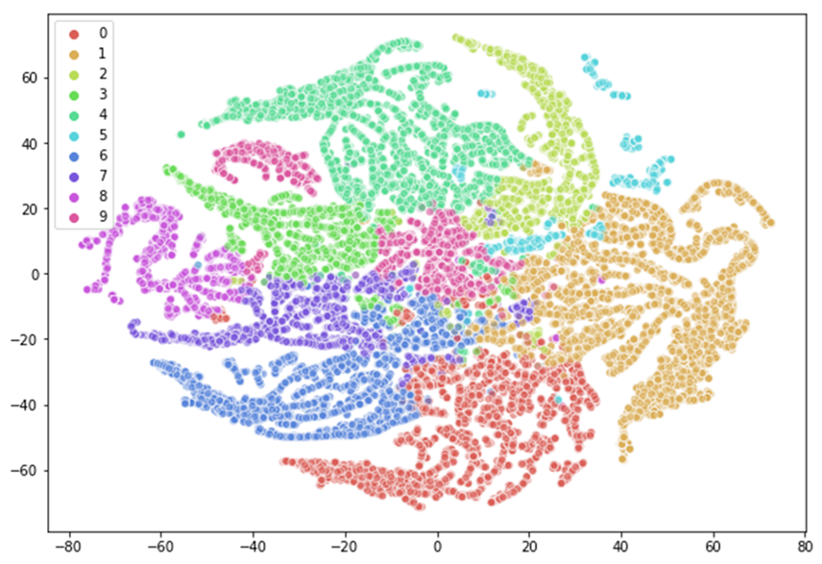
Fig A: Topic map of the Fridays for Future Twitter discourse in March 2019: each point represents a tweet, the colour signifies the topic to which the tweet has the highest probability of belonging, the topic cluster visualisation is based on t-SNE (t-distributed stochastic neighbour embedding)

Keywords within the extracted topics:
Topic 0: kids climate school change people children know time think planet years want young day students future climatechange earth today stop good take really way right back adults parents real protest old look global education nothing better left science never youth work could instead little care year using power vote generation warming believe political money teachers age politicians government aoc enough tell actually strike media used green carbon please learn realdonaldtrump environment class protesting hope child end living stupid system plastic pollution brainwashed clean listen truth must told walk white trump voting read schools destroy
Topic 1: climate world today students people young action change future strike school youth climatechange kids planet global help protest climateaction across countries children us proud march demand support take streets movement striking demanding going day join many stand standing government time tomorrow worldwide news strikes thank friday voices solidarity better protests million fight city fridayforfuture hope need marching leaders great student globe climateemergency want inspiring adults climateactionnow protesting fighting inspired heard inaction generation amazing joining save together act growing joined environment actonclimate listen schools politicians call saving governments vegan participating activists power old fridaysforfurture protect history climatejustice environmental crisis message justice worldnews incredible biggest generations class voice
Topic 2: climate greta today climatechange change thunberg year peace nobel global strike prize march students nominated world movement action school climateaction day future youth activist countries inspired join protest people 2019 swedish friday fridayforfuture lanet ever biggest great strikes nobelpeaceprize support london extinctionrebellion kids thanks thank week globalwarming student stop girl act nworldwide young hope please earth save news extinctionr talk important environment globalstrikeforfuture work schoolstrike 15th come life nobelprize children greennewdeal striking million story climateactionnow girls teen environmental uk choice fight parliament continents youth4climate event love climatejustice thinking sweden protests media best nominee demonstration parentsforfuture good amazing justice activism europe
Topic 3: people kids today climate climatechange school young jeremycorbyn michaelgove theresa_may sadiqkhan need future children change right march protest carolinelucas god extinctionr planet great good london party strike bbcnews media stop parliament news police politicians done heard really hope going love brexit system uk better please bbc nicolasturgeon square youth world support political extinctionrebellion students back listen trying free voices ukscn damianhinds vincecable auspol ukscn1 may coverage fmwales adamprice maryloumcdonald dupleader labour government claireperrymp ukycc look friday save climateaction 2019 understand education adults believe action power little green important vote manchester thank work tories corbyn protesting wrong proud georgemonbiot liverpool best parents
Topic 4: today people young climate change hope future proud see action need world support us kids climatechange amazing students youth climateaction thank great take generation want stand planet inspiring children taking act emergency listen solidarity inspired adults message day thanks school voices strike march join movement leaders standing urgency heard marching better politicians important across turnout climateactionnow striking treets love kidlit4climate fridaysforfurture fighting voice global supporting feel incredible fridayforfuture fantastic power vancouver energy london climateemergency art spreading actions morning awareness hear know look teens city made fight demanding words speaking theatre passion strikers passionate friends dublin generations wonderful greenpeace seriously campaign huge leadership climatestrikeuk parliament youth4climate inspiration awesome
Topic 5: climate change young people demand leaders seriously climateaction climatechange greennewdeal actonclimate world auspol climatejustice stopadani extinctionrebellion climateemergency malaysia climatestrikeindia gogreen4globalgoals justice leavenoonebehind schoolstrike ireland4sdgs thegreen17 earth sunrisemvmt fridayforfutures climatechangeisreal plea inclusive fossil future 2030 notreesnowater gas children adopted renewables waste leavenochildbehind globalgeening scientists nonewcoal business youth climate2020 donate phones political rising listen want emmanuelmacron timeforaction financing renewableenergy disrupt countries bank block america nonewfossilfuels fuels support leadonclimate raise science share funds university noplanetb social classroom globalgreening speaking mother extinctionr soon stealing destroy fuel whateverittakes protect murdering congress
Topic 6: climate change climatechange action climateaction global need world energy fossil emissions us people carbon future today planet youth students greennewdeal stop support green co2 must oil act fuel coal take children gas make government young real crisis strike science warming fuels generation years extinctionrebellion environment actonclimate power renewable solutions kids industry climateactionnow solar end zero political money issue pollution clean countries effects environmental governments policy system economy ipcc renewables leaders justintrudeau work earth sustainable water responsible emergency movement current air climatecrisis reduce health transition fight already state national greenhouse demand globalwarming problem cop25 together worldwide policies politicians scientists strikes impact biggest big climatechangeisreal adults response rise history urgent paris growing climateemergency electricity save natural
Topic 7: climate change climatechange right future children planet human world earth people century survive events survival generation scale collective save stop kids 21st alarm unprecedented environment trigger pragmatic latitude life politicians generations climateaction ipcc please fridayforfuture better humanity extinctionr action food adults global nature water power fighting strike hope next every care together trying needs problem real money species capitalism extinction plastic fridaysforfurture rights history work long thank sustainable pollution yes older important eat environmental face green leaders first trees ldnrebellion destroying stand threat protect education end enough wars floods
Topic 8: christchurch zealand newzealandshooting muslim newzealand italy muslims daily newzealandterroristattack business music avengersendgame paris rednoseday2019 islamophobia piday japan islam attack news video worldsleepday trump iheartawards2019 allah expert angel terrorist startup barcelona christchurchmosqueattack hate united youtube networking wholesale nzmosqueshooting real city manchester global white fight mosque myanmar terror fixed terrorism uefa guardians bans visit realdonaldtrump court finds climatechange raped rape victim outrage brexit may ugly maga matchday2019 london media power christian convert shooter mosqueshooting order fridayfeeiing instagramdown newzealandmosqueattack channel guardiansofthegalaxy3 gold chester wordpress creative amazon peoplesvote weekend
Topic 9: today climate kids climatechange students school march strike youth climateaction future world great join children friday good change need hope please protest planet london paris global love extinctionrebellion coverage earth media thanks million show climateactionnow find fridayforfuture talk schools scientists call environment stories young important old france right friends movement share sydney story years proud local montreal australia work science amazing marching save happy adults education town help strikes berlin class supporting canada morning think green power sign together country life dublin extinctionr climateemergency done political ireland 2019 park us india Mumbai

