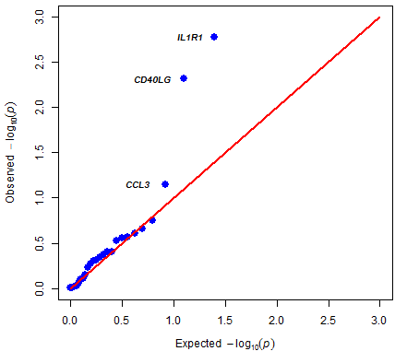
S8 Fig: QQ-plot for significance of differences in cytokine distribution between CD101 Ig-like risk variant carriers and non-carriers.

