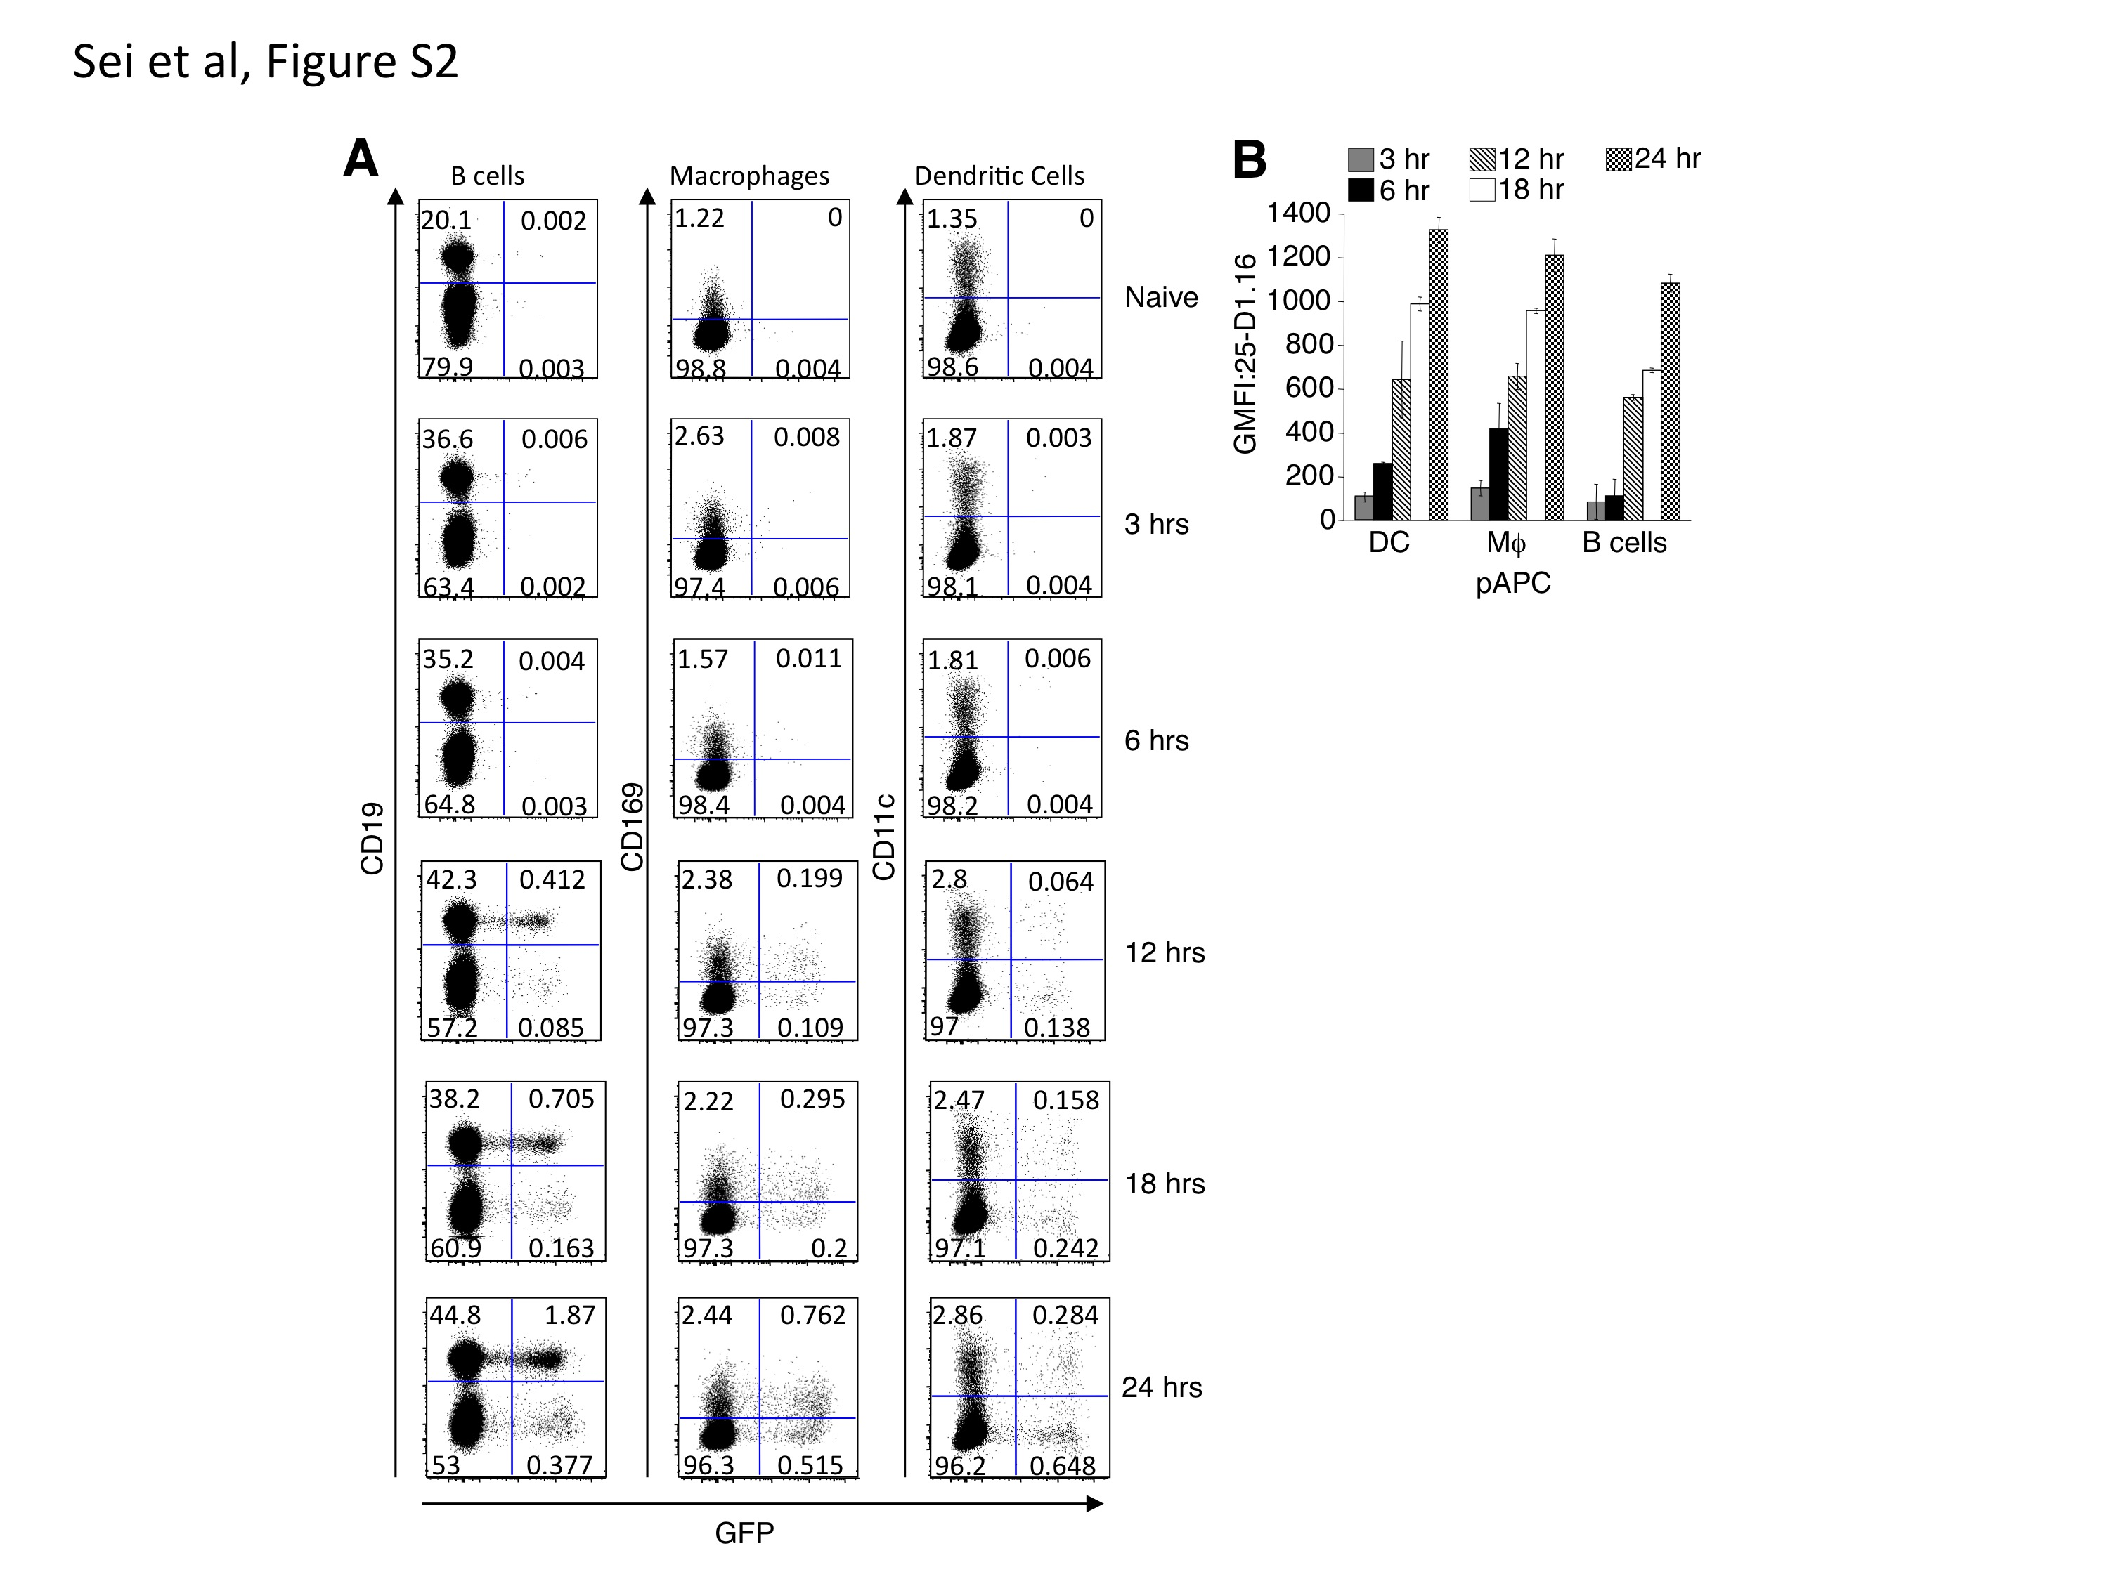

Supplementary Figure 2.
(A) Kinetic analysis to determine when pAPC become infected by ECTV. Mice were injected with NP-EGFP i.d. and cervical LN harvested at various time points post infection. EGFP⁺ pAPC were assessed following staining with antibodies to identify pAPC as outlined in Fig. S1B. (B) K^{b}-SIINFEKL complexes on the surface of each population of pAPC. Mice were injected with NP-S-EGFP i.d. and D-LN harvested at various time points post infection. pAPC were identified as described above, and GMFI of 25-D1.16 was performed to quantify levels of K^{b}-SIINFEKL complexes on EGFP⁺ pAPC.

