Table S1: Cluster width distribution of KSHV miRNA seed match-containing clusters
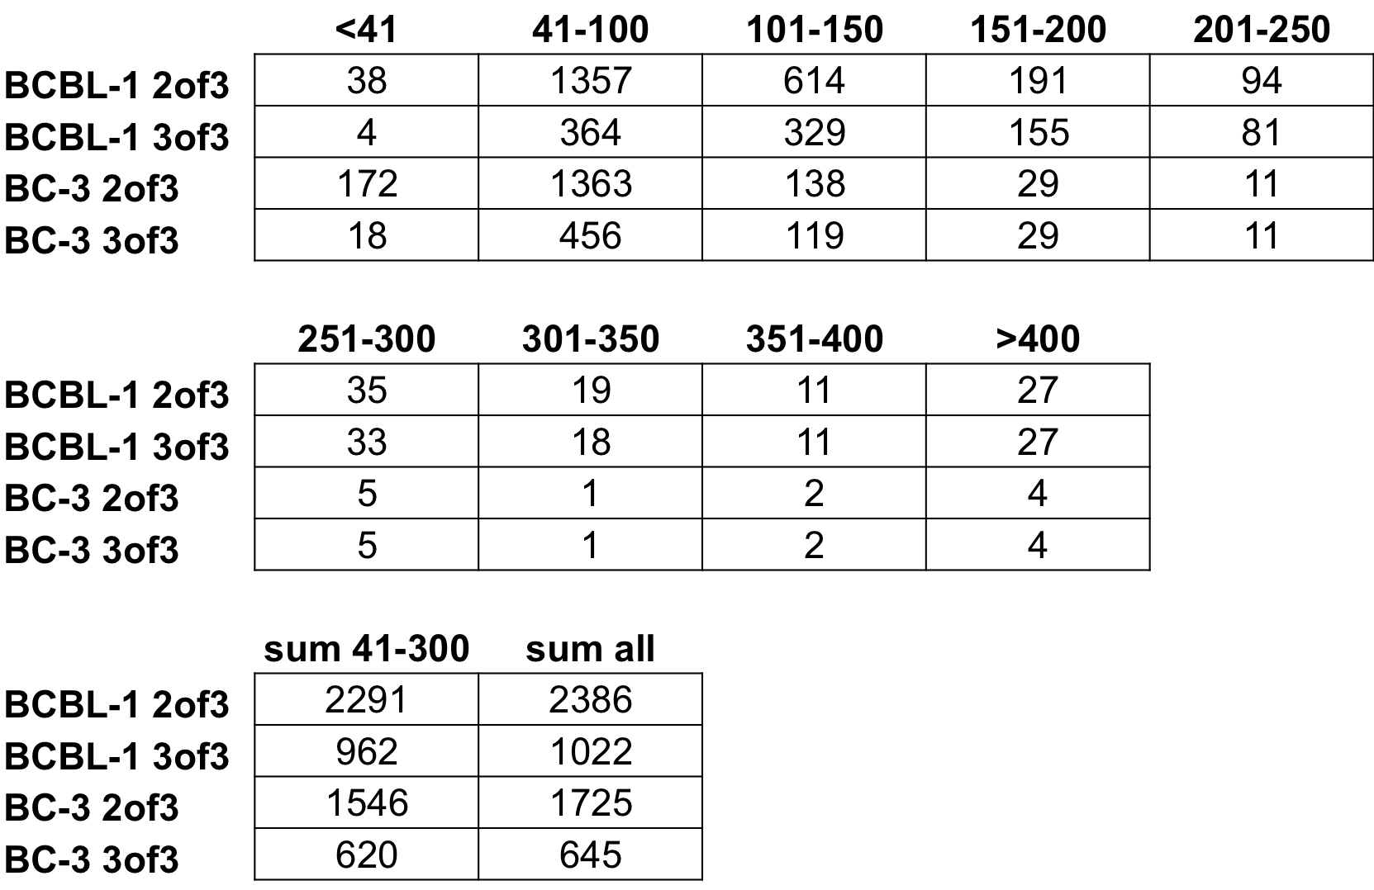
Based on all super clusters that align to annotated human transcripts, with coverage of at least 2 copies/cluster per 10e6 reads, and contain a KSHV miRNA seed match, at a stringency of 2of3 or 3of3. All 25 KSHV miRNAs (23 in BC-3) were included in this analysis. Clusters listed multiple times due to different miRNA seed matches in the cluster sequence were counted only once. Columns show the number of clusters of a certain width (in bp). For a graphical display see Figure 3A.

