SUPPLEMENTARY TABLES

TABLE S1. Bacterial pathogens used to screen for potential lethal effects in axenic zebrafish larvae.

Name | Origin | Reference
Aeromonas hydrophila sp. anaerogenes CIP 76.15 | Used oil-emulsions | CRBIP
Aeromonas hydrophila sp. dhakensis CIP 107500 | Human feces, Bangladesh | CRBIP
Aeromonas hydrophila sp. hydrophila CIP 52.94 | Frog | CRBIP
Aeromonas hydrophila sp. hydrophila CIP 76.14 | Tin of milk with a fishy odor | CRBIP
Aeromonas hydrophila sp. hydrophila CIP 103561 | Unknown | CRBIP
Aeromonas hydrophila sp. hydrophila CIP 103697 | Unknown | CRBIP
Aeromonas hydrophila sp. hydrophila CIP107274 | Human feces | CRBIP
Aeromonas hydrophila sp. hydrophila CIP 200522 | Fish isolate | CRBIP
Aeromonas hydrophila sp. ranae CIP 107985 | Frog, Thailand | CRBIP
Aeromonas salmonicida sp. achromogenes CIP 104001 | Trout, Salmo trutta, UK | CRBIP
Aeromonas salmonicida sp. masoucida CIP 103210 | Fish blood, Oncorhynchus masou | CRBIP
Aeromonas salmonicida sp. pectinolytica CIP 107036 | River water, Argentina | CRBIP
Aeromonas salmonicida sp. salmonicida CIP 63.4 | Fish, trout | CRBIP
Aeromonas salmonicida sp. salmonicida CIP 107106 | Diseased fish, Denmark | CRBIP
Aeromonas veronii CIP 109836 | Fish | CRBIP
Edwardsiella ictaluri CIP 81.96 | Catfish enteric septicemia, USA | CRBIP
Edwardsiella tarda CIP 78.61 | Human, feces, USA | CRBIP
Listonella anguillara CIP 63.36 | Ulcerated cod, Gadus morhua, Norway | CRBIP
Listonella anguillara CIP 64.14 | Ulcerous lesion in plaice, Pleuronectes platessa, UK | CRBIP
Listonella anguillara CIP 73.4 | Diseased rainbow trout | CRBIP
Photobacterium damselae sp. piscicida CIP 103910 | White perch, USA | CRBIP
Vibrio parahaemolyticus CIP 71.1 | Sea fish isolate | CRBIP
Vibrio parahaemolyticus CIP 71.2 | Sea fish isolate | CRBIP
Vibrio ichthyoenteri CIP 104815 | Japanese flounder fish isolate | CRBIP
Yersinia ruckeri CIP 82.80 | Rainbow trout, red mouth disease, USA | CRBIP
CRBIP: Institut Pasteur, Centre de Resources Biologiques de l’Institut Pasteur.
TABLE S2. Commensal and probiotic bacteria used to screen for potential protective effect in axenic zebrafish larvae.
Name | Origin | Reference
Aeromonas veronii CIP 109836 | Fish | CRBIP
Bacillus cereus CIPA28 | Lactic ferment | CRBIP
E. coli BW25113 | Laboratory strain | [1]
E. coli ED1a | Human feces from healthy man (France), Probiotic | [2]
E. coli ED1a-sm | Spontaneous streptomycin-resistant mutant of ED1a | This study
E. coli ED1a-sm F’tet | Laboratory strain | This study
E. coli K-12 MG1655 | Laboratory strain | [3]
E. coli K-12 MG1655 attB::gfp-bla (F’tet ∆traD::apra ∆tetR::zeo tetA::TnluxCDABE-Km) | Laboratory strain | This study
E. coli 10.22 | Commensal strain from hospitalized adult faeces | [4]
E. coli 10.94 | Commensal strain isolated from healthy adult faeces | [4]
E. coli 11.25 | Commensal strain isolated from a healthy adult | [4]
E. coli Nissle 1917 - DSM6601 | Human feces, Commensal strain used as probiotic | [5]
E. coli 083 | Commensal strain used as probiotic | Lab collection
Enterobacter cloacae 10.91 | Commensal strain isolated from a healthy adult | C. Le Bougennec
Lactobacillus casei CIP103137 T-ATCC393 | Cheese | CRBIP
Lactobacillus casei sp. rhamnosus | Human isolate used as probiotic | Lab collection
Lactobacillus delbruecki sp bulgaricus CIP 101027 | Bulgarian yogurt | CRBIP
Lactobacillus paracasei sp. paracasei CIP103918 T-ATCC25302 | Unknown | CRBIP
Lactobacillus paracasei CIP 109805 | Human feces, The Netherlands | CRBIP
Lactobacillus plantarum WCFS1 | Human saliva, Probiotic | [6]
Lactobacillus rhamnosus A157T-ATCC7449 | Unknown | CRBIP
Lactobacillus rhamnosus GG – ATCC53103 | Probiotic human isolate | [7]
Pediococcus acidilactici CIP 103408 | Neotype strain | CRBIP
Phaeobacter inhibens CIP 109852 | Fish, Scophthalmus maximus, Spain | CRBIP
Pseudomonas fluorescens CIP 109851 | Unknown | CRBIP
Vibrio parahaemolyticus CIP 109835 | Human feces | CRBIP
Escherichia coli H19 | EHEC UK Human isolate | [8]
Escherichia coli DAEC 7 | Human isolate (Brazil)- Diffusely adhering (DAEC) | [8]
Escherichia coli DAEC18 | Human isolate (Brazil)- Diffusely adhering (DAEC) | [8]
Escherichia coli iai 44 | Human isolate (France)- Urinary infection | [8]
Escherichia coli iai 73 | Human isolate (France)- septicemia | [8]
Escherichia coli G001 | Human isolate (French Guyana) | [8]
Escherichia coli Ec111 | Commensal, Roe-Deer, Capreolus capreolus, France | [8]
Escherichia coli Ec029 | Commensal Impala, Aepyceros melampus Gabon | [8]
Escherichia coli Ec248 | Commensal, Horse, Equus caballus, France | [8]
Escherichia coli Ec300 | Commensal, Dog, Canis familiaris, France | [8]
Escherichia coli Ec212 | Commensal, Horse, Equus caballus, France | [8]
CRBIP: Institut Pasteur, Centre de Resources Biologiques
References
1. Baba T, Ara T, Hasegawa M, Takai Y, Okumura Y, et al. (2006) Construction of Escherichia coli K-12 in-frame, single-gene knockout mutants: the Keio collection. Mol Syst Biol 2: 2006 0008.
2. Clermont O, Lescat M, O'Brien CL, Gordon DM, Tenaillon O, et al. (2008) Evidence for a human-specific Escherichia coli clone. Environ Microbiol 10: 1000-1006.
3. Guyer MS, Reed RR, Steitz JA, Low KB (1981) Identification of a sex-factor-affinity site in E. coli as gamma delta. Cold Spring Harb Symp Quant Biol 45 Pt 1: 135-140.
4. Hilali F, Ruimy R, Saulnier P, Barnabe C, Lebouguenec C, et al. (2000) Prevalence of virulence genes and clonality in Escherichia coli strains that cause bacteremia in cancer patients. Infection and immunity 68: 3983-3989.
5. Grozdanov L, Raasch C, Schulze J, Sonnenborn U, Gottschalk G, et al. (2004) Analysis of the genome structure of the nonpathogenic probiotic Escherichia coli strain Nissle 1917. Journal of Bacteriology 186: 5432-5441.
6. Kleerebezem M, Boekhorst J, van Kranenburg R, Molenaar D, Kuipers OP, et al. (2003) Complete genome sequence of Lactobacillus plantarum WCFS1. Proc Natl Acad Sci U S A 100: 1990-1995.
7. Kankainen M, Paulin L, Tynkkynen S, von Ossowski I, Reunanen J, et al. (2009) Comparative genomic analysis of Lactobacillus rhamnosus GG reveals pili containing a human- mucus binding protein. Proc Natl Acad Sci USA 106: 17193-17198.
8. Escobar-Páramo P, Le Menac'h A, Le Gall T, Amorin C, Gouriou S, et al. (2006) Identification of forces shaping the commensal Escherichia coli genetic structure by comparing animal and human isolates. Environmental Microbiology 8: 1975-1984.
TABLE S3. CFU quantification at 9 dpf of germ-free larvae pretreated with selected probiotics at 4 dpf. Means and standard deviations of the number of CFU recovered from larvae are reported (n=4).

 | Cfu/larvae
Germ free | 0 ± 0
E. coli K-12 MG1655 F’ | 2.2 x10³ ± 6.11x10²
E. coli ED1a | 1.93x10⁴ ± 1.04x10³
V. parahaemolyticus | 7.15x10³ ± 1.08 x10³
TABLE S4. qPCR quantification of colonization by E. ictaluri in germ-free and probiotic-preteated larvae . Shown are mean ± SEM from three pools of three larvae each; data have been normalized to one of the samples from high-dose E. ictaluri.

 | E. ictaluri gDNA / fish gDNA
E. ictaluri 2.10⁶ 3dpi |  | 0.22 ± 0.04
E. ictaluri 2.10⁷3dpi |  | 0.85 ± 0.31
E. ictaluri 2.10⁸ 3dpi |  | 1.10 ± 0.19
E. coli MG1655 + E. ictaluri 2.10⁸ 3dpi |  | 1.24 ± 0.49
E. coli MG1655F’ + E. ictaluri 2.10⁸ 3dpi |  | 1.62 ± 0.45

TABLE S5. Primers used in this study.

Procedure | Name | Sequence
Sterility-16S | B27 forward | 5’-AGAGTTTGATCCTGGCTCAG -3’
 | B1492 reverse | 5’-GGTTACCTTGTTACGACTT -3’
IL-1β antisense probe | IL-1β forward | 5’-ATGGCATGCGGGCAATATGA-3’
 | IL-1β reverse | 5’-GAATTCATTAACCCTCACTAAAGGGAGGCCAGGTACAGGTTACTTT-3’
RT-PCR | TNF-α forward | 5’-CAGAGTTGTATCCACCTGTTA -3’
 | TNF-α reverse | 5’-TTCACGCTCCATAAGACCCA -3’
 | IL-1β forward | 5’-GAGACAGACGGTGCTGTTTA -3’
 | IL-1β reverse | 5’-GTAAGACGGCACTGAATCCA -3’
 | IL-10 forward | 5’-AGAGCAGGAGAGTCGAATGC -3’
 | IL-10 reverse | 5’-GTACCTCTTGCATTTCACCA -3’
 | IL-22 forward | 5’-TTGGAATCAGACGAGCACAC-3’
 | IL-22 reverse | 5’-GGCCAAATCCATAATTGCAC-3’
genomic qPCR | Eictaluri-forward  forward | 5’-AGCGCCACCTTTGTGGATAA-3’
 | Eictaluri-reverse | 5’-TACGCTTTCCTCAGTGAGTG-3’
 | Csf1r-forward | 5’-TGGACTTCACAGGAACATACAAG-3’
 | Csf1r-reverse | 5’-TCGGAGAAACAAAGAGAACTCG-3’

SUPPLEMENTARY FIGURES
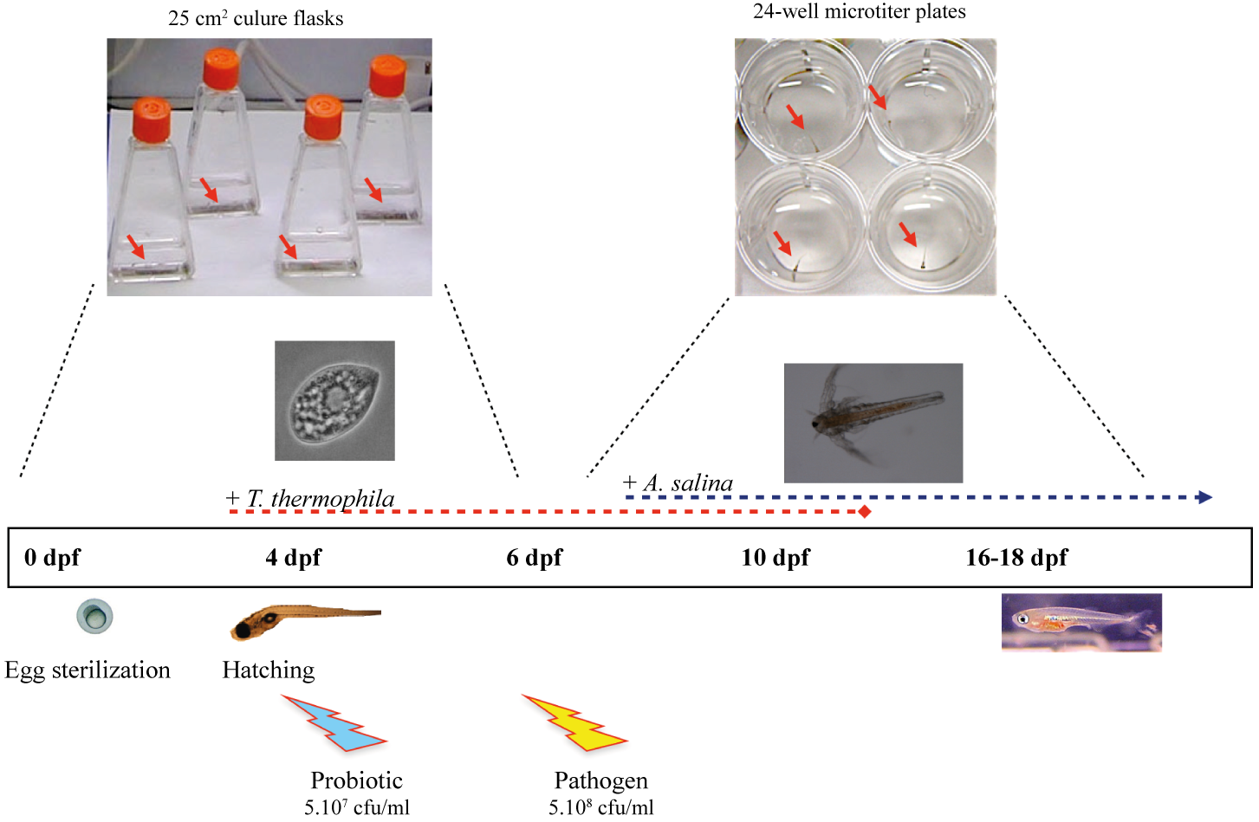

Figure S1, Rendueles et al

Figure S1. Protocol and timeline of axenic zebrafish infection and co-infection used in this study. After fertilization, eggs are sterilized and kept in sterile, autoclaved mineral water at 28°C in vented cap cell culture flasks until 6 dpf. Zebrafish larvae are then transferred one-by-one into 24-well microtiter plates containing 2 ml of water per well. Starting at 4 dpf, larvae are fed every 2 days with axenic T. thermophila till day 15. For longer experiments, in addition to Tetrahymena, larvae were also fed axenic A. salina from 10 dpf onwards. Pathogenic bacteria are added to the water at 6 dpf for 6 h and then larvae are transferred to fresh water. To test the protective effect of potentially probiotic strains, larvae were pre-colonized by commensal bacteria diluted in water at 4 dpf, after hatching.

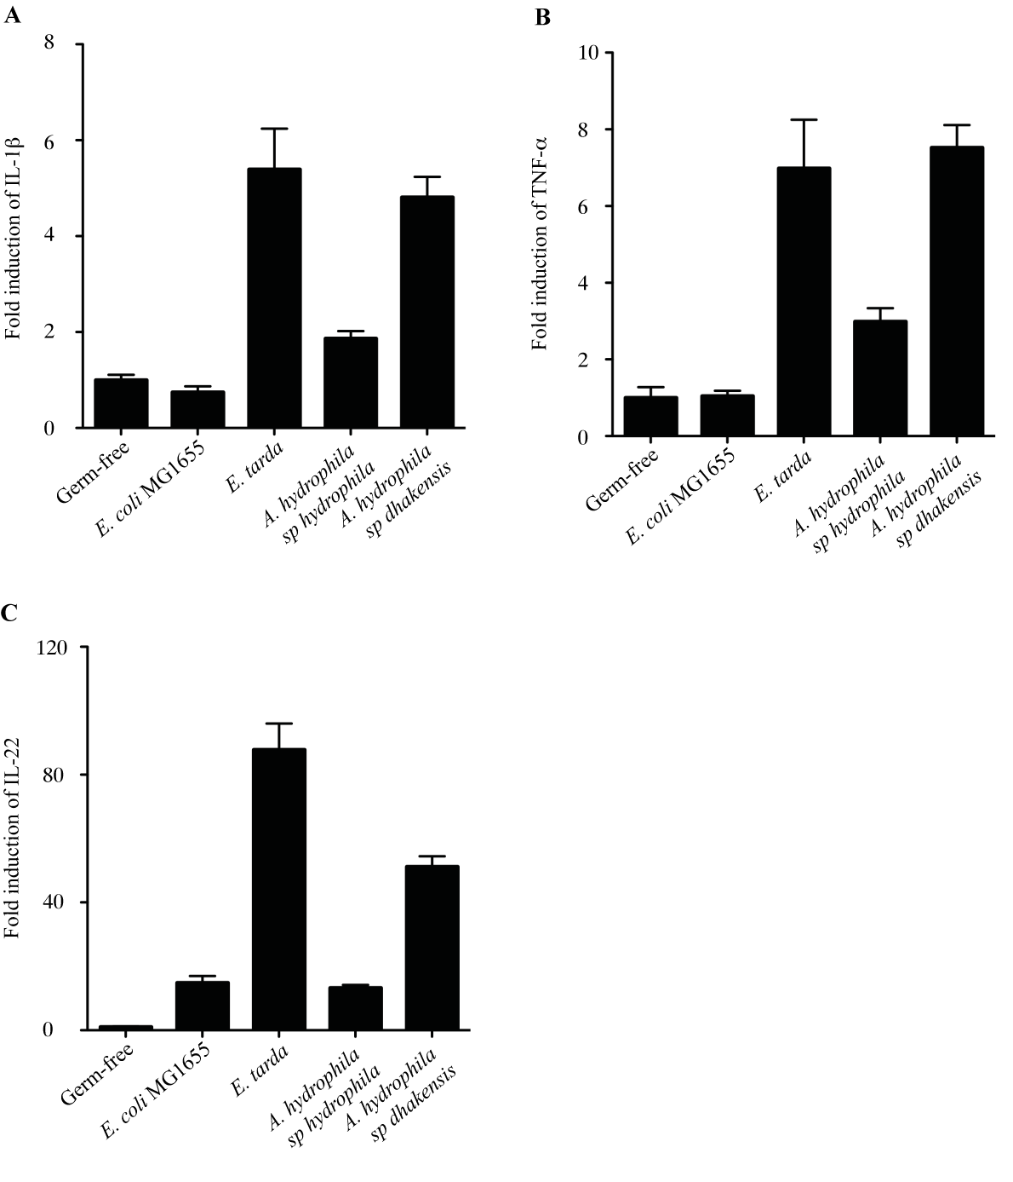

Figure S2, Rendueles et al

Figure S2. Inflammation marker expression of gnotobiotic zebrafish larvae upon infection by mild pathogens. qRT-PCR was performed using primers specific to il1b (A), tnfa (B), and il22 (C) (inflammation markers) on RNA extracted from pools of 5 larvae at 3 dpi from germ-free larvae or larvae exposed to E. coli MG1655 (control), E. tarda, A. hydrophila sp. hydrophila or A hydrophila sp. dhakensis at 4 dpf. Levels are expressed relative to the germ-free larvae. Error bars represent 95% confidence intervals from three technical replicates; one representative experiment out of two.
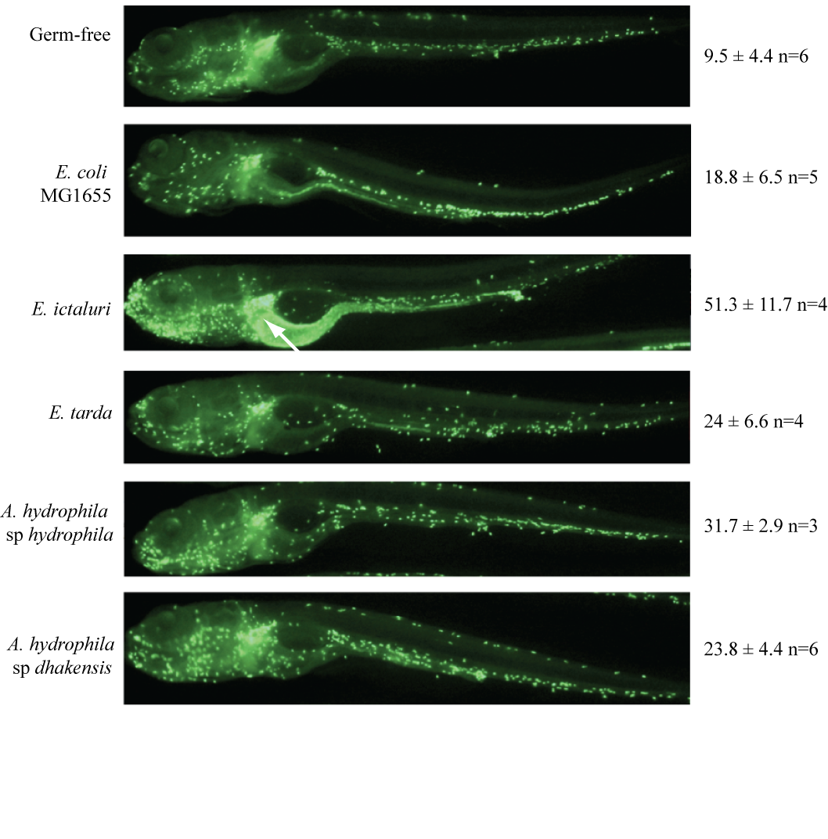
Figure S3, Rendueles et al

Figure S3. Neutrophil localization upon pathogen infection. Neutrophil infection in germ-free mpx::gfp larvae or mpx::gfp larvae infected with E. coli MG1655 (control) or different pathogens. At 4 days post-infection, larvae were fixed and analyzed by whole-mount immunofluorescence. Neutrophils were detected as GFP-expressing leukocytes (green). A quantification of gut-associated neutrophils in infected larvae is indicated on the right for each group of larvae. Note also GFP-expressing enterocytes as indicated by white arrow.

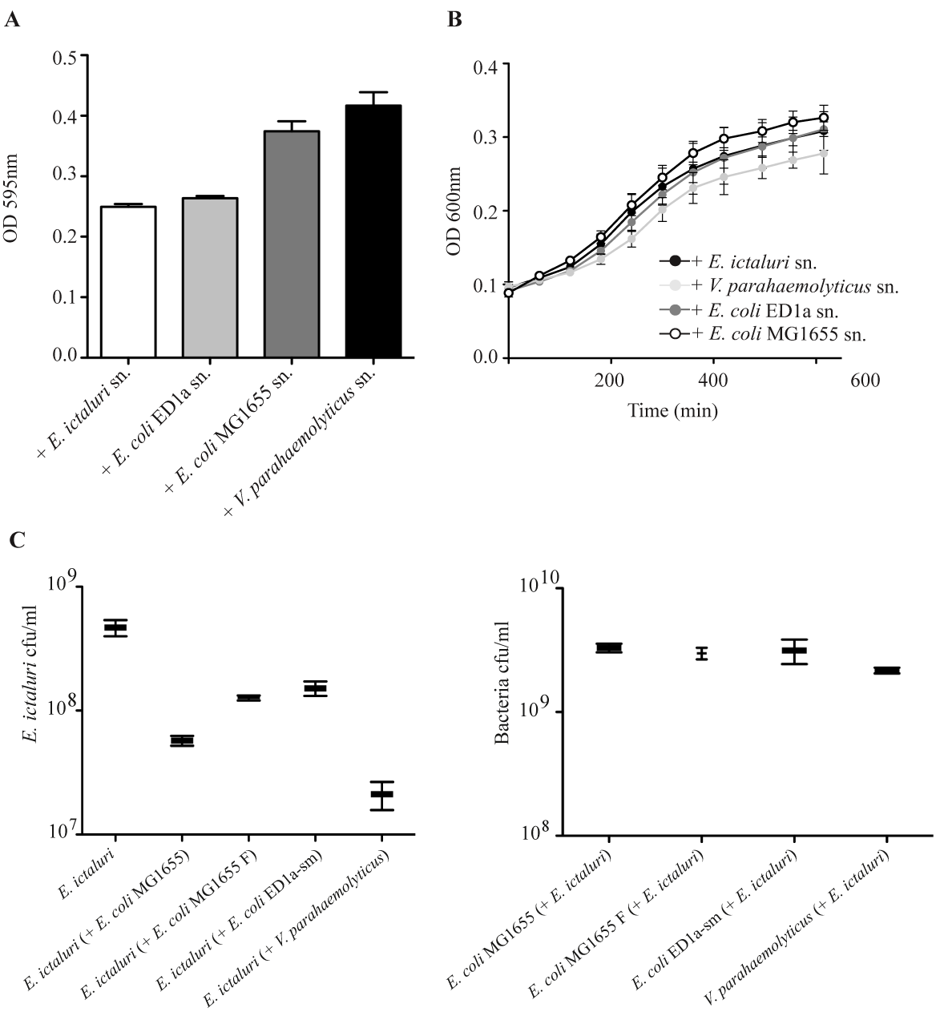

Figure S4, Rendueles et al

Figure S4. Impact of identified protective strains on E. ictaluri growth and biofilm formation (A) Biofilm assay: E. ictaluri was mixed in a 1:1 ratio with filtered supernatants of probiotic strains and grown in 96-well microtiter plates at 28°C for 48 h. Microtiter plates were then washed 3 times with water and stained with crystal violet. Biofilm formation was quantified by dissolution of crystal violet and measurement at OD 595 nm. Addition of E. ictaluri’s own supernatant was included as a control. (B) E. ictaluri growth in presence of probiotic supernants: E. ictaluri inoculum was mixed in a 1:1 ratio with filtered supernatant (sn.) from E. coli MG1655,E. coli ED1a-sm, and V. parahaemolyticus and allowed to grow at 28°. OD 600 nm measurements were taken every 30 minutes. Growth of E. ictaluri with its own supernatant was included as a control. The assay was performed twice in microtiterplates, and 12 different wells were monitored for each condition. (C) Broth co-cultures of E. ictaluri with the three identified protective strains. 3ml of BHI medium was inoculated with E. ictaluri alone or with probiotic strain and co-cultures were incubated at 30°C with agitation. Serial dilutions of over-night resulting co-cultures were spotted on BHI+catalase plates in order to obtained isolated colonies (E. ictaluri forms patches rather than individualized colonies in absence of catalase). Plates were incubated at 30°C overnight and E. ictaluri and E. coli MG1655,E. coli ED1a-sm, and V. parahaemolyticus cfu were counted. E. ictaluri was distinguished from co-cultivated bacteria based on its characteristic yellowish colony morphotype. Left panel: E. ictaluri cfu in corresponding co-cultures. Right panel: Corresponding protective bacteria cfu in corresponding co-cultures with E. ictaluri. Results are expressed as mean±SD of three co-cultures for each condition.

Figure S5, Rendueles et al

Figure S5.Neutrophils redistribution in head and gut. Neutrophils redistribution was quantified by calculating the ratio (neutrophils counts in hematopoietic sites/neutrophils counts in the head and gut) for each larvae. Results are presented as mean+SEM. Statistical significance was calculated between the corresponding pretreated larvae infected and non-infected by E. ictaluri using unpaired two-tailed t-test with Welch's correction (*p<0.05, **p< 0.01, ***p<0.001). One larvae infected by E. ictaluri with a high ratio value was considered as an outlier and excluded from this analysis.
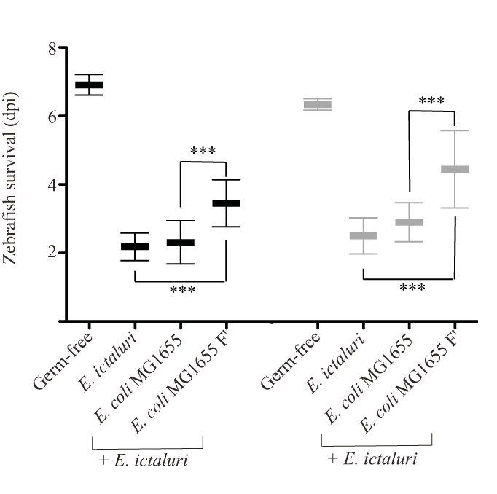
Figure S6, Rendueles et al

Figure S6. Compared life expectancy upon E. ictaluri infection in germ-free and conventional larvae pre-colonized with various E. coli. Mortality of germ-free (black) and conventional (grey) zebrafish larvae pre-colonized at 4 dpf with E. coli MG1655 and E. coli MG1655 F’, and infected at 6 dpf with E. ictaluri. Mean survival is represented by a large hyphen. Standard deviations are also indicated ( ***p<0.001).

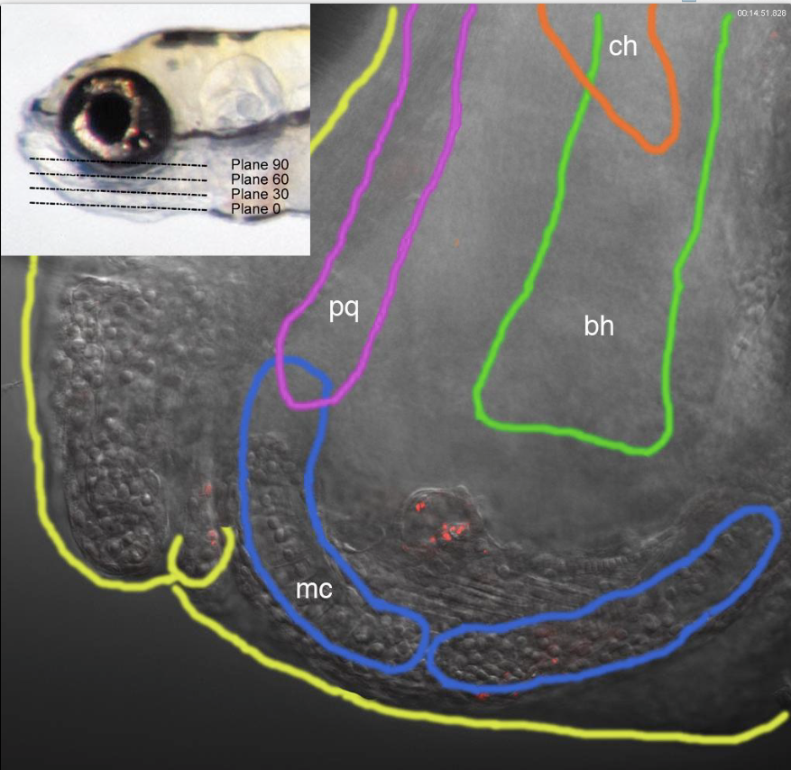

Video S1, Rendueles et al

Video S1. Edwardsiella ictaluri colonizes both sides of the lower jaw of zebrafish larvae. Larva analyzed 3 days post-infection by whole-mount immunofluorescence, using an antibody staining bacteria; fluorescence image (red) superimposed to transmission images (gray). Larva Z-stack taken with a confocal microscope and 40x objective. Ventral view with some lateral tilt, anterior to bottom. The first image of the movies provides a visual help on the top left corner (over the eye) roughly indicating the planes of observation throughout the movie, and a coloured scheme of the cartilages visible in the stack. mc: Meckel's cartilage; pq: palatoquadrate; bh: basihyal; ch: ceratohyal (see Kimmel CB; Miller CT and Moens CB. (2001),Specification and morphogenesis of the zebrafish larval head skeleton. Dev Biol. 15;233(2):239-57.) The yellow line depicts the contour of the fish. Note that figure 3D corresponds to a maximal projection of planes 61 to 75 of the whole stack.

