Table S1. Tryptic peptides identified from healthy and infected mouse proteomes

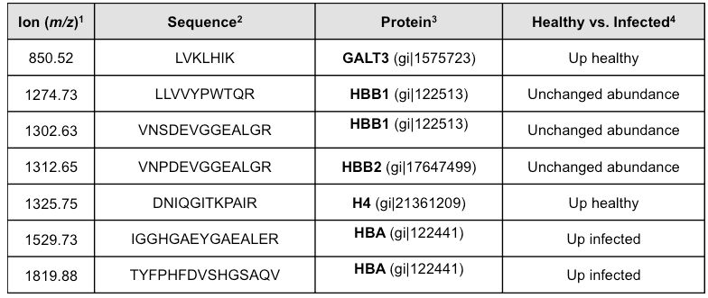

¹Monoisotopic mass, [M+H⁺]⁺¹
²Except for m/z 1819.88, all peptides were identified after LIFT sequencing directly from tissue. The fragmentation spectra are given in Supplementary Fig. S5B. For m/z 1819.88, MS/MS spectrum from on-tissue sequencing was not informative. The peptide was sequenced after LIFT fragmentation from a lesion-enriched tissue extract, which was submitted to in-solution digestion using standard protocols, followed by spotting onto MALDI plate and data acquisition.
³Proteins identified in the course of the analysis, with NCBI access numbers given in parentheses. The identification parameters are given in Figure S5.
⁴Spectral abundance of the individual peptides was determined in the course of ROC curve analysis with ClinProTools 2.2 software (Bruker), according to manufacturer’s recommendations. Increased abundance was defined when AUC≥0.85 in multiple pair-wise comparisons (2 vs. 2 biological replicates, and 3 vs. 3 biological replicates).

