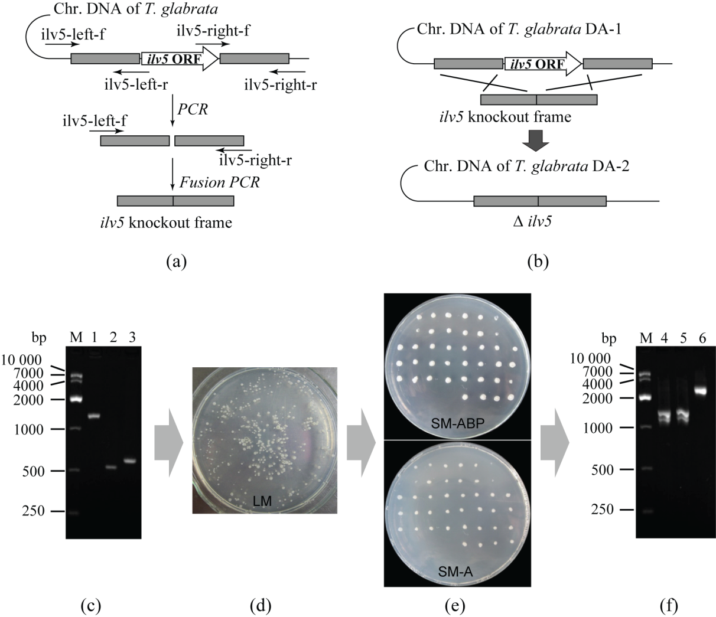

(E)
(F)
(D)
(C)
(B)
(A)

Figure S2 The knockout and confirmation of the ILV5 gene. (A) Construction of fusion frames used for gene deletion; (B) The schematics of gene knockouts; (C) Purified PCR fragments used for ILV5 deletion; (D) Enrichment result of ILV5 mutants on LM; (E) Confirmation of the auxotrophic mutants on SM-A and SM-ABP plates; (F) Colony PCR of the DA-2 positive clones. Lane M, 10 kb DNA Marker; Lane 1, ILV5 knockout frame; Lane 2, ILV5 left arm; Lane 3, ILV5 right arm; Lane 4-5, strain DA-2; Lane 6, control stain DA-1.

