SUPPORTING INFORMATION: Manuscript PONE-D-15-0835R1

S1 Fig. A and B: Parametric and non parametric lod score analyses
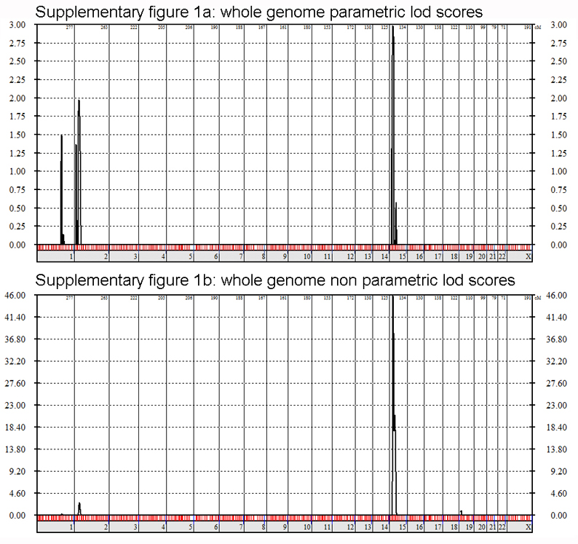

S1 Fig. A and B legend
(a) whole genome calculation of parametric lodscores (mutation prevalence: 0.01%), penetrance: 100%, phenocopy rate: 0%). The lod score values are indicated on the Y axis, the chromosomal positions on the X axis from chromosome 1 to chromosome X. The maximum lod score is obtained on chromosome 15 (2.98) while there exists only a minor peak on chromosome 1 and 2. The peak lod score remained at 2.98 up to a penetrance value of 85%. (b) whole genome calculation of non parametric lod scores (there is no hypothesis made on mutation prevalence, penetrance, phenocopy rate and inheritance type). There is a single peak on chromosome 15. The non-parametric lod score values are indicated on the Y axis the chromosomal positions on the X axis from chromosome 1 to chromosome X.

