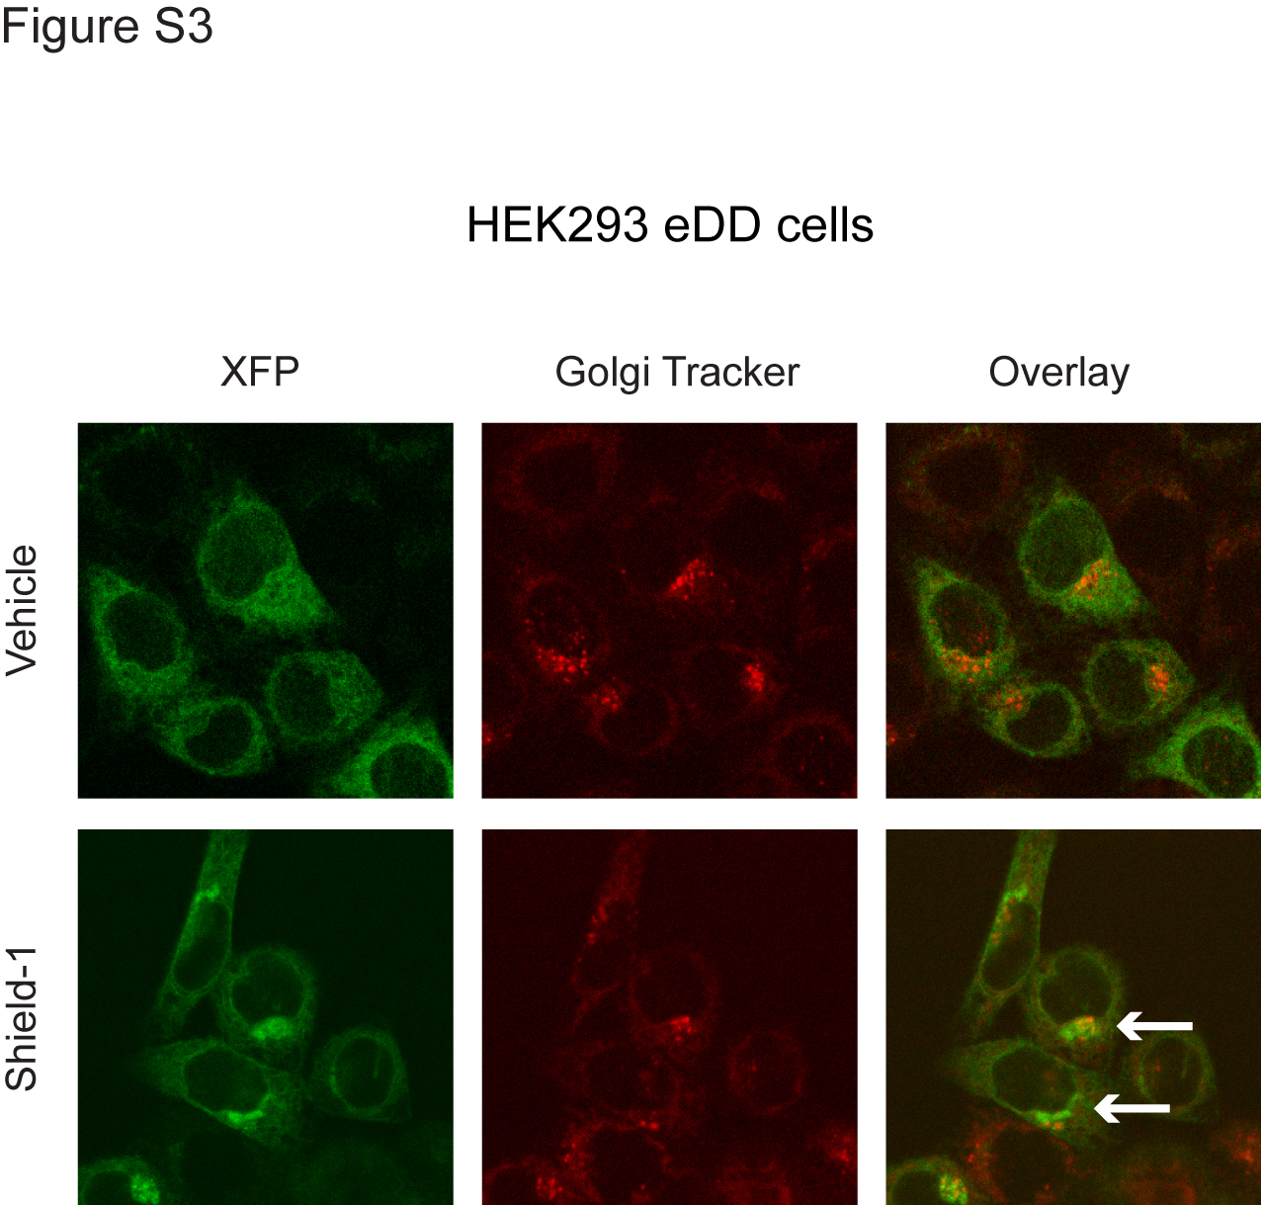
Figure S3. eDD colocalizes with the Golgi apparatus in the presence of Shield-1. Fluorescence micrographs of eDD cells. The overlay image shows eDD (green) and a ceramide Golgi Tracker (red). White arrows indicate colocalization of eDD with Golgi bodies after Shield-1 treatment.

