Supporting information S2

Cross-sectional Findings
Figure S1 and Table S2 summarize the main findings of cross-sectional comparisons of rCBF effects in patients versus healthy controls. See main manuscript for details.

Figure S1. Cross-sectional CBF differences between healthy controls and patients.
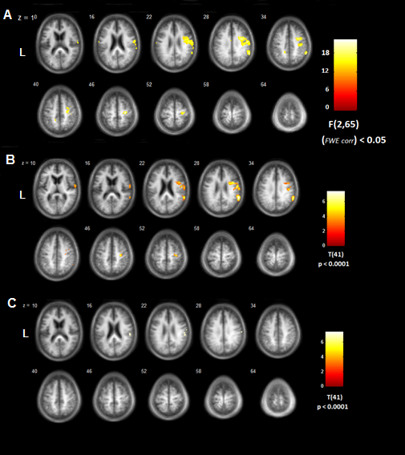
Panel A: ANOVA for the complete study population. Panel B: t-test between healthy controls and patients at exam 1. Panel C: t-test between healthy controls and patients at exam 2. Maps are projected onto axial slices of an average anatomical image of the complete cohort (L, left). Coordinates are given in MNI space (mm).
Table S2. Results of between-group comparison of CBF in healthy controls and stroke patients
Anatomical region | Cytoarchitectonic Area (%)* | x | y | z | voxels | HC-P F(p_{FWE})° | HC-P Month 3 T(p_{unc})# | HC-P Month 9 T(p_{unc})# | rCBF HC | rCBF P Month 3 | rCBF P Month 9
Ipsilesional
Premotor cortex | Area 6 (60.1) | 38 | -13 | 45 | 918 | 26.05  (< .001) | 5.39  (<.001) | 3.27  (< .01) | 50.4±17.0 | 29.7±22.1 | 31.9±22.2
Parietal operculum | OP1 (11.1) IPC(PFop) (7.1) | 61 | -24 | 18 | 575 | 22.23  (< .01) | 3.49  (<.01) | 3.91  (<.005) | 48.9±16 | 28.8±18.4 | 31.8±17.4
Inferior parietal lobule | IPC (PGa) (71.6) | 56 | -44 | 30 | 409 | 14.21  (< .01) | 5.67  (<.001) | 3.44  (< .01) | 54.8±16.0 | 28.6±18.4 | 31.7±17.4
Post-/Precentral gyrus | Area 4p (40.3) Area 3b (32.0) | 28 | -36 | 61 | 122 | 14.41  (< .01) | 5.2  (<.001) | 2.92  (< .01) | 50.3±18.0 | 21.5±15.5 | 22.0±15.5
Contralesional
Inferior Precuneus | n. a. | -15 | -42 | 36 | 136 | 2.02  (< .01) | 1.58  (n.s.) | 3.99  (< .01) | 50.3±20.2 | 41.5±9.5 | 27.6±13.0

Abbreviations: CBF, cerebral blood flow, HC, healthy controls; n.a., not assigned. P, patients. FWE-corr and unc, indicate family-wise error corrected or uncorrected p-values. CBF values are in [ml/100g/min].° F-statistic from mixed ANOVA (HC, one measurement; P, two repeated measurements). #T-statistic from post-hoc unpaired t-test (HC versus P at each time point). * Percent of cluster on that area.

