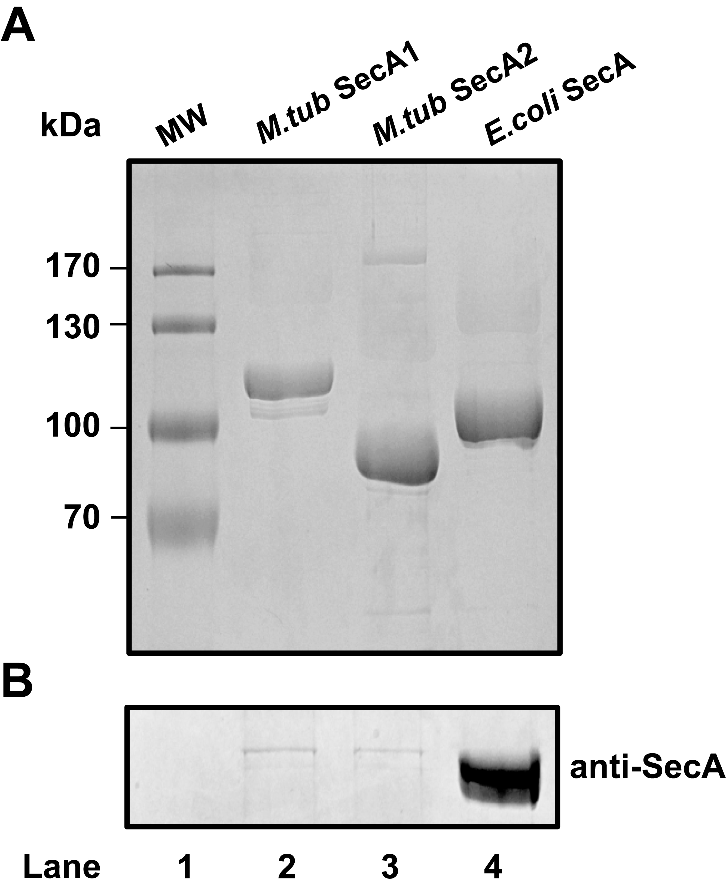

S1 Fig. SDS-PAGE and western blot analysis of purified M. tuberculosis SecA1 and SecA2. A) Coomassie-stained SDS-PAGE of purified M. tuberculosis SecA1 (lane 1), SecA2 (lane 2), and E. coli SecA (lane 3) and B) western blot using an anti-E. coli SecA antibody.

