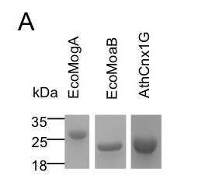 | 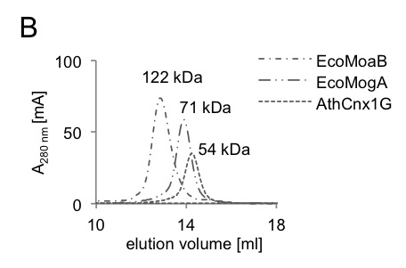

Figure S2. Purification of His-tagged fusion proteins EcoMogA, EcoMoaB and AthCnx1G expressed in E. coli.

