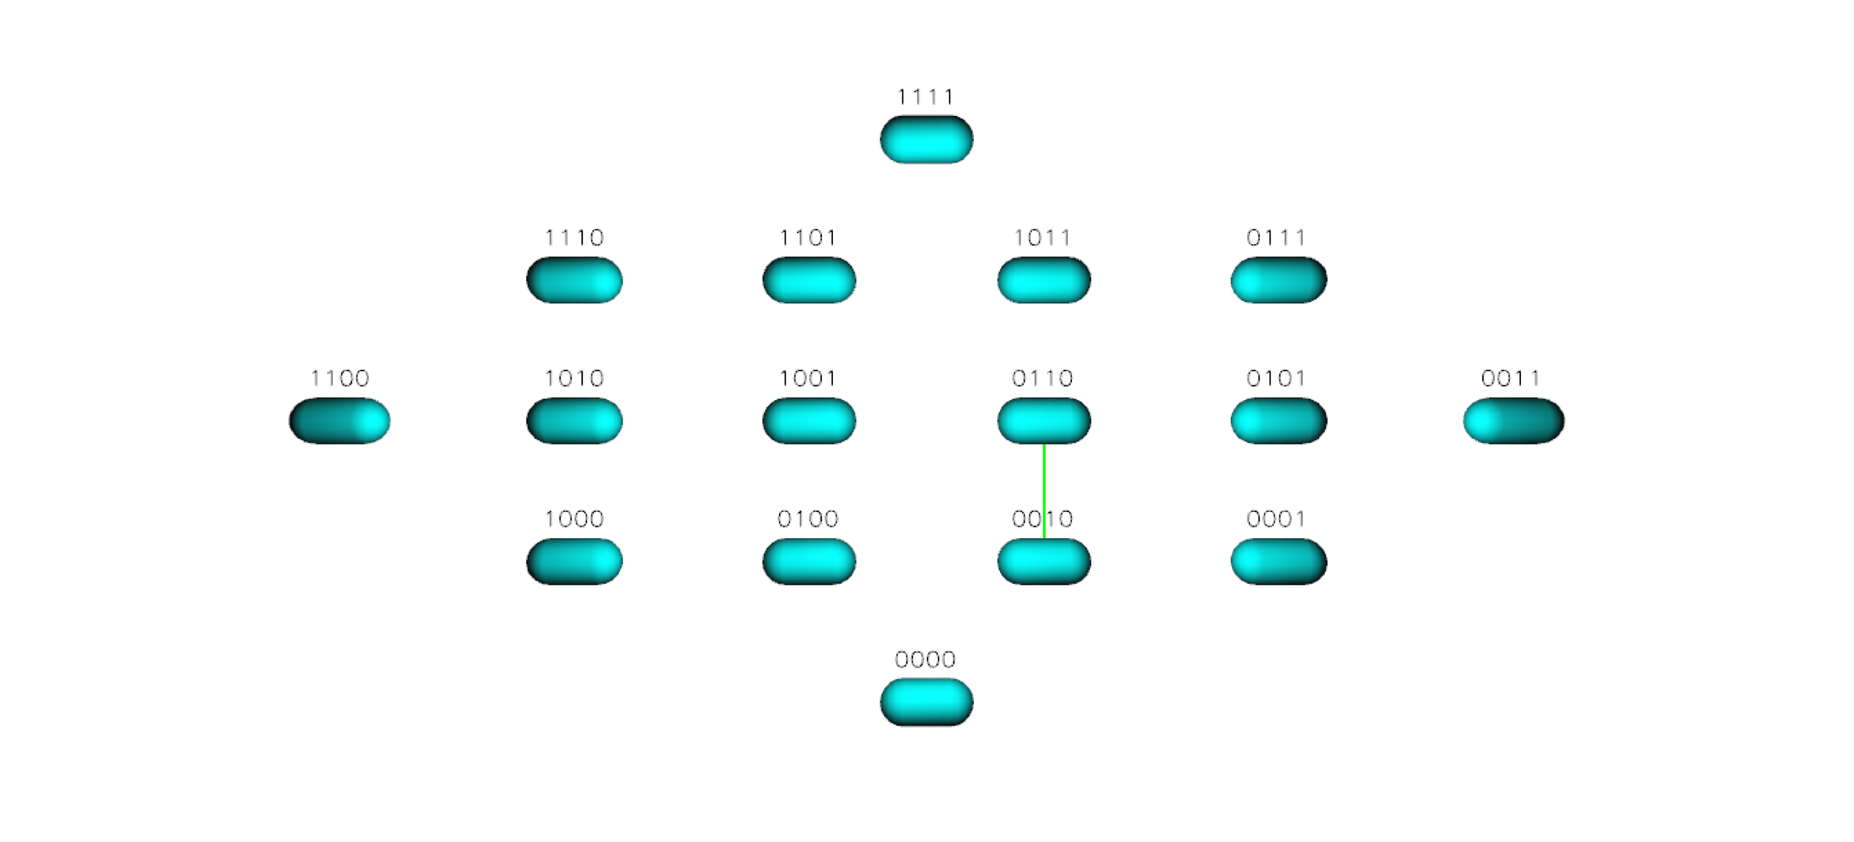
Figure S26 TEM 85 Landscape for Cefoxitin

