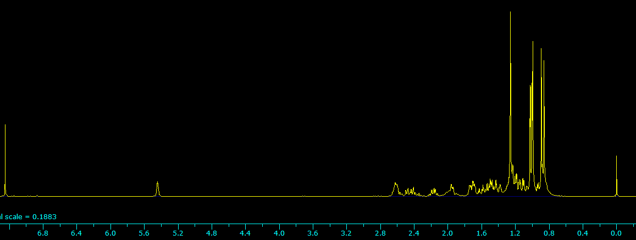
Figure S5. ¹H NMR of miltiradiene in whole scale.

