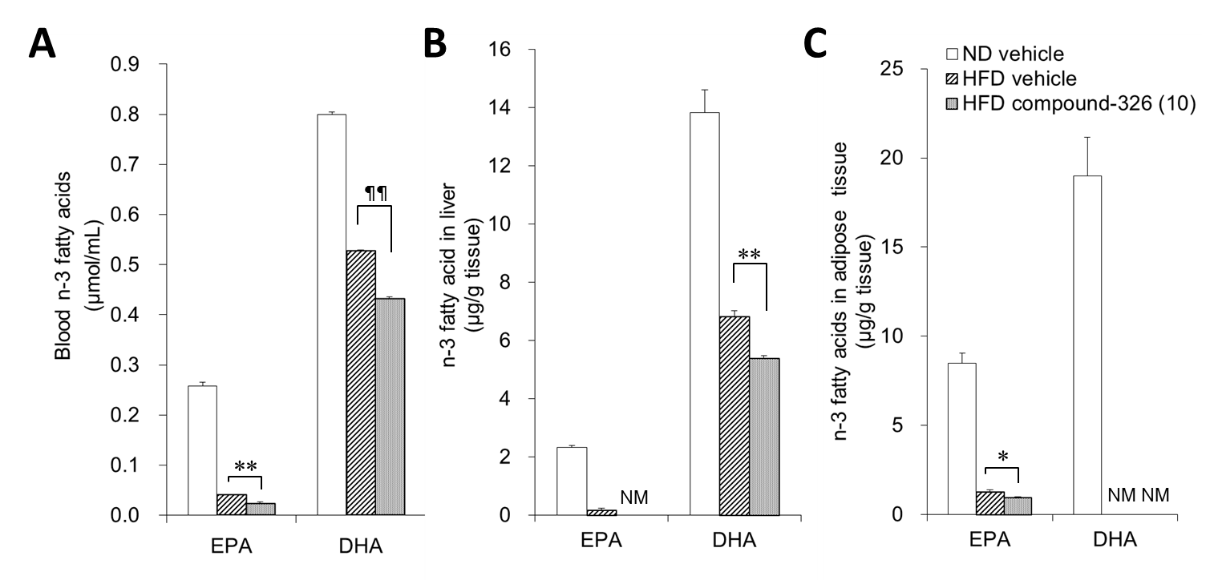
S5 Fig. Effects of chronic treatment with compound-326 on blood and tissue EPA and DHA levels in HFD-fed mice.
HFD-fed mice were treated with compound-326 (10 mg/kg), p.o. for 6 weeks. Mice fed a normal diet (ND) were used as normal reference. (A) Levels of EPA and DHA in the blood. (B) Levels of EPA and DHA in epididymal adipose tissue. (C) Levels of EPA and DHA in epididymal adipose tissue. NM stands for note measureable. Data are expressed as mean ± SE (n=8-9). *p≤ 0.05 and **p≤ 0.01 vs. DIO vehicle by Aspin-Welch test. ¶¶p≤ 0.01 vs. DIO vehicle by Student's t-test.

