6. GLUT4 contents in membranes of the muscles
Fig. 5A
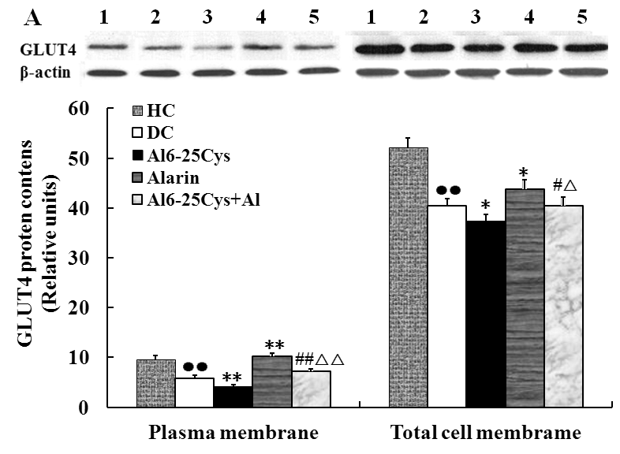
6.1. GLUT4 contents in plasma membranes
6.1.1. Data
10.46 | 4.13 | 3.63 | 11.01 | 7.26
8.57 | 5.65 | 4.65 | 9.86 | 6.54
9.64 | 4.92 | 3.92 | 10.94 | 6.93
9.51 | 6.06 | 4.68 | 10.32 | 8.25
8.91 | 6.11 | 3.86 | 9.78 | 7.06
9.46 | 5.76 | 3.76 | 9.64 | 7.14
10.26 | 7.17 | 4.17 | 9.21 | 6.58
9.34 | 6.43 | 4.23 | 11.17 | 7.46
9.51875 | 5.77875 | 4.1125 | 10.24125 | 7.1525

6.1.2. Statistical analysis

(I) VAR00001 | (J) VAR00001 |  | Mean Difference (I-J) |  | Std. Error |  | Sig. |  | 95% Confidence Interval
 |  |  |  |  |  |  |  |  | Lower Bound | Upper Bound
1 | 2 |  | 3.74000* |  | .33452 |  | .000 |  | 2.7782 | 4.7018
 | 3 |  | 5.40625* |  | .33452 |  | .000 |  | 4.4445 | 6.3680
 | 4 |  | -.72250 |  | .33452 |  | .219 |  | -1.6843 | .2393
 | 5 |  | 2.36625* |  | .33452 |  | .000 |  | 1.4045 | 3.3280
2 | 1 |  | -3.74000* |  | .33452 |  | .000 |  | -4.7018 | -2.7782
 | 3 |  | 1.66625* |  | .33452 |  | .000 |  | .7045 | 2.6280
 | 4 |  | -4.46250* |  | .33452 |  | .000 |  | -5.4243 | -3.5007
 | 5 |  | -1.37375* |  | .33452 |  | .002 |  | -2.3355 | -.4120
3 | 1 |  | -5.40625* |  | .33452 |  | .000 |  | -6.3680 | -4.4445
 | 2 |  | -1.66625* |  | .33452 |  | .000 |  | -2.6280 | -.7045
 | 4 |  | -6.12875* |  | .33452 |  | .000 |  | -7.0905 | -5.1670
 | 5 |  | -3.04000* |  | .33452 |  | .000 |  | -4.0018 | -2.0782
4 | 1 |  | .72250 |  | .33452 |  | .219 |  | -.2393 | 1.6843
 | 2 |  | 4.46250* |  | .33452 |  | .000 |  | 3.5007 | 5.4243
 | 3 |  | 6.12875* |  | .33452 |  | .000 |  | 5.1670 | 7.0905
 | 5 |  | 3.08875* |  | .33452 |  | .000 |  | 2.1270 | 4.0505
5 | 1 |  | -2.36625* |  | .33452 |  | .000 |  | -3.3280 | -1.4045
 | 2 |  | 1.37375* |  | .33452 |  | .002 |  | .4120 | 2.3355
 | 3 |  | 3.04000* |  | .33452 |  | .000 |  | 2.0782 | 4.0018
 | 4 |  | -3.08875* |  | .33452 |  | .000 |  | -4.0505 | -2.1270

6.2. GLUT4 contents in total cell membranes
6.2.1. Data
54.32 | 38.59 | 37.25 | 44.83 | 40.83
54.89 | 40.94 | 36.33 | 41.23 | 40.23
50.22 | 41.01 | 38.62 | 42.42 | 39.42
49.67 | 42.28 | 37.94 | 44.84 | 41.84
48.67 | 43.61 | 36.85 | 44.25 | 39.25
50.34 | 41.94 | 37.18 | 45.27 | 41.27
52.49 | 35.62 | 36.79 | 42.89 | 39.49
56.33 | 39.67 | 37.91 | 44.61 | 41.61
52.11625 | 40.4575 | 37.35875 | 43.7925 | 40.4925

6.2.2. Statistical analysis
(I) VAR00001 | (J) VAR00001 |  | Mean Difference (I-J) |  | Std. Error | Sig. | 95% Confidence Interval
 |  |  |  |  |  |  | Lower Bound | Upper Bound
1 | 2 |  | 116.58750* |  | 9.49431 | .000 | 89.2908 | 143.8842
 | 3 |  | 147.57500* |  | 9.49431 | .000 | 120.2783 | 174.8717
 | 4 |  | 85.73750* |  | 9.49431 | .000 | 58.4408 | 113.0342
 | 5 |  | 116.23750* |  | 9.49431 | .000 | 88.9408 | 143.5342
2 | 1 |  | -116.58750* |  | 9.49431 | .000 | -143.8842 | -89.2908
 | 3 |  | 30.98750* |  | 9.49431 | .019 | 3.6908 | 58.2842
 | 4 |  | -30.85000* |  | 9.49431 | .020 | -58.1467 | -3.5533
 | 5 |  | -.35000 |  | 9.49431 | 1.000 | -27.6467 | 26.9467
3 | 1 |  | -147.57500* |  | 9.49431 | .000 | -174.8717 | -120.2783
 | 2 |  | -30.98750* |  | 9.49431 | .019 | -58.2842 | -3.6908
 | 4 |  | -61.83750* |  | 9.49431 | .000 | -89.1342 | -34.5408
 | 5 |  | -31.33750* |  | 9.49431 | .018 | -58.6342 | -4.0408
4 | 1 |  | -85.73750* |  | 9.49431 | .000 | -113.0342 | -58.4408
 | 2 |  | 30.85000* |  | 9.49431 | .020 | 3.5533 | 58.1467
 | 3 |  | 61.83750* |  | 9.49431 | .000 | 34.5408 | 89.1342
 | 5 |  | 30.50000* |  | 9.49431 | .022 | 3.2033 | 57.7967
5 | 1 |  | -116.23750* |  | 9.49431 | .000 | -143.5342 | -88.9408
 | 2 |  | .35000 |  | 9.49431 | 1.000 | -26.9467 | 27.6467
 | 3 |  | 31.33750* |  | 9.49431 | .018 | 4.0408 | 58.6342
 | 4 |  | -30.50000* |  | 9.49431 | .022 | -57.7967 | -3.2033

6.3. GLUT4 contents in plasma membranes to total cell membranes
Fig. 5B
6.3.1. Data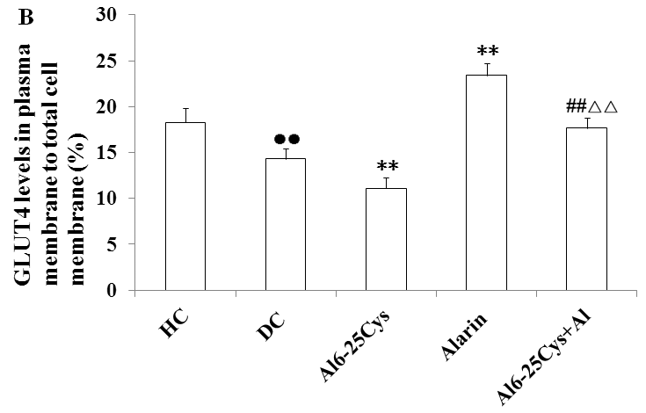
20.5 |  | 14.6 |  | 9.4 |  | 23.5 |  | 17.6
15.9 |  | 12.3 |  | 10.6 |  | 21.9 |  | 18.9
19.7 |  | 15.1 |  | 11.8 |  | 23.4 |  | 19.1
16.4 |  | 14.2 |  | 12.5 |  | 23.3 |  | 18.4
18.5 |  | 15.8 |  | 14.3 |  | 24.6 |  | 16.6
16.6 |  | 12.6 |  | 10.2 |  | 23.7 |  | 15.4
17.4 |  | 13.3 |  | 11.6 |  | 24.1 |  | 17.8
21.1 |  | 16.4 |  | 8.7 |  | 22.5 |  | 17.4
6.3.2. Statistical analysis
(I) VAR00001 | (J) VAR00001 |  | Mean Difference (I-J) |  | Std. Error |  | Sig. |  | 95% Confidence Interval
 |  |  |  |  |  |  |  |  | Lower Bound |  | Upper Bound
1 | 2 |  | 4.10000* |  | .74350 |  | .000 |  | 1.9624 |  | 6.2376
 | 3 |  | 7.25000* |  | .74350 |  | .000 |  | 5.1124 |  | 9.3876
 | 4 |  | -4.98750* |  | .74350 |  | .000 |  | -7.1251 |  | -2.8499
 | 5 |  | .73750 |  | .74350 |  | .857 |  | -1.4001 |  | 2.8751
2 | 1 |  | -4.10000* |  | .74350 |  | .000 |  | -6.2376 |  | -1.9624
 | 3 |  | 3.15000* |  | .74350 |  | .001 |  | 1.0124 |  | 5.2876
 | 4 |  | -9.08750* |  | .74350 |  | .000 |  | -11.2251 |  | -6.9499
 | 5 |  | -3.36250* |  | .74350 |  | .001 |  | -5.5001 |  | -1.2249
3 | 1 |  | -7.25000* |  | .74350 |  | .000 |  | -9.3876 |  | -5.1124
 | 2 |  | -3.15000* |  | .74350 |  | .001 |  | -5.2876 |  | -1.0124
 | 4 |  | -12.23750* |  | .74350 |  | .000 |  | -14.3751 |  | -10.0999
 | 5 |  | -6.51250* |  | .74350 |  | .000 |  | -8.6501 |  | -4.3749
4 | 1 |  | 4.98750* |  | .74350 |  | .000 |  | 2.8499 |  | 7.1251
 | 2 |  | 9.08750* |  | .74350 |  | .000 |  | 6.9499 |  | 11.2251
 | 3 |  | 12.23750* |  | .74350 |  | .000 |  | 10.0999 |  | 14.3751
 | 5 |  | 5.72500* |  | .74350 |  | .000 |  | 3.5874 |  | 7.8626
5 | 1 |  | -.73750 |  | .74350 |  | .857 |  | -2.8751 |  | 1.4001
 | 2 |  | 3.36250* |  | .74350 |  | .001 |  | 1.2249 |  | 5.5001
 | 3 |  | 6.51250* |  | .74350 |  | .000 |  | 4.3749 |  | 8.6501
 | 4 |  | -5.72500* |  | .74350 |  | .000 |  | -7.8626 |  | -3.5874

