S1_Figure
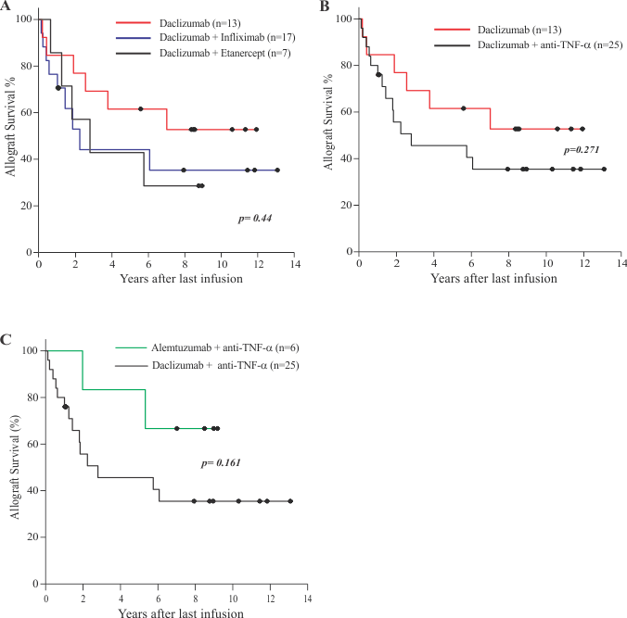

S1 Figure: Effect of different induction regimens on allograft survival. A) Comparison of the effect of induction with Daclizumab alone or in combination with Etanercept anti-TNF-α treatments. C) Comparison of allograft survival obtained using Daclizumab or Alentuzumab in combination with anti-TNF-α treatments or with Infliximab. B) Allograft survival obtained with Daclizumab alone or in combination with all.

