S1 Fig

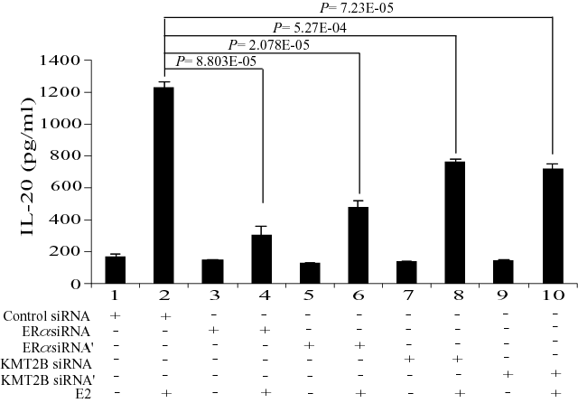

S1 Fig. IL-20 expression levels determined by ELISA. ELISA measurements of IL-20 levels in the culture medium from MCF-7 cells transfected with ERα or KMT2B siRNAs following E2-stimulation.

