Supporting Information Table S2. Scatterplot of relationships among measured environmental variables in the nitrogen plots.
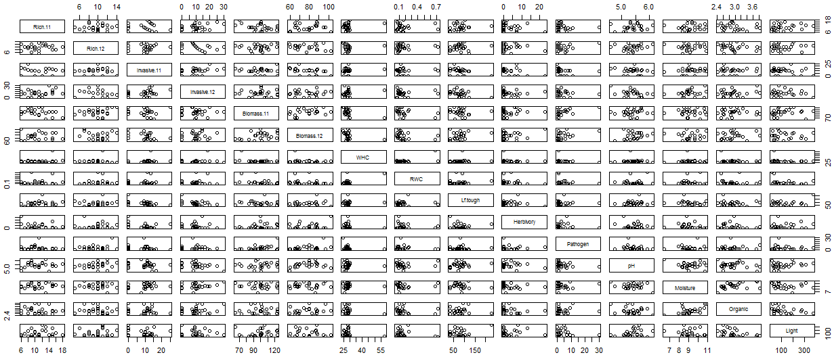
Scatterplot of relationships among measured environmental variables in the warming plots.
