S1 Supporting Information

On the chronological structure of the Solutrean in Southern Iberia

Appendix A - Bayesian modelling results for each archaeological site

Central Portugal

Caldeirão
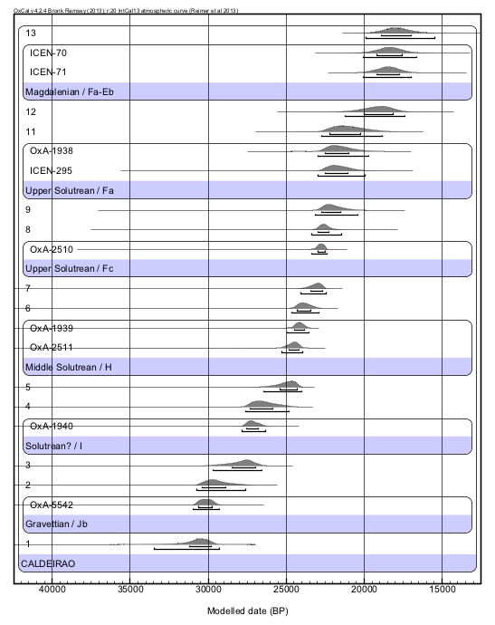
Lagar Velho
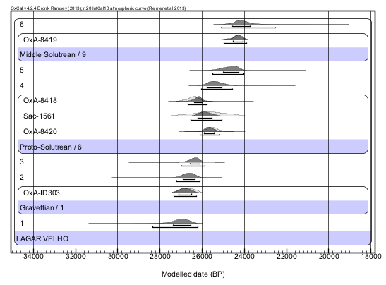

Vale Almoinha
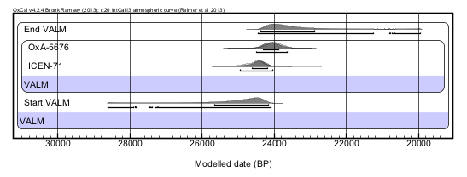

Salemas
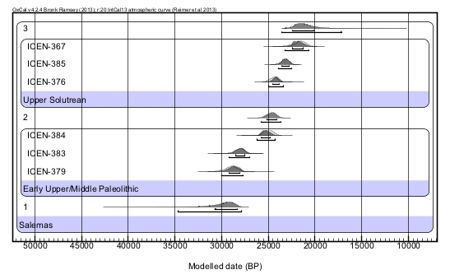

Southern Portugal

Vale Boi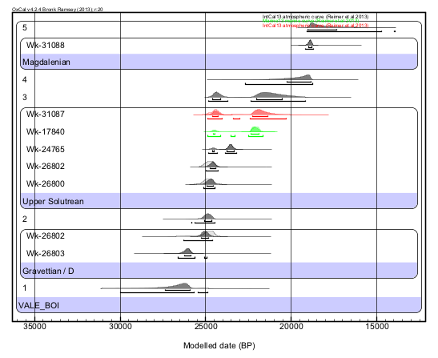

Southwestern Spain

Gorham’s
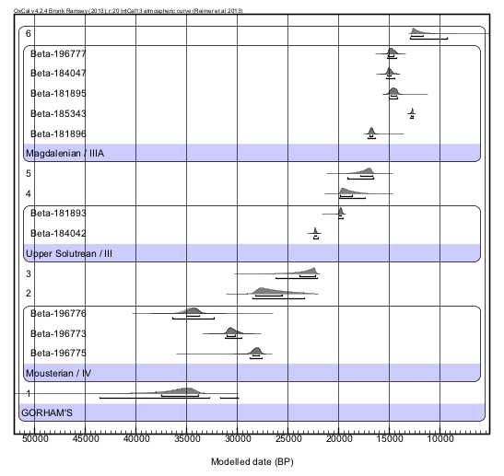

Nerja
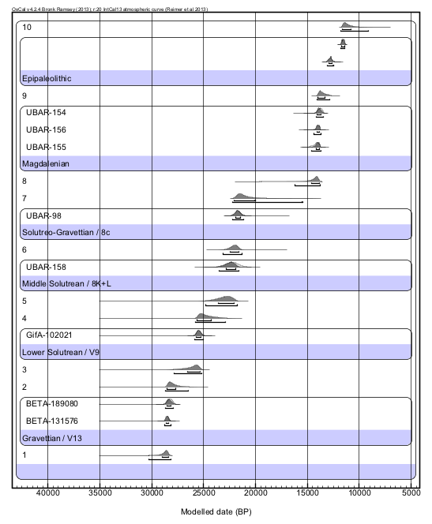

Bajondillo
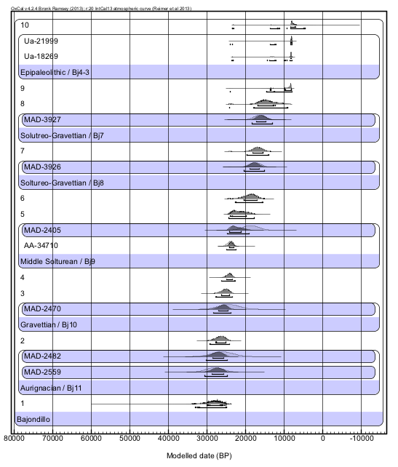

Southeastern Spain

Ambrosio
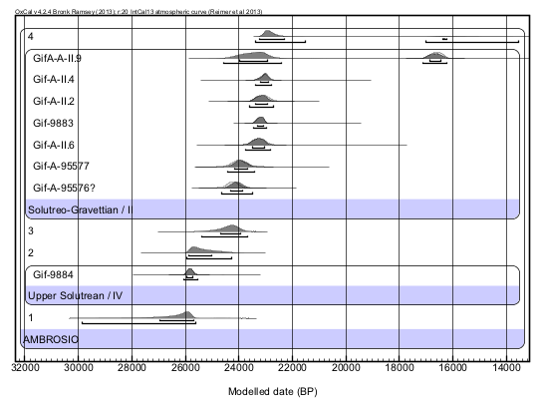

La Boja
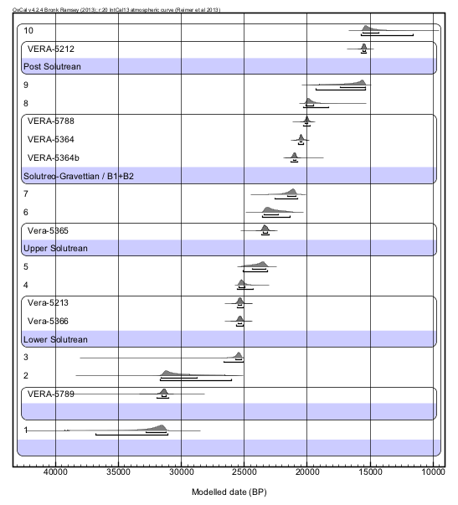

Mallaetes
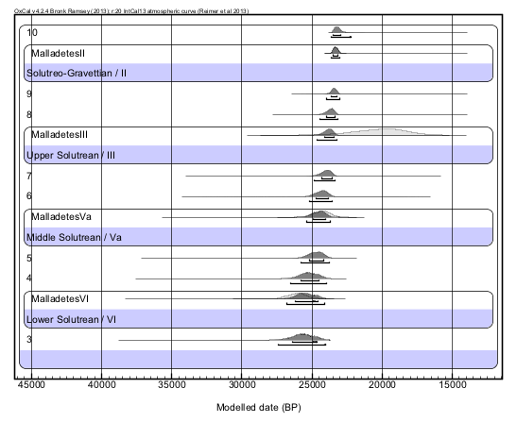

Parpalló
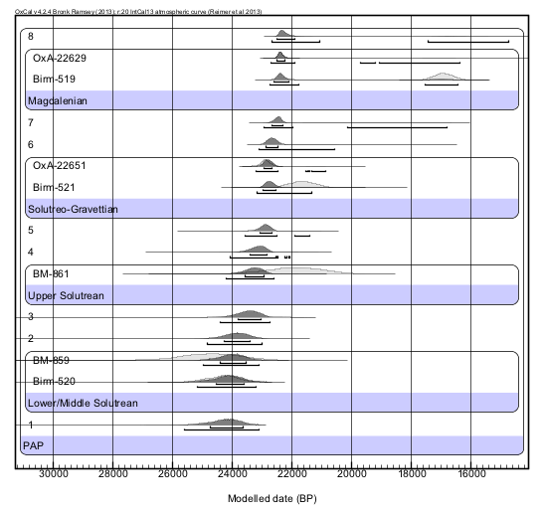

Cendres
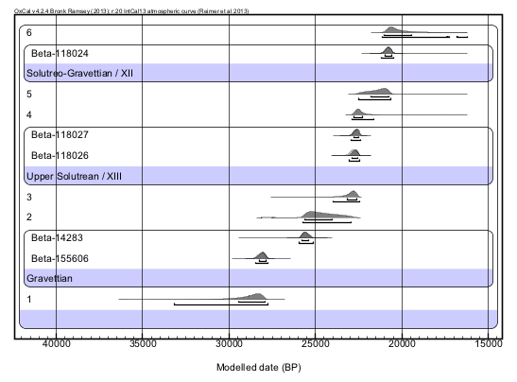

S1B - Bayesian CQL Codes

Central Portugal

Caldeirão
Options()
{
Resolution=20;
};
Plot()
{
Outlier_Model("General",T(5),U(0,4),"t");
Sequence("CALDEIRAO")
{
Boundary("1");
Phase("Gravettian / Jb")
{
R_Date("OxA-5542", 26020, 320)
{
Outlier("General", 0.05);
};
};
Boundary("2");
Boundary("3");
Phase("Solutrean? / I")
{
R_Date("OxA-1940", 22900, 380)
{
Outlier("General", 0.05);
};
};
Boundary("4");
Boundary("5");
Phase("Middle Solutrean / H")
{
R_Date("OxA-2511", 20530, 270)
{
Outlier("General", 0.05);
};
R_Date("OxA-1939", 19900, 260)
{
Outlier("General", 0.05);
};
};
Boundary("6");
Boundary("7");
Phase("Upper Solutrean / Fc")
{
R_Date("OxA-2510", 18840, 200)
{
Outlier("General", 0.05);
};
};
Boundary("8");
Boundary("9");
Phase("Upper Solutrean / Fa")
{
R_Date("ICEN-295", 21200, 2300)
{
Outlier("General", 0.05);
};
R_Date("OxA-1938", 20400, 270)
{
Outlier("General", 0.05);
};
};
Boundary("11");
Boundary("12");
Phase("Magdalenian / Fa-Eb")
{
R_Date("ICEN-71", 15170, 740)
{
Outlier("General", 0.05);
};
R_Date("ICEN-70", 14450, 890)
{
Outlier("General", 0.05);
};
};
Boundary("13");
};
Sequence()
{
Boundary("=5");
Date("Caldeirao Middle Solutrean");
Boundary("=6");
};
Sequence()
{
Boundary("=7");
Date("Caldeirao Upper Solutrean");
Boundary("=8");
};
Sequence("Total")
{
Boundary("=5");
Date("Caldeirao");
Boundary("=8");
};
};

Lagar Velho
Options()
{
Resolution=20;
};
Plot()
{
Outlier_Model("General",T(5),U(0,4),"t");
Sequence("LAGAR VELHO")
{
Boundary("1");
Phase("Gravettian / 1")
{
R_Date("OxA-ID303", 22390, 280)
{
Outlier("General", 0.05);
};
};
Boundary("2");
Boundary("3");
Phase("Proto-Solutrean / 6")
{
R_Date("OxA-8420", 21180, 240)
{
Outlier("General", 0.05);
};
R_Date("Sac-1561", 21380, 810)
{
Outlier("General", 0.05);
};
R_Date("OxA-8418", 22180, 180)
{
Outlier("General", 0.05);
};
};
Boundary("4");
Boundary("5");
Phase("Middle Solutrean / 9")
{
R_Date("OxA-8419", 20200, 180)
{
Outlier("General", 0.05);
};
};
Boundary("6");
};
Sequence()
{
Boundary("=5");
Date("Lagar Velho Middle Solutrean");
Boundary("=6");
};
};

Vale Almoinha
Options()
{
Resolution=20;
};
Plot()
{
Outlier_Model("General",T(5),U(0,4),"t");
Sequence("VALM")
{
Boundary("Start VALM");
Phase("VALM")
{
R_Date("ICEN-71", 20380, 150)
{
Outlier("General", 0.05);
};
R_Date("OxA-5676", 19940, 180)
{
Outlier("General", 0.05);
};
};
Boundary("End VALM");
};
Sequence()
{
Boundary("=Start VALM");
Date("VALM");
Boundary("=End VALM");
};
};

Salemas
Options()
{
Resolution=20;
SD2=TRUE;
};
Plot()
{
Outlier_Model("General",T(5),U(0,4),"t");
Sequence("Salemas")
{
Boundary("1");
Phase("Early Upper/Middle Paleolithic")
{
R_Date("ICEN-379", 24820, 550)
{
Outlier("General", 0.05);
};
R_Date("ICEN-383", 23830, 580)
{
Outlier("General", 0.05);
};
R_Date("ICEN-384", 20740, 470)
{
Outlier("General", 0.05);
};
};
Boundary("2");
Phase("Upper Solutrean")
{
R_Date("ICEN-376", 20250, 320)
{
Outlier("General", 0.05);
};
R_Date("ICEN-385", 19220, 300)
{
Outlier("General", 0.05);
};
R_Date("ICEN-367", 17770, 420)
{
Outlier("General", 0.05);
};
};
Boundary("3");
};
Sequence()
{
Boundary("=2");
Date("Salemas Upper Solutrean");
Boundary("=3");
};
};

Southern Portugal

Vale Boi
Options()
{
Resolution=20;
};
Plot()
{
Outlier_Model("General",T(5),U(0,4),"t");
Sequence(VALE_BOI)
{
Boundary("1");
Phase("Gravettian / D")
{
R_Date("Wk-26803", 21859, 186)
{
Outlier("General", 0.05);
};
R_Date("Wk-26802", 20570, 158)
{
Outlier("General", 0.05);
};
};
Boundary("2");
Sequence("Upper Solutrean")
{
R_Date("Wk-26800", 20620, 160)
{
Outlier("General", 0.05);
};
R_Date("Wk-26802", 20570, 158)
{
Outlier("General", 0.05);
};
R_Date("Wk-24765", 19533, 92)
{
Outlier("General", 0.05);
};
Curve("Marine13","Marine13.14c");
Delta_R("LocalMarine",265,107);
R_Date("Wk-17840", 18859, 90)
{
Outlier("General", 0.05);
};
Curve("IntCal13","IntCal13.14c");
R_Date("Wk-31087", 20339, 161)
{
Outlier("General", 0.05);
};
};
Boundary("3");
Boundary("4");
Phase("Magdalenian")
{
R_Date("Wk-31088", 15660, 86)
{
Outlier("General", 0.05);
};
};
Boundary("5");
};
Sequence()
{
Boundary("=2");
Date("Vale Boi Upper Solutrean");
Boundary("=3");
};
};

Southwestern Spain

Gorham’s
Options()
{
Resolution=20;
};
Plot()
{
Outlier_Model("General",T(5),U(0,4),"t");
Sequence("GORHAM'S")
{
Boundary("1");
Phase("Mousterian / IV")
{
R_Date("Beta-196775", 24010, 320)
{
Outlier("General", 0.05);
};
R_Date("Beta-196773", 26400, 440)
{
Outlier("General", 0.05);
};
R_Date("Beta-196776", 30560, 720)
{
Outlier("General", 0.05);
};
};
Boundary("2");
Boundary("3");
Phase("Upper Solutrean / III")
{
R_Date("Beta-184042", 18440, 80)
{
Outlier("General", 0.05);
};
R_Date("Beta-181893", 16420, 60)
{
Outlier("General", 0.05);
};
};
Boundary("4");
Boundary("5");
Phase("Magdalenian / IIIA")
{
R_Date("Beta-181896", 13870, 80)
{
Outlier("General", 0.05);
};
R_Date("Beta-185343", 10880, 80)
{
Outlier("General", 0.05);
};
R_Date("Beta-181895", 12460, 100)
{
Outlier("General", 0.05);
};
R_Date("Beta-184047", 12640, 100)
{
Outlier("General", 0.05);
};
R_Date("Beta-196777", 12540, 100)
{
Outlier("General", 0.05);
};
};
Boundary("6");
};
Sequence()
{
Boundary("=3");
Date("Gorhams Upper Solutrean");
Boundary("=4");
};
};

Nerja
Options()
{
Resolution=20;
};
Plot()
{
Outlier_Model("General",T(5),U(0,4),"t");
Sequence()
{
Boundary("1");
Phase("Gravettian / V13")
{
R_Date("BETA-131576", 24480, 110)
{
Outlier("General", 0.05);
};
R_Date("BETA-189080", 24200, 200)
{
Outlier("General", 0.05);
};
};
Boundary("2");
Boundary("3");
Phase("Lower Solutrean / V9")
{
R_Date("GifA-102021", 21140, 190)
{
Outlier("General", 0.05);
};
};
Boundary("4");
Boundary("5");
Phase("Middle Solutrean / 8K+L")
{
R_Date("UBAR-158", 18420, 530)
{
Outlier("General", 0.05);
};
};
Boundary("6");
Phase("Solutreo-Gravettian / 8c")
{
R_Date("UBAR-98", 17940, 200)
{
Outlier("General", 0.05);
};
};
Boundary("7");
Boundary("8");
Phase("Magdalenian")
{
R_Date("UBAR-155", 12190, 150)
{
Outlier("General", 0.05);
};
R_Date("UBAR-156", 12130, 130)
{
Outlier("General", 0.05);
};
R_Date("UBAR-154", 11930, 160)
{
Outlier("General", 0.05);
};
};
Boundary("9");
Phase("Epipaleolithic")
{
R_Date(10860, 160)
{
Outlier("General", 0,05);
};
R_Date(10040, 40)
{
Outlier("General", 0,05);
};
};
Boundary("10");
};
Sequence()
{
Boundary("=3");
Date("Nerja Lower Solutrean");
Boundary("=4");
};
Sequence()
{
Boundary("=5");
Date("Nerja Middle Solutrean");
Boundary("=6");
};
Sequence()
{
Boundary("=6");
Date("Nerja Solutreo-Gravettian");
Boundary("=7");
};
Sequence("Total")
{
Boundary("=3");
Date("Nerja");
Boundary("=7");
};
};

Bajondillo
Options()
{
Resolution=20;
};
Plot()
{
Outlier_Model("General",T(5),U(0,4),"t");
Sequence("Bajondillo")
{
Boundary("1");
Phase("Aurignacian / Bj11")
{
Age("MAD-2559", N(28019, 2334))
{
Outlier("General", 0.05);
};
Age("MAD-2482", N(26013, 2777))
{
Outlier("General", 0.05);
};
};
Boundary("2");
Phase("Gravettian / Bj10")
{
Age("MAD-2470", N(24344, 2653))
{
Outlier("General", 0.05);
};
};
Boundary("3");
Boundary("4");
Phase("Middle Solturean / Bj9")
{
R_Date("AA-34710", 19990, 480)
{
Outlier("General", 0.05);
};
Age("MAD-2405", N(18701, 2154))
{
Outlier("General", 0.05);
};
};
Boundary("5");
Boundary("6");
Phase("Soltureo-Gravettian / Bj8")
{
Age("MAD-3926", N(17582, 1521))
{
Outlier("General", 0.05);
};
};
Boundary("7");
Phase("Solutreo-Gravettian / Bj7")
{
Age("MAD-3927", N(16438, 1497))
{
Outlier("General", 0.05);
};
};
Boundary("8");
Boundary("9");
Phase("Epipaleolithic / Bj4-3")
{
R_Date("Ua-18269", 7475, 80)
{
Outlier("General", 0.05);
};
R_Date("Ua-21999", 7325, 65)
{
Outlier("General", 0.05);
};
};
Boundary("10");
};
Sequence()
{
Boundary("=4");
Date("Bajondillo Middle Solutrean");
Boundary("=5");
};
Sequence()
{
Boundary("=6");
Date("Bajondillo Solutreo-Gravettian");
Boundary("=8");
};
Sequence("Total")
{
Boundary("=4");
Date("Bajondillo");
Boundary("=8");
};
};

Southeastern Spain

Ambrosio
Options()
{
Resolution=20;
};
Plot()
{
Outlier_Model("General",T(5),U(0,4),"t");
Sequence("AMBROSIO")
{
Boundary("1");
Phase("Upper Solutrean / IV")
{
R_Date("Gif-9884", 21520, 120)
{
Outlier("General", 0.05);
};
};
Boundary("2");
Boundary("3");
Phase("Solutreo-Gravettian / II")
{
R_Date("Gif-A-95576?", 20150, 200)
{
Outlier("General", 0.05);
};
R_Date("Gif-A-95577", 19950, 210)
{
Outlier("General", 0.05);
};
R_Date("Gif-A-II.6", 19300, 190)
{
Outlier("General", 0.05);
};
R_Date("Gif-9883", 19250, 70)
{
Outlier("General", 0.05);
};
R_Date("Gif-A-II.2", 19170, 190)
{
Outlier("General", 0.05);
};
R_Date("Gif-A-II.4", 19110, 90)
{
Outlier("General", 0.05);
};
R_Date("GifA-A-II.9", 13740, 140)
{
Outlier("General", 0.05);
};
};
Boundary("4");
};
Sequence()
{
Boundary("=1");
Date("Upper Solutrean");
Boundary("=2");
};
Sequence()
{
Boundary("=3");
Date("Solutreo-Gravettian");
Boundary("=4");
};
};

La Boja
Options()
{
Resolution=20;
};
Plot()
{
Outlier_Model("General",T(5),U(0,4),"t");
Sequence()
{
Boundary("1");
Phase("")
{
R_Date("VERA-5789", 27620, 230)
{
Outlier("General", 0.05);
};
};
Boundary("2");
Boundary("3");
Phase("Lower Solutrean")
{
R_Date("Vera-5366", 20980, 120)
{
Outlier("General", 0.05);
};
R_Date("Vera-5213", 20980, 110)
{
Outlier("General", 0.05);
};
};
Boundary("4");
Boundary("5");
Phase("Upper Solutrean")
{
R_Date("Vera-5365", 19390, 100)
{
Outlier("General", 0.05);
};
};
Boundary("6");
Boundary("7");
Phase("Solutreo-Gravettian / B1+B2")
{
R_Date("VERA-5364b", 17430, 70)
{
Outlier("General", 0.05);
};
R_Date("VERA-5364", 16990, 70)
{
Outlier("General", 0.05);
};
R_Date("VERA-5788", 16580, 70)
{
Outlier("General", 0.05);
};
};
Boundary("8");
Boundary("9");
Phase("Post Solutrean")
{
R_Date("VERA-5212", 12965, 40)
{
Outlier("General", 0.05);
};
};
Boundary("10");
};
Sequence()
{
Boundary("=3");
Date("La Boja Lower Solutrean");
Boundary("=4");
};
Sequence()
{
Boundary("=5");
Date("La Boja Upper Solutrean");
Boundary("=6");
};
Sequence()
{
Boundary("=7");
Date("La Boja Solutreo-Gravettian");
Boundary("=8");
};
Sequence("Total")
{
Boundary("=3");
Date("La Boja");
Boundary("=8");
};
};

Parpalló
Options()
{
Resolution=20;
};
Plot()
{
Outlier_Model("General",T(5),U(0,4),"t");
Sequence("PAP")
{
Boundary("1");
Sequence("Lower/Middle Solutrean")
{
R_Date("Birm-520", 20166, 380)
{
Outlier("General", 0.05);
};
R_Date("BM-859", 20490, 900)
{
Outlier("General", 0.05);
};
};
Boundary("2");
Boundary("3");
Sequence("Upper Solutrean")
{
R_Date("BM-861", 18080, 800)
{
Outlier("General", 0.05);
};
};
Boundary("4");
Boundary("5");
Phase("Solutreo-Gravettian")
{
R_Date("Birm-521", 17896, 340)
{
Outlier("General", 0.05);
};
R_Date("OxA-22651", 19020, 100)
{
Outlier("General", 0.05);
};
};
Boundary("6");
Boundary("7");
Phase("Magdalenian")
{
R_Date("Birm-519", 13960, 200)
{
Outlier("General", 0.05);
};
R_Date("OxA-22629", 18510, 100)
{
Outlier("General", 0.05);
};
};
Boundary("8");
};
Sequence()
{
Boundary("=1");
Date("Parpallo Lower/Middle Solutrean");
Boundary("=2");
};
Sequence()
{
Boundary("=3");
Date("Parpallo Upper Solutrean");
Boundary("=4");
};
Sequence()
{
Boundary("=5");
Date("Parpallo Solutreo-Gravettian");
Boundary("=6");
};
Sequence("Total")
{
Boundary("=1");
Date("Parpallo");
Boundary("=6");
};
};

Mallaetes
Options()
{
Resolution=20;
};
Plot()
{
Outlier_Model("General",T(5),U(0,4),"t");
Sequence()
{
Boundary("3");
Phase("Lower Solutrean / VI")
{
R_Date("MalladetesVI", 21710, 650)
{
Outlier("General", 0.05);
};
};
Boundary("4");
Boundary("5");
Phase("Middle Solutrean / Va")
{
R_Date("MalladetesVa", 20140, 460)
{
Outlier("General", 0.05);
};
};
Boundary("6");
Boundary("7");
Phase("Upper Solutrean / III")
{
R_Date("MalladetesIII", 16300, 1500)
{
Outlier("General", 0.05);
};
};
Boundary("8");
Boundary("9");
Phase("Solutreo-Gravettian / II")
{
R_Date("MalladetesII", 19370, 105)
{
Outlier("General", 0.05);
};
};
Boundary("10");
};
Sequence()
{
Boundary("=3");
Date("Mallaetes Lower Solutrean");
Boundary("=4");
};
Sequence()
{
Boundary("=5");
Date("Mallaetes Middle Solutrean");
Boundary("=6");
};
Sequence()
{
Boundary("=7");
Date("Mallaetes Upper Solutrean");
Boundary("=8");
};
Sequence()
{
Boundary("=9");
Date("Mallaetes Solutreo-Gravettian");
Boundary("=10");
};
Sequence("Total")
{
Boundary("=3");
Date("Mallaetes");
Boundary("=10");
};
};
Cendres
Options()
{
Resolution=20;
};
Plot()
{
Outlier_Model("General",T(5),U(0,4),"t");
Sequence()
{
Boundary("1");
Phase("Gravettian")
{
R_Date("Beta-155606", 24080, 150)
{
Outlier("General", 0.05);
};
R_Date("Beta-14283", 21230, 180)
{
Outlier("General", 0.05);
};
};
Boundary("2");
Boundary("3");
Phase("Upper Solutrean / XIII")
{
R_Date("Beta-118026", 18920, 180)
{
Outlier("General", 0.05);
};
R_Date("Beta-118027", 18750, 130)
{
Outlier("General", 0.05);
};
};
Boundary("4");
Boundary("5");
Phase("Solutreo-Gravettian / XII")
{
R_Date("Beta-118024", 17230, 130)
{
Outlier("General", 0.05);
};
};
Boundary("6");
};
Sequence()
{
Boundary("=3");
Date("Upper Solutrean");
Boundary("=4");
};
Sequence()
{
Boundary("=5");
Date("Solutreo-Gravettian");
Boundary("=6");
};
Sequence("Total")
{
Boundary("=5");
Date("Cendres");
Boundary("=6");
};
};

