Figure S1. Polish provinces with names, with the definition of an endemic area. Provinces included in the study are shaded, Poland, 2004-2008.
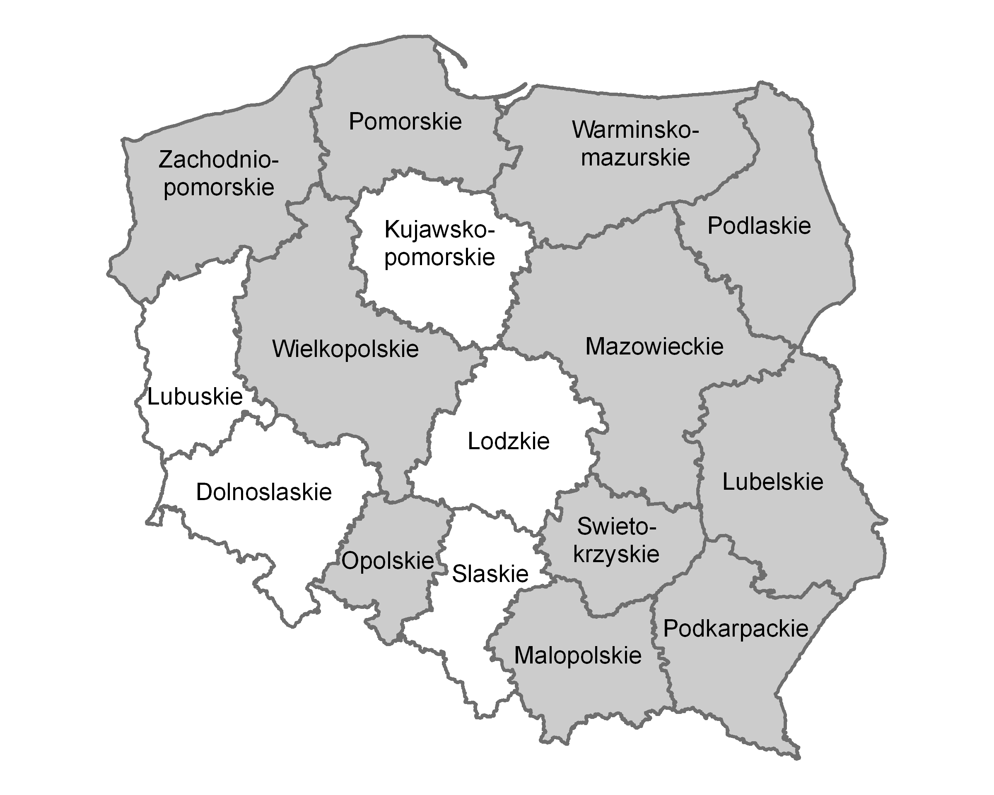

Definition of endemic area

An endemic area for tick-borne encephalitis is defined as an administrative district (poviat) in which the average incidence of locally-exposed tick-borne encephalitis exceeds 1 case per 100,000 inhabitants during the previous five years. Township districts are assigned the category of the surrounding rural districts.

NOTE: The above definition is currently used for research purposes only. It is planned to implement a relevant definition of endemic areas by the national public health authorities in order to improve the targeting of vaccination recommendations.

