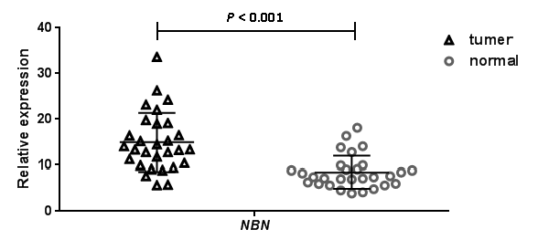
S2 Fig. The NBN mRNA expression analysis between 29 paired gastric adenocarcinoma and adjacent normal tissues based on TCGA data. (http://cancergenome.nih.gov/)

