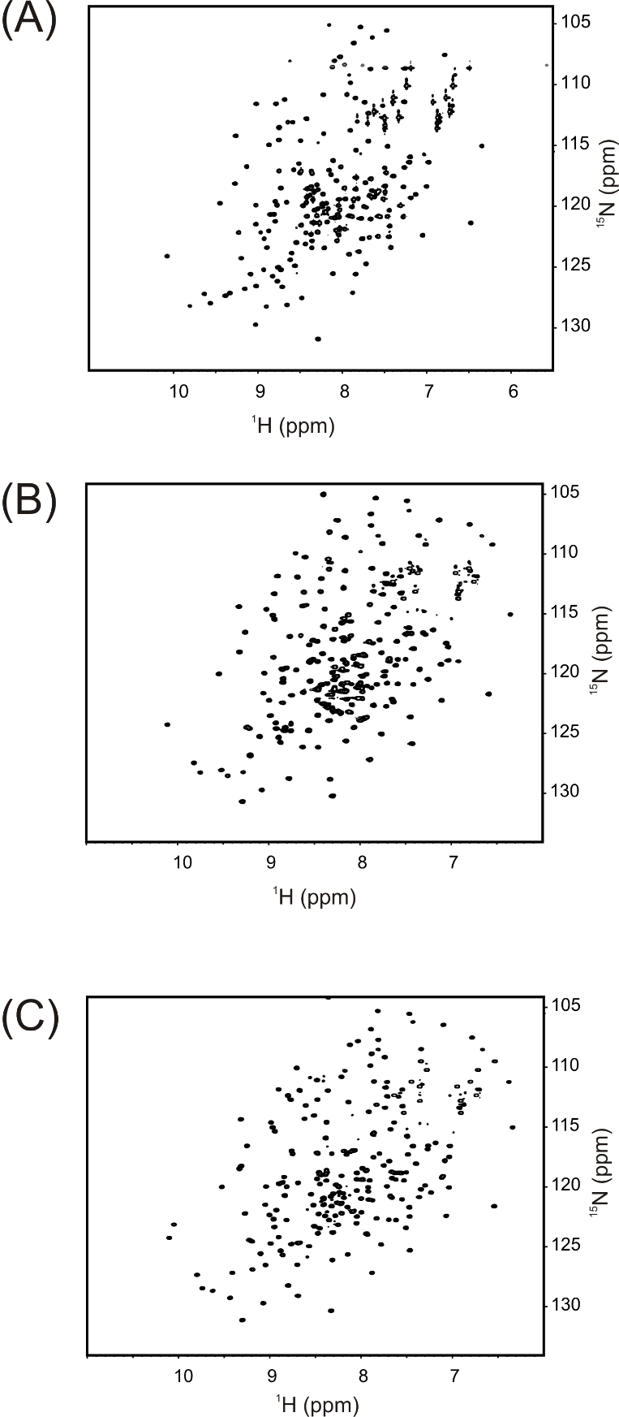
S3 Fig. ¹H-¹⁵N HSQC spectra of Adk_{eco} variants. (A) I116G. (B) R36S+11a.a. (C) K13Q.

