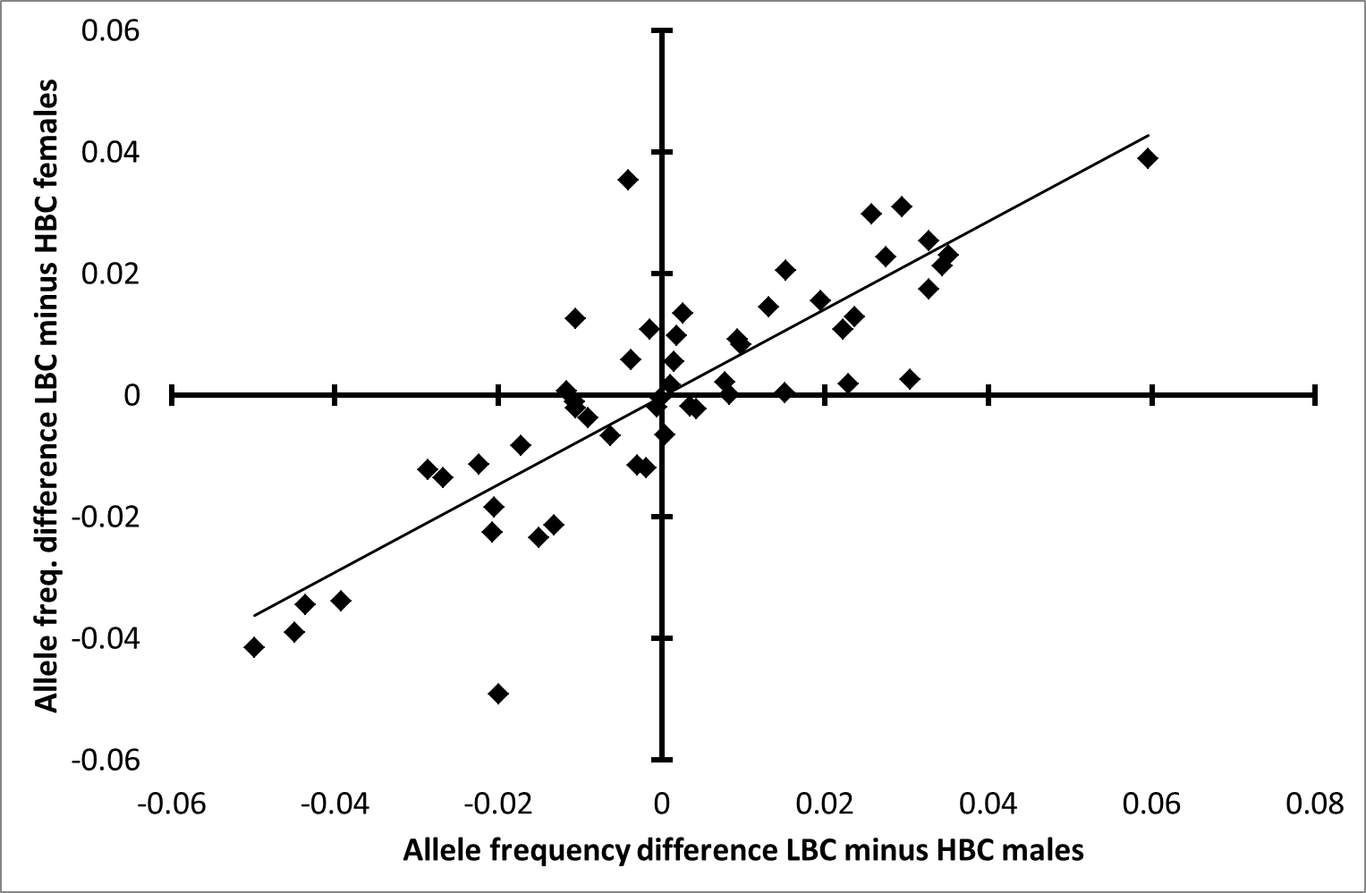
Figure S3: Positive correlation between males and females in LBC-minus-HBC allele frequency difference in the null model (Spearman rank correlation: ρ = 0.83)
n_{alleles} = 53 excluding rare alleles (frequency < 0.05) to prevent low sample size bias, n_{LBC females} = 138, n_{HBC females}= 48, n_{LBC males} = 92, n_{HBC males} = 42, n_{herds} = 20. Data are from southern Kruger. In the null model allele frequencies were equalized between sexes and body condition classes in each herd. Expected counts of alleles per herd were subsequently summed across herds. The allele frequencies depicted in the figure are based on these summed allele counts. A positive correlation indicates that both allele frequencies per herd and proportion of LBC individuals per herd were correlated between sexes. Abbreviations: LBC: low body condition, HBC: high body condition.

