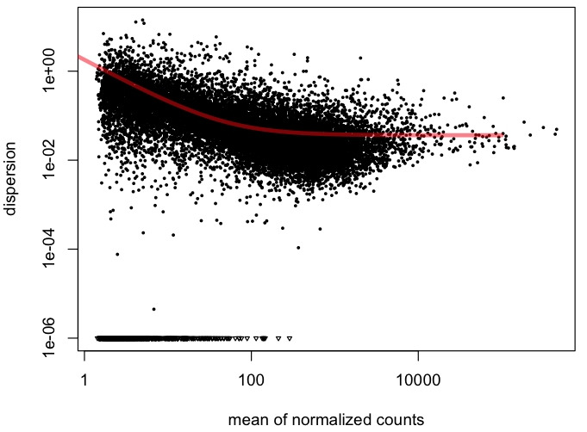
Figure S2: Empirical (black dots) and fitted (red lines) dispersion values (log₂) plotted against the mean of the normalized counts from RNA-Seq data of Longissimus dorsi muscle of Nellore steers. The black dots represent the empirical dispersion values and the red line represents fitted dispersion values (log₂). Y-axis represents the dispersion of expression level and X-axis represents the mean of normalized counts.

