A
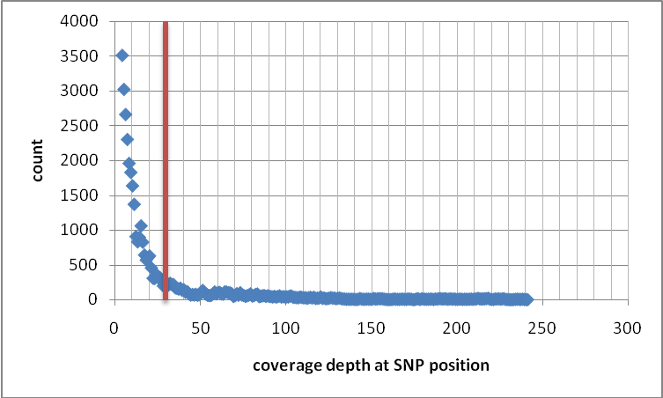
B
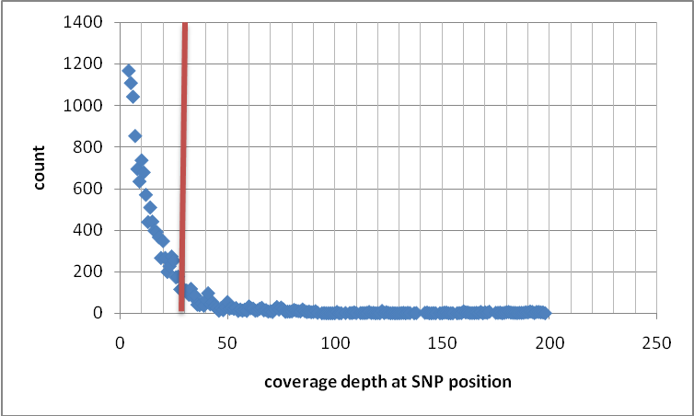
Figure S2. Depth at SNP positions for [A] EG01 and [B] EO01 contigs. The red line indicates the cut-off of two standard deviation from the mean, where the SNPs on the left of the line were defined as unreliable.

