S1 Figure: Photomicrographs of lung parenchyma stained with hematoxylin-eosin.

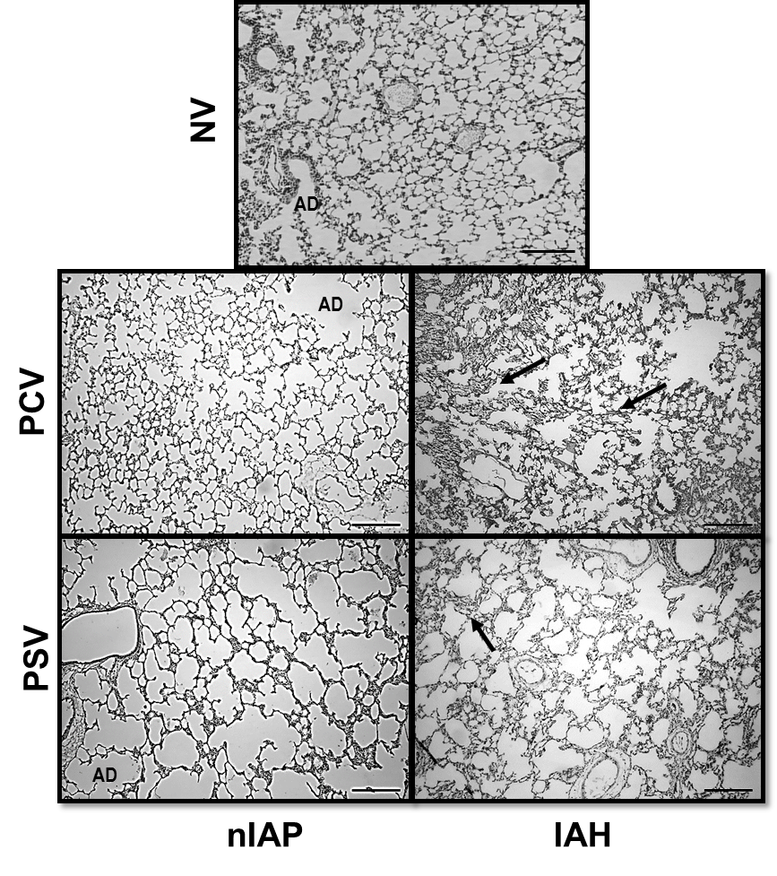

Original magnification ×200. Arrows: alveolar collapse. AD: alveolar duct. nIAP: animals with normal intra-abdominal pressure. IAH: animals with intra-abdominal hypertension. PCV: mechanically ventilated in pressure-controlled ventilation. PSV: mechanically ventilated with pressure support ventilation. NV: non-ventilated animals.

