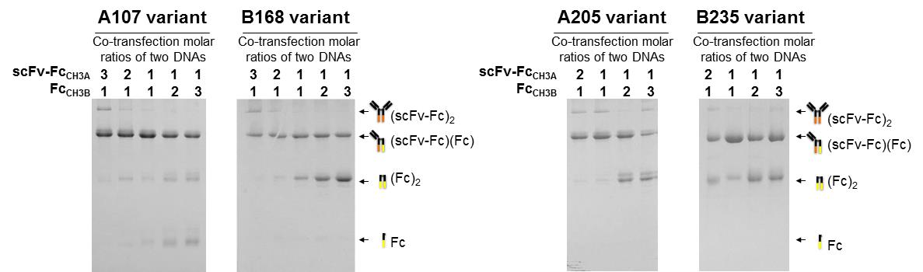

S2 Fig. Evaluation of heterodimerization yields of the representative heterodimeric Fc variants (A107, B168, A205, and B235) depending on the co-transfected molar rations of two DNAs encoding scFv-Fc_{CH3A} and Fc_{CH3B} at indicated ratio in the panel. The purified proteins (each 5μg) were analyzed by SDS-PAGE under non-reducing conditions. The arrows indicate the assembled scFv-Fc_{CH3A} homodimer (~150 kDa), scFv-Fc_{CH3A}/Fc_{CH3B} heterodimer (~78 kDa), Fc_{CH3B} homodimer (~53 kDa), and unassembled Fc_{CH3B} monomeric species (~ 27 kDa).

