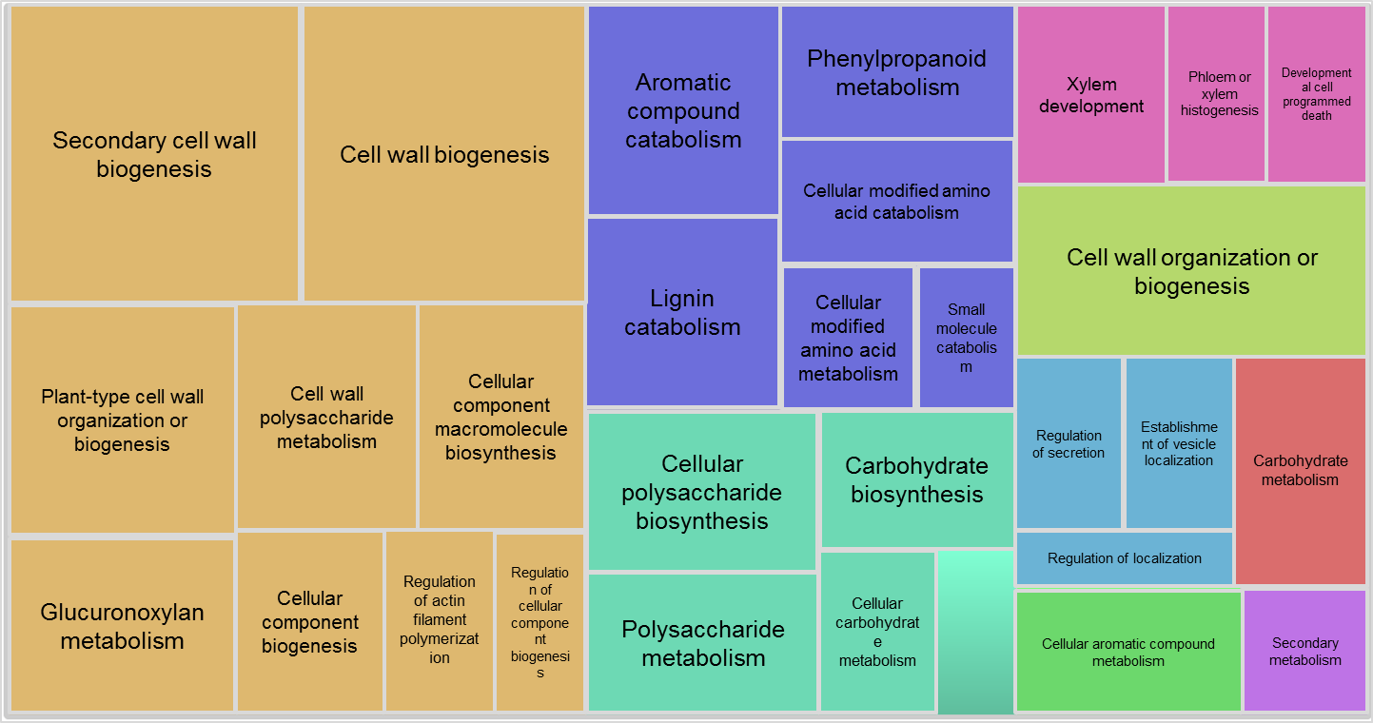
S2 Fig. Gene ontology enrichment of MWL-1 top 300 co-expressed genes in Arabidopsis.
Co-expressed genes were extracted from ATTED-II [1]. GO-full was conducted in Cytoscape 2.8.2 [2] using BiNGO 2.44 [3], while overrepresentation summary enrichment was performed with the REVIGO server [4].

References
1. Obayashi T, Hayashi S, Saeki M, Ohta H, Kinoshita K. ATTED-II provides coexpressed gene networks for Arabidopsis. Nucleic Acids Res. 2009. 37: D987-D991.
2. Smoot ME, Ono K, Ruscheinski J, Wang P-L, Ideker T. Cytoscape 2.8: new features for data integration and network visualization. Bioinformatics. 2011. 27: 431-432.
3. Maere S, Heymans K, Kuiper M. BiNGO: a Cytoscape plugin to assess overrepresentation of gene ontology categories in biological networks. Bioinformatics. 2005. 21: 3448-3449.
4. Supek F, Bošnjak M, Škunca N, Šmuc T. REVIGO summarizes and visualizes long lists of gene ontology terms. PloS One. 2011. 6: e21800.

