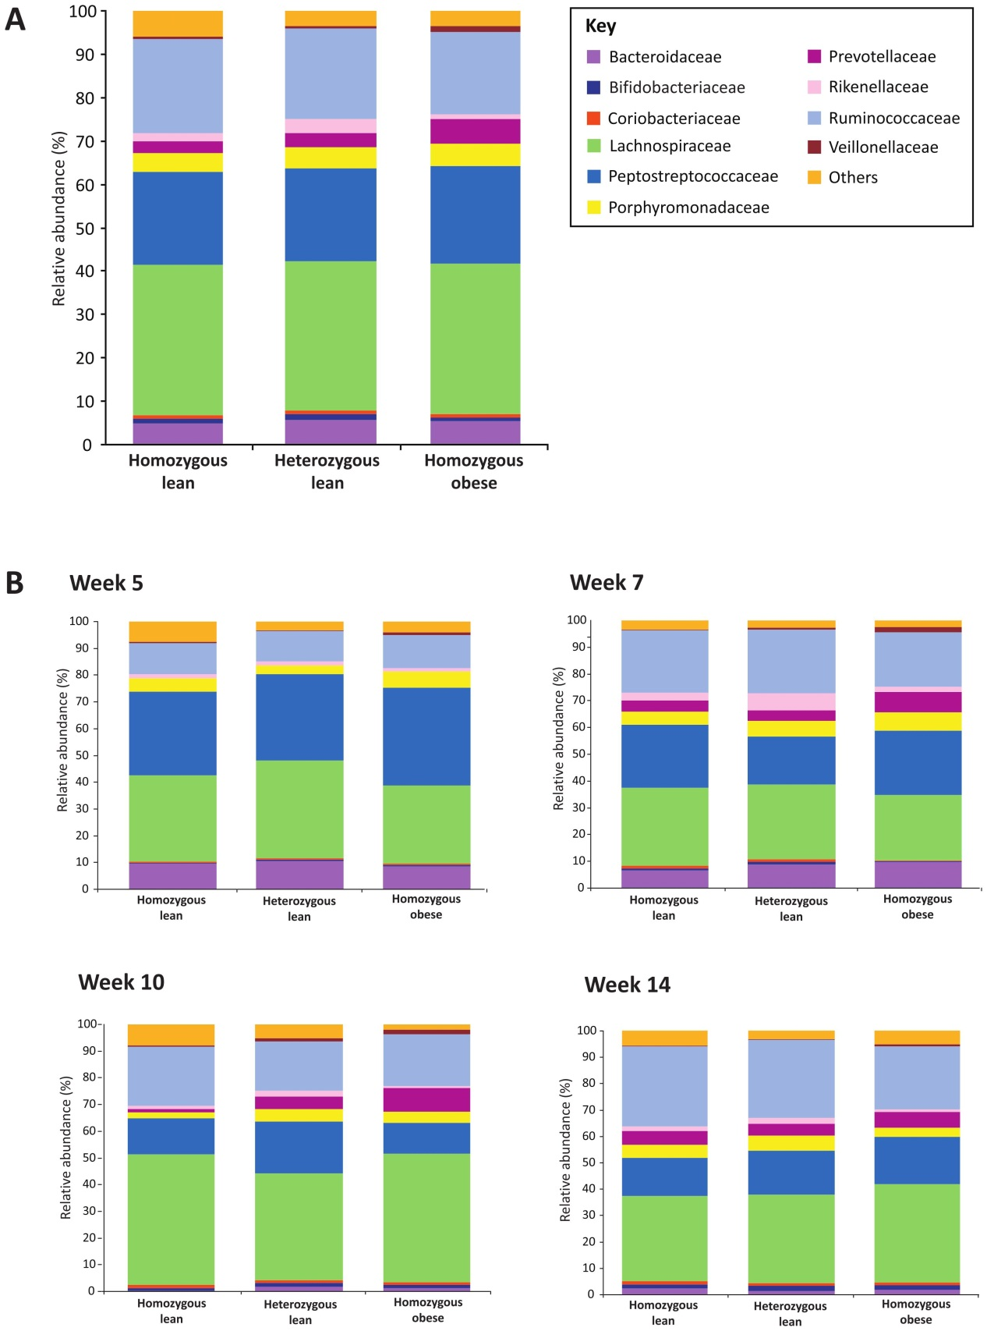

Figure S16: A: mean relative abundances of each family for each genotype (all time points included). B: mean relative abundances of each family for each genotype at each time point separately. Family key: ‘Others’ composed of the families: Alcaligenaceae, Anaeroplasmataceae, Bacillaceae, Clostridiaceae, Enterobacteriaceae, Erysipelotrichaceae, Eubacteriaceae, Halomonadaceae, Incertae Sedis XIII, Incertae Sedis XIV, Lactobacillaceae, Peptococcaceae, Pseudomonadaceae and Sphingomonadaceae.

