Evaluating the benefits of aphasia intervention delivered in virtual reality:
Results of a quasi-randomised study
Supplementary material: S3 File

This supplement provides box plots of dependent variables’ scores across time for the immediate and waitlist control groups. The box plots show the median as a dark line; the box represents the 25-75 centiles, i.e. the interquartile range; and the lines the full range of scores.

Figure A: Boxplot of CADL scores across time for immediate (n=10) and waitlist control (n=10) groups

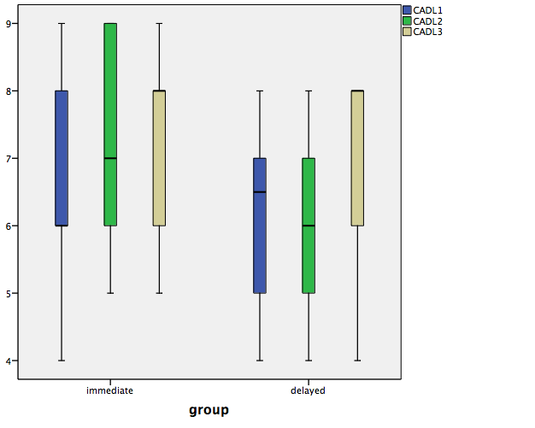
CADL: Communication Activities of Daily Living test scores
1: Week 1 (pre-therapy for immediate treatment group and pre-therapy 1 for waitlist control group)
2: Week 7 (post-therapy for immediate treatment group and pre-therapy 2 for waitlist control group)
3: Week 13 (maintenance for immediate treatment group and post-therapy for waitlist control group)
Figure B: Boxplot of Verbal Fluency scores across time for immediate (n=10) and waitlist control (n=10) groups

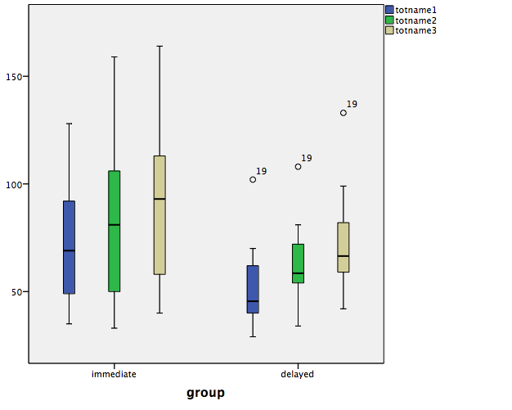

totname: Verbal Fluency scores
1: Week 1 (pre-therapy for immediate treatment group and pre-therapy 1 for waitlist control group)
2: Week 7 (post-therapy for immediate treatment group and pre-therapy 2 for waitlist control group)
3: Week 13 (maintenance for immediate treatment group and post-therapy for waitlist control group)

Figure C: Boxplot of Conversation % content words scores across time for immediate (n=10) and waitlist control (n=10) groups

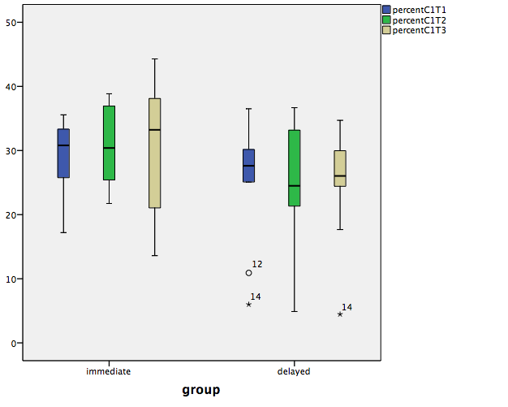

percentC1: Conversation % of content words scores
T1: Week 1 (pre-therapy for immediate treatment group and pre-therapy 1 for waitlist control group)
T2: Week 7 (post-therapy for immediate treatment group and pre-therapy 2 for waitlist control group)
T3: Week 13 (maintenance for immediate treatment group and post-therapy for waitlist control group)

Figure D: Boxplot of Conversation content words per turn scores across time for immediate (n=10) and waitlist control (n=10) groups

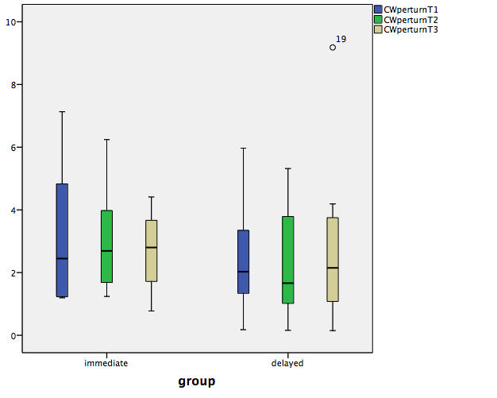

CWperturn: Conversation content words per turn scores
T1: Week 1 (pre-therapy for immediate treatment group and pre-therapy 1 for waitlist control group)
T2: Week 7 (post-therapy for immediate treatment group and pre-therapy 2 for waitlist control group)
T3: Week 13 (maintenance for immediate treatment group and post-therapy for waitlist control group)

Figure E: Boxplot of Narrative Words per minute scores across time for immediate (n=10) and waitlist control (n=9) groups

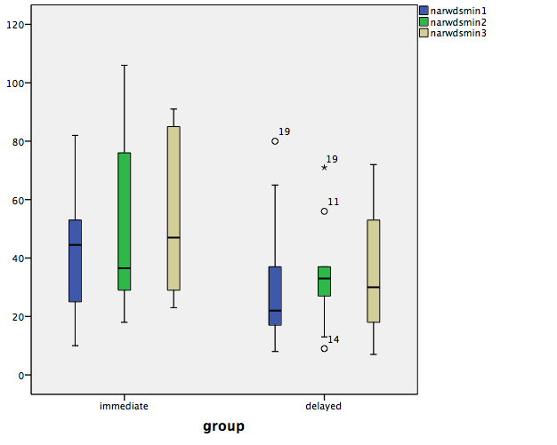

narwdsmin: Narrative words per minute scores
1: Week 1 (pre-therapy for immediate treatment group and pre-therapy 1 for waitlist control group)
2: Week 7 (post-therapy for immediate treatment group and pre-therapy 2 for waitlist control group)
3: Week 13 (maintenance for immediate treatment group and post-therapy for waitlist control group)

Figure F: Boxplot of Narrative Sentences scores across time for immediate (n=10) and waitlist control (n=9) groups

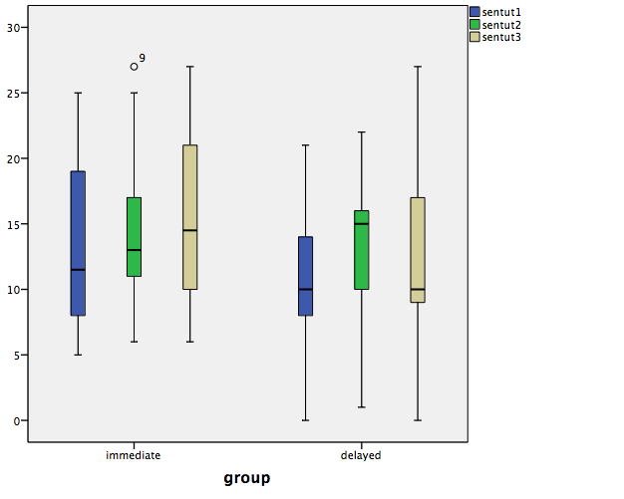

sentut: Narrative sentences scores
1: Week 1 (pre-therapy for immediate treatment group and pre-therapy 1 for waitlist control group)
2: Week 7 (post-therapy for immediate treatment group and pre-therapy 2 for waitlist control group)
3: Week 13 (maintenance for immediate treatment group and post-therapy for waitlist control group)

Figure G: Boxplot of CCRSA scores across time for immediate (n=10) and waitlist control (n=10) groups

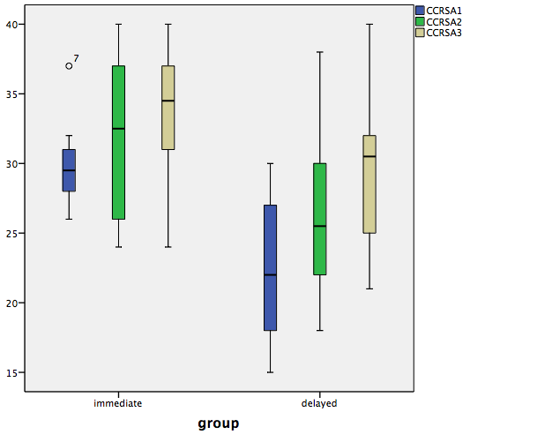

CCRSA: Communication Confidence Rating Scale for Aphasia scores
1: Week 1 (pre-therapy for immediate treatment group and pre-therapy 1 for waitlist control group)
2: Week 7 (post-therapy for immediate treatment group and pre-therapy 2 for waitlist control group)
3: Week 13 (maintenance for immediate treatment group and post-therapy for waitlist control group)

Figure H: Boxplot of Friendship Scale scores across time for immediate (n=10) and waitlist control (n=10) groups

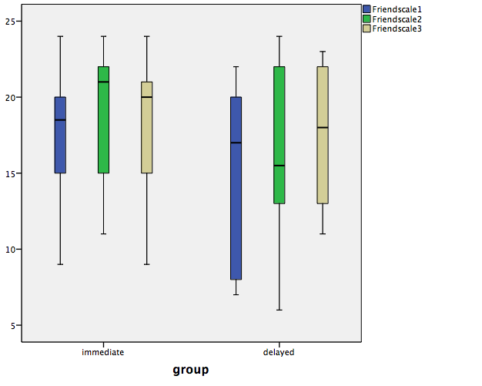

Friendscale: Friendship Scale scores
1: Week 1 (pre-therapy for immediate treatment group and pre-therapy 1 for waitlist control group)
2: Week 7 (post-therapy for immediate treatment group and pre-therapy 2 for waitlist control group)
3: Week 13 (maintenance for immediate treatment group and post-therapy for waitlist control group)

