Supplementary Data
Table S1. Vdr genotyping PCR conditions. Panda et al. 2004 (29)
Wild Type Vdr Primers |  |  | Amplicon length
Forward | 5’-CTCCATCCCCATGTGTCTTT-3’ |  | 750 bp
Reverse | 5’-TTCTTCAGTGGCCAGCTCTT-3’
Mutant Vdr Primers |  |  | Amplicon length
Forward | 5’-GCTGCTCTGATGCCGCCGTGTTC-3’ |  | 294 bp
Reverse | 5’-GCACTTCGCCCAATAGCAGCCAG-3’
Cycling Conditions
Denature | 94°C | 60 sec | 35 cycles
Anneal | 65°C | 60 sec
Extend | 72°C | 60 sec

A | B
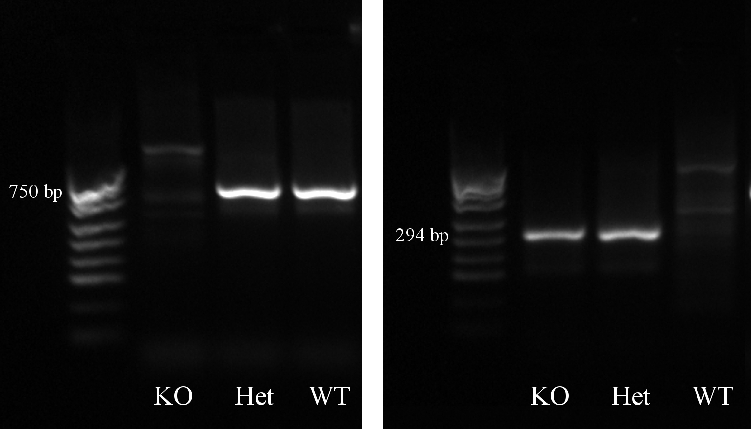

Figure S1. Genotyping of Vdr alleles by PCR and Gel electrophoresis.
A Primers for wild-type allele. B Primers for knockout allele.

Table S2. Primers and PCR conditions for sex typing of mice. Albay et al., 2009 (30)
Sry Primers |  |  |  | Amplicon length
Forward | 5’-AACAACTGGGCTTTGCACATTG-3’ |  |  | 7166, 146 bp (doublet)
Reverse | 5’-GTTTATCAGGGTTTCTCTCTAGC-3’
Nfiα Primers |  |  |  | Amplicon length
Forward | 5’-TGCTGTGTTCTGGTCAGTCAAG-3’ |  |  | 405 bp
Reverse | 5’-CAAAGCAAATCTCCATGCTCGG-3’
Cycling Conditions
Denature | 94°C | 60 sec | 33 cycles
Anneal | 60°C | 60 sec
Extend | 72°C | 72 sec
 | 72°C | 9 min | 1 cycle

Table S3. PCR primers and cycling conditions to validate DNAse treatment of placental RNA extracts
Primers |  |  |  | Amplicon length
Forward | 3’-GGCACTGACTGAGGTCAAAC-5’ |  |  | 120 bp
Reverse | 3’-GTCACAATCACAGAGACTTTGA-5’
Cycling Conditions
Denature | 94°C | 10 sec | 40 cycles
Anneal | 60°C | 15 sec
Extend | 72°C | 60 sec

Table S3. Quantitative PCR assay and cycling conditions
Gene | Taqman Assay ID |  | Amplicon size
Vdr | Mm00437297_m1 |  | 95 bp
Cyp24a1 | Mm00487244_m1 |  | 99 bp
Deptor | Mm01195336_m1 |  | 82 bp
Hbms | Mm01143545_m1 |  | 81 bp
Plscr1 | Mm01228223_g1 |  | 79 bp
Cycling Conditions
Activation | 95°C | 10 min
Denature | 95°C | 15 sec | 40 cycles
Anneal/extend | 60°C | 60 sec

