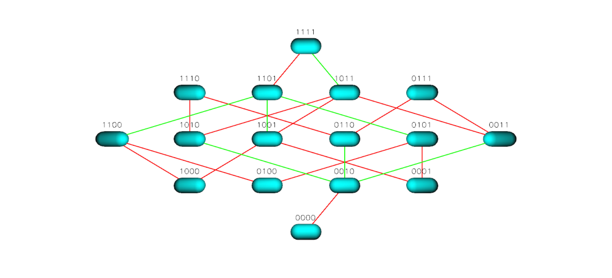
Figure S13 TEM 50 Landscape for Ampicillin + Sulbactam

