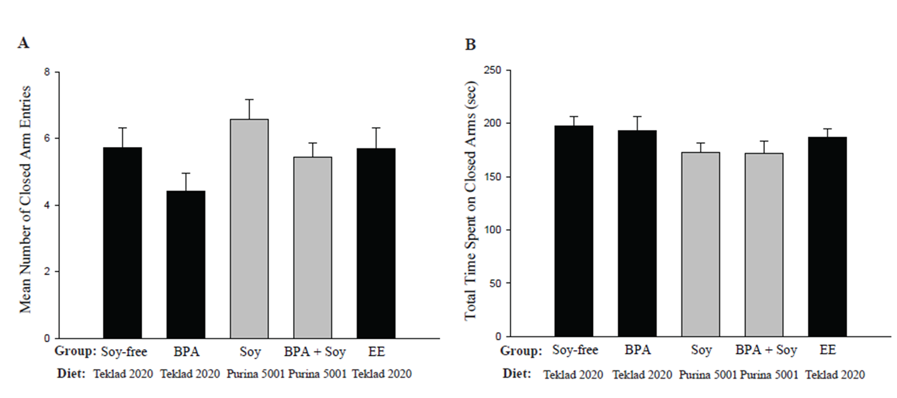
Figure S1. Juvenile Closed Arm Activity

