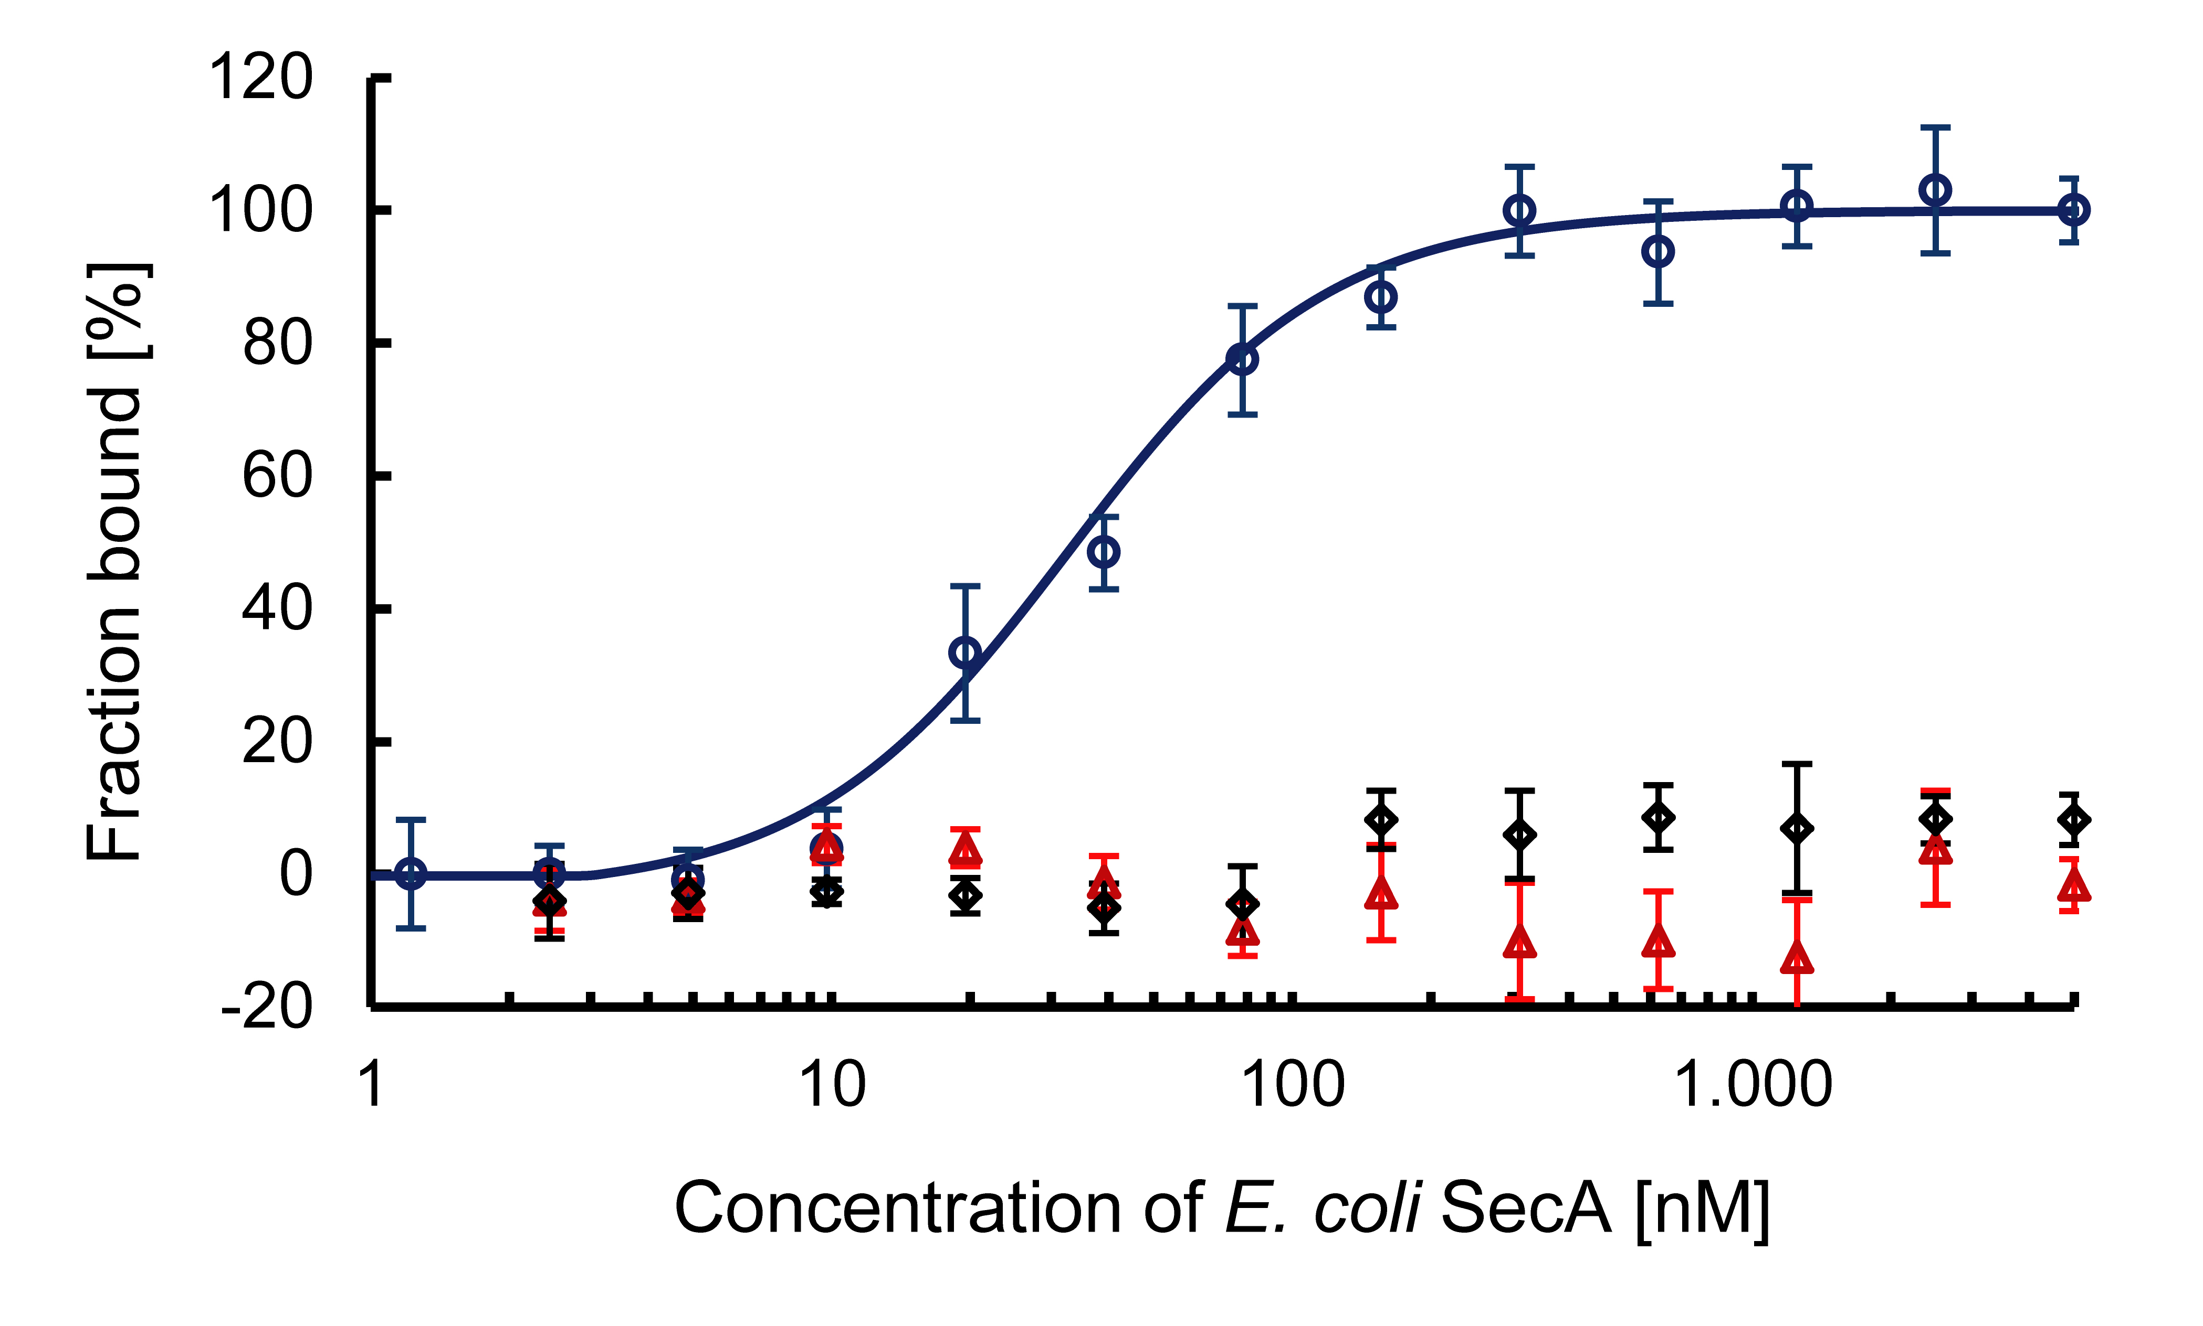S2 Fig. MST analysis on the interaction between E. coli SecA and M. tuberculosis SecA1 and SecA2. MST measurement of E. coli SecA-Cy5 (open circles), M. tuberculosis SecA1-Cy5 (open triangles), and SecA2-Cy5 (open square) titrated with increasing concentrations of unlabeled E. coli SecA, The curves were fitted using the Hill-equation and the apparent K_{d} values were determined with a standard error of 3 measurements. The formation of the SecA homodimer showed an apparent K_{d} of 31 ± 1.5 nM, whereas for the M. tuberculosis SecA proteins, no interaction with E. coli SecA was observed.

