The ARRIVE Checklist
A Subregion of Reelin Suppresses Lipoprotein-Induced Cholesterol Accumulation in Macrophages
Emmanuel U. Okoro^{1,¶}, Hongfeng Zhang^{1,2,¶}, Zhongmao Guo¹, Fang Yang^{1,3}, Carlie Smith Jr.¹ and Hong Yang^{1,}*
¹ Department of Physiology, Meharry Medical College, Nashville, Tennessee, United States of America
² Department of Pathology, Central Hospital of Wuhan, Wuhan City, People’s Republic of China
³ Wuhan University School of Basic Medical Science, Wuhan City, People’s Republic of China

 |  | ITEM | RECOMMENDATION | Section/  Paragraph
 |  |  |  | Title
Abstract

This study used a cell line.
Lipoproteins isolated from mice were used as a reagent to treat cells.
 | INTRODUCTION
 | 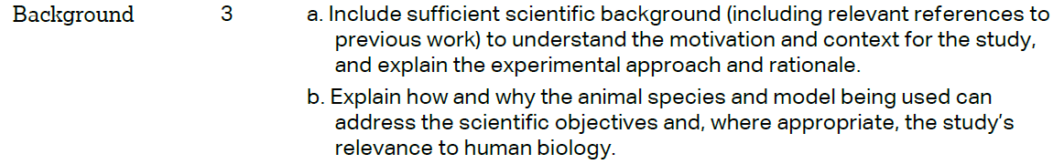 |  |  | paragraph 1-2  N/A  Mice were used for isolation of lipoproteins.
 |  |  |  | Paragraph 3
 | METHODS
Methods
Paragraph 1
 | 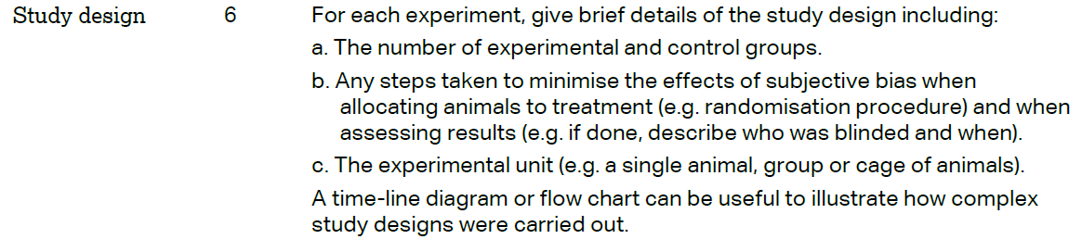 |  |  | Paragraph 8  Mice were used for isolation of lipoproteins.
 | 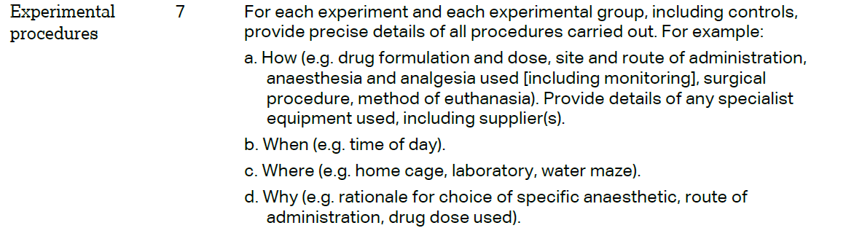 |  |  | Paragraph 8
 | 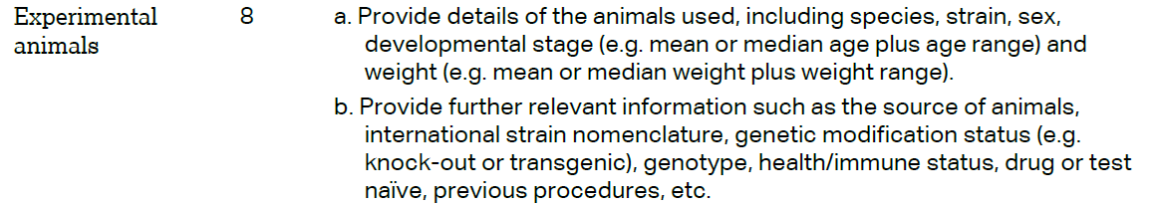 |  |  | Paragraph 8

 | 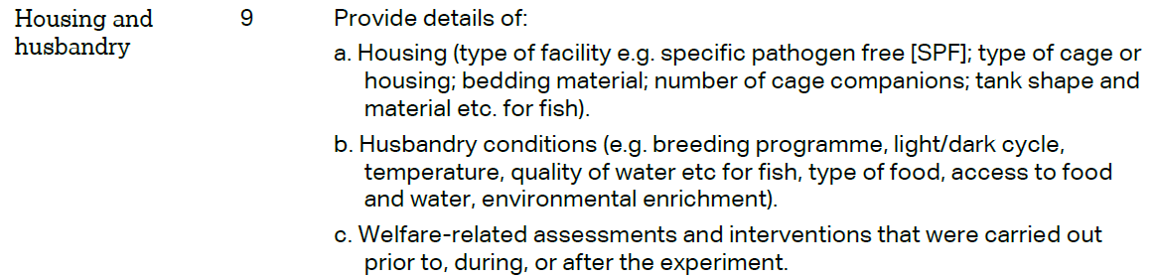 | Paragraph 8
 | 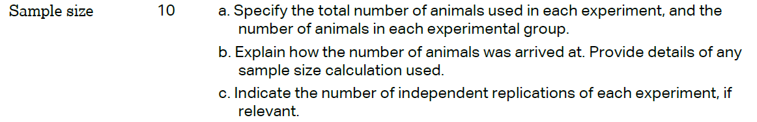 | Paragraph 8
 | 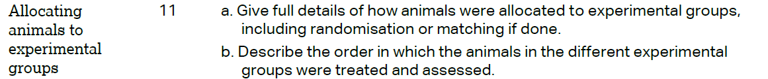 | Paragraph 8.  Mice were used for isolation of lipoproteins
Results
Paragraph 1-12
 | 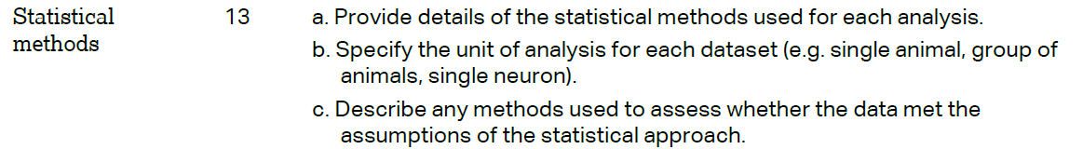 | Paragraph 14
 | RESULTS
Method
Paragraph 8
Method
Paragraph 8
Mice were used for isolation of lipoproteins
 |  | Paragraph 1-12
N/A.
Mice were used for isolation of lipoproteins
 | DISCUSSION
 | 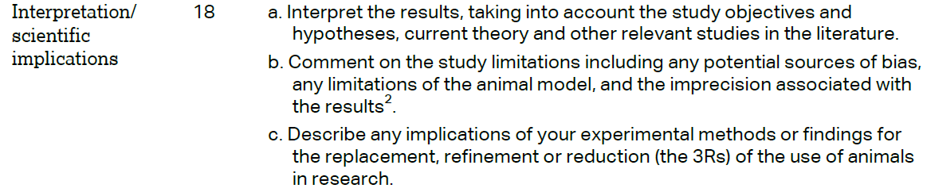 | Paragraph 1-5  N/A. this study used a cell line.
 |  | Paragraph 6
References
Paragraph 3

