S2 Fig Neutralization of toxic activity from MHI 1507 by mAb 1A8 (▼) and the isotype control ().

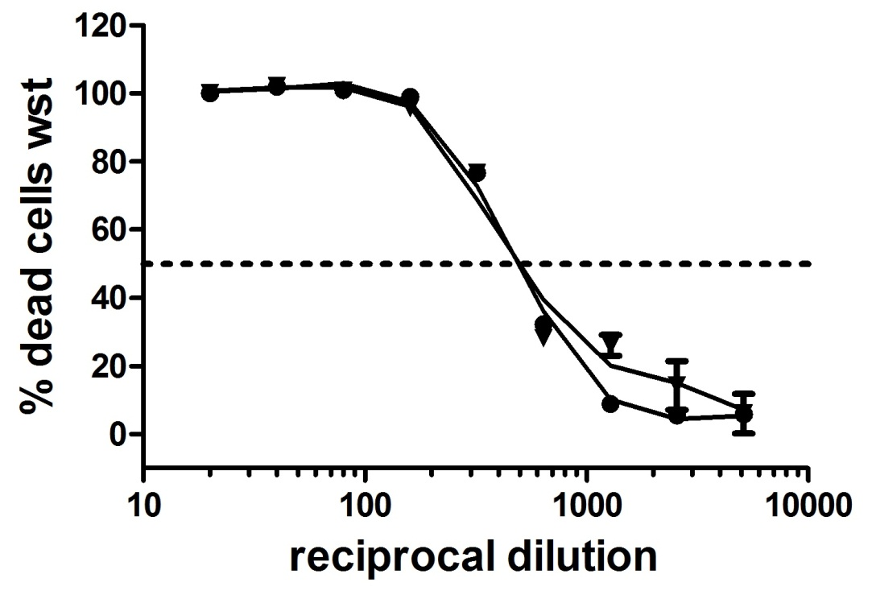
Application of the mAb 1A8 or an unspecific isotype control result in a similar 50 % cytotoxicity titer thus indicating that mAb 1A8 has no neutralizing effects.

