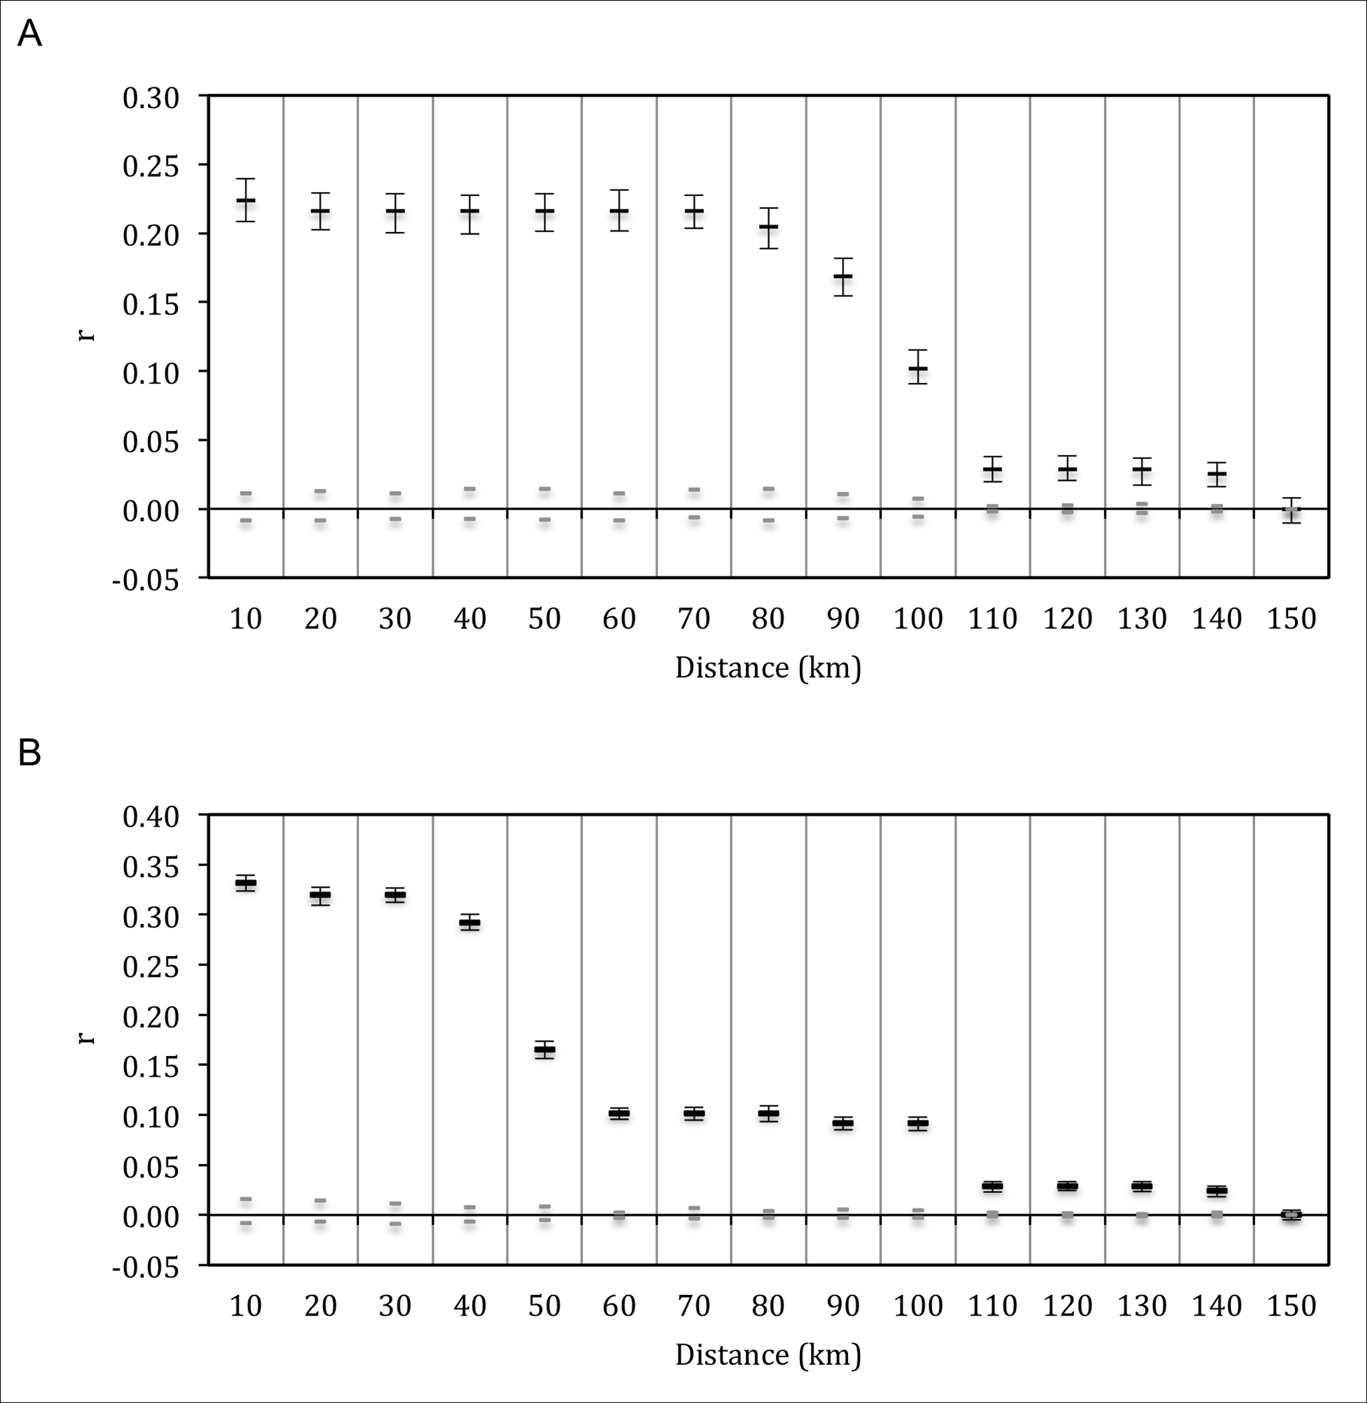
Figure S2. Correlograms showing the autocorrelation coefficient r as a function of increasing distance classes for A) pure Eastern, and B) Merri/Curdies ESUs. Distances are the maximum for each class, grey bars indicate 95% CI about the null hypothesis of no genetic structure, and error bars about r indicate 95% CI as determined by bootstrapping.

