Expanding the Repertoire of Gene Tools for Precise Manipulation of the Clostridium difficile Genome: Allelic Exchange Using PyrE Alleles.

SUPPORTING INFORMATION

Yen Kuan Ng^{≠ 1}, Muhammad Ehsaan^{≠ 1}, Sheryl Philip¹, Mark Collery¹, Clare Janoir², Anne Collignon², Stephen T. Cartman¹, Nigel P. Minton¹*

≠ These authors contributed equally to this work.

Author affiliations:
¹Clostridia Research Group, NIHR Biomedical Research Unit in GI Disease, Centre for Biomolecular Sciences, University Park, University of Nottingham, Nottingham, NG7 2RD, United Kingdom. ²Université Paris-Sud, Faculté de Pharmacie, Département de Microbiologie, Unité EA 40-43, 92296 Châtenay-Malabry Cedex, France.

*To whom correspondence should be addressed: Nigel P. Minton
Clostridia Research Group, Centre for Biomolecular Sciences, University Park, University of Nottingham,
Nottingham, NG7 2RD, United Kingdom
Phone: +44 (0)115 84 67458
Fax: +44 (0)115 82 32120

(a)
(b)
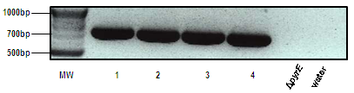

Figure S1. PCR screening of ACE generated pyrE mutant and wildtype strains in C. difficile strains 630∆erm and C. difficile R20291. (a) five random FOA^{R}, pyrE mutants (lanes 1-5) made in R20291 using pMTL-YN18, and; (b) five random pyrE repaired clones (lanes 1-5) from R20291 made using pMTL-YN2. MW is a 2-Log DNA Ladder (NEB) molecular weight marker, plasmid is a pMTL-YN18 DNA control, WT is a wild-type C. difficile DNA control, and ∆pyrE is a mutants control taken from the strain in lane 1 of (a). The primers used, and expected size of the DNA fragments generated were: (a) primers pyrE-F2/pyrE-R2 and a 565 bp DNA fragment, and; (b) primers cdi630-pyrD-SF1/pyrE-R2 and a 750 bp DNA fragment.
FIGURE 10a
Figure S2. PCR screening of double crossover candidate clones of C. difficile 630Δerm for spo0A, cwp84 and mtlD. (A) PCR screening of four (1-4) putative spo0A in-frame deletion clones using primers spo0A-YN-F2 and spo0A-YN-R2. The desired mutant should give a DNA product of 1,845 bp in size (clone 2), while the wild type allele (clones 1, 3 and 4) generates a product of 2,331 bp in size. (B) PCR screening of three (1-3) putative cwp84 in-frame deletion clones using primers cwp84-F3 and cwp84-R4. A double crossover mutant (clone 3) should give a PCR product of 1,418 bp in size, as opposed to the 2,636 bp fragment predicted for the wild type allele (clones 1 and 2). (C) PCR screening of three (1-3) putative in-frame deletions of mtlD using primers mtlD-F3 and mtlD-R3. The in-frame deletion mutant is predicted to yield a PCR DNA product 1,418 bp in size (clones 1 and 3), whereas the wild-type allele (clone 2) gives a DNA product of 2,582 bp in size. PCR product from wild-type or double-crossover wild-type revertants. MW is a 2-Log DNA Ladder (NEB) molecular weight marker and WT is a wild-type C. difficile DNA control.

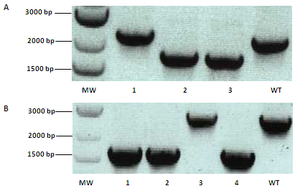

Figure S3. PCR screening of double crossover candidate clones of C. difficile R20291 for spo0A and cwp84. (A) PCR screening of three (1-3) putative spo0A in-frame deletion clones using primers spo0A-YN-F2 and spo0A-YN-R2. The desired mutant should give a DNA product of 1,845 bp in size (clones 2 and 3), while the wild type allele (clone1) generates a product of 2,331 bp in size. (B) PCR screening of four (1-4) putative cwp84 in-frame deletion clones using primers cwp84-F3 and cwp84-R4. Double crossover mutants (clones 1, 2 and 4) should give a PCR product of 1,418 bp in size, compared to the 2,636 bp fragment predicted for the wild type allele (clone 3). MW is a 2-Log DNA Ladder (NEB) molecular weight marker and WT is a wild-type C. difficile DNA control.

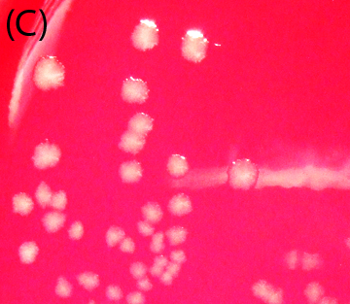
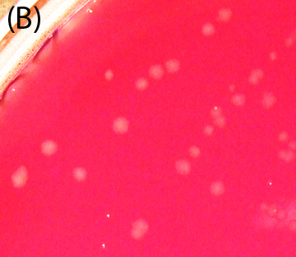
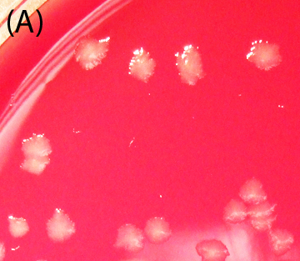

Figure S4. Comparison of colony morphology of C. difficile 630Δerm strains. C. difficile 630Δerm (A) 630ΔermΔcwp84 mutant (B), and 630ΔermΔcwp84-complemented (C) were streaked onto anaerobic blood agar plate and incubated overnight to observe colony morphology. Colonies of C. difficile 630Δerm (A) and 630ΔermΔ cwp84-complemented (C) are indistinguishable and showed irregular edged colonies compared to C. difficile 630Δerm cwp84 mutant (B) showed more rounded colonies and are noticeably smaller due to its slower growth rate.

Figure S5. Complementation of spo0A mutants of 630Δerm∆pyrE and R20291∆pyrE. The sporulation phenotype of the mutants and complemented mutants were compared to the wildtype strains by assaying colony forming units (CFU) on BHIS supplemented with 0.1% [w/v] sodium taurocholate before and after heat shock (65°C for 30 min) following growth of each strain in BHIS media for 120 h. Assayed strains are: 630∆erm∆pyrE∆spo0A; 630∆erm*(spo0A); 630∆erm; R20291∆pyrE∆spo0A; R20291*(spo0A), and; R20291, where * indicates the spo0A-complemented strain (spo0A) which has had a copy of the spo0A gene inserted into the chromosome, concomitant with the correction of the pyrE allele back to wildtype. The detection limit for the assay was 50 CFU/ml. All experiments were undertaken in triplicate. Phase contrast microscopy confirmed that phase-bright spores were absent in the mutant cultures but present in both the complemented and wildtype strains.

Fig. S6. Growth of C. difficile 630Δerm strains with mannitol as the sole carbon source.. (B) The growth of ∆mtlD was limited in mannitol broth, while growth of the ∆mtlD complemented and mtlD overexpressed strains were restored to wildtype levels. (C) The pH of the media broth showed a dip in pH caused by the fermentation of mannitol for the wildtype, ∆mtlD complemented and ∆mtlD overexpressed strains, which correlate to their growth. The 630 ∆erm ∆mtlD mutant strain grew very weakly in mannitol broth, which was reflected in the sustained pH levels of the media. Experiments were undertaken in triplicate.

